**Fig. 1. *A Concordance to Fascicle Three of the Inscriptions from the Yin Ruins* (1985) p. 2**

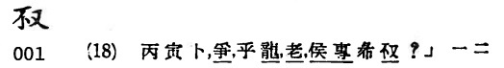

**Fig. 2. *A Concordance to Fascicle Three of the Inscriptions from the Yin Ruins* (1985) p. 2**

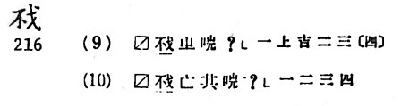

**Fig. 3. *A Concordance to Fascicle Three of the Inscriptions from the Yin Ruins* (1985) p. 4**

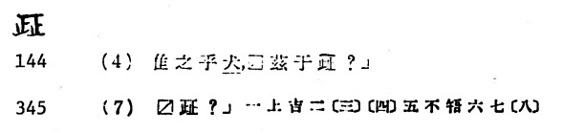

**Fig. 4. *A Concordance to Fascicle Three of the Inscriptions from the Yin Ruins* (1985) p. 18**

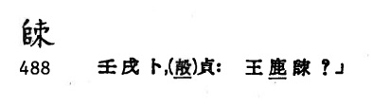

**Fig. 5. *A Concordance to Fascicle Three of the Inscriptions from the Yin Ruins* (1985) p. 21**

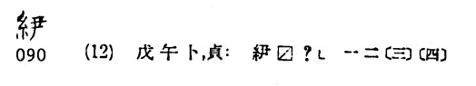

**Fig. 6. *A Concordance to Fascicle Three of the Inscriptions from the Yin Ruins* (1985) p. 47**

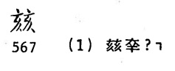

**Fig. 7. *A Concordance to Fascicle Three of the Inscriptions from the Yin Ruins* (1985) p. 82**

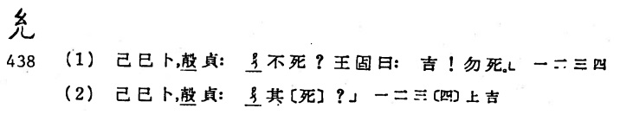

**Fig. 8. *A Concordance to Fascicle Three of the Inscriptions from the Yin Ruins* (1985) p. 115**

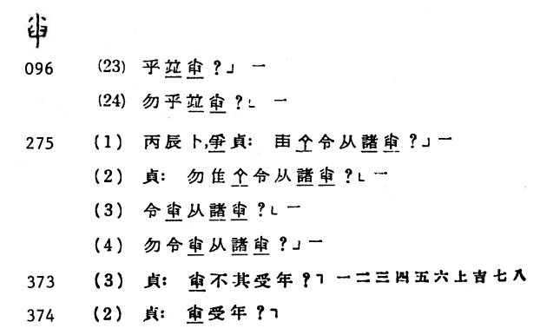

**Fig. 9. *A Concordance to Fascicle Three of the Inscriptions from the Yin Ruins* (1985) p. 117**

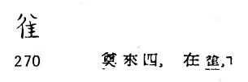

**Fig. 10. *A Concordance to Fascicle Three of the Inscriptions from the Yin Ruins* (1985) p. 117**

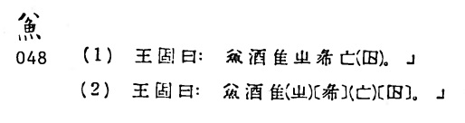

**Fig. 11. *A Concordance to Fascicle Three of the Inscriptions from the Yin Ruins* (1985) p. 117**

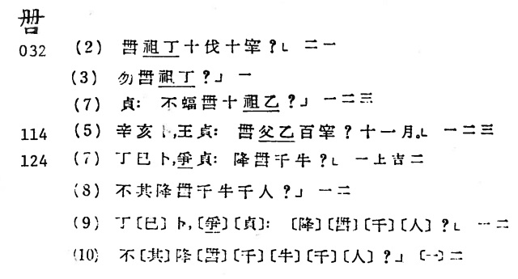

**Fig. 12. *A Concordance to Fascicle Three of the Inscriptions from the Yin Ruins* (1985) p. 118**

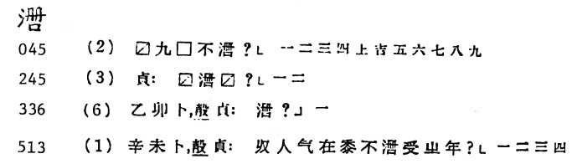

**Fig. 13. *A Concordance to Fascicle Three of the Inscriptions from the Yin Ruins* (1985) p. 119**

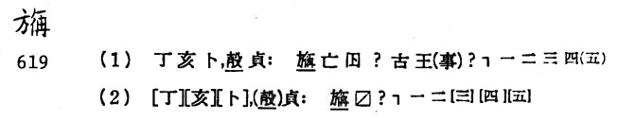

**Fig. 14. *A Concordance to Fascicle Three of the Inscriptions from the Yin Ruins* (1985) p. 119**

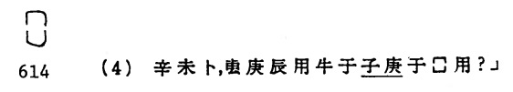

**Fig. 15. *A Concordance to Fascicle Three of the Inscriptions from the Yin Ruins* (1985) p. 119**

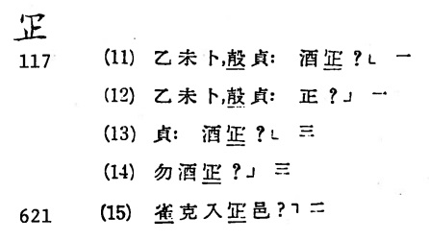

**Fig. 16. *A Concordance to Fascicle Three of the Inscriptions from the Yin Ruins* (1985) p. 120**

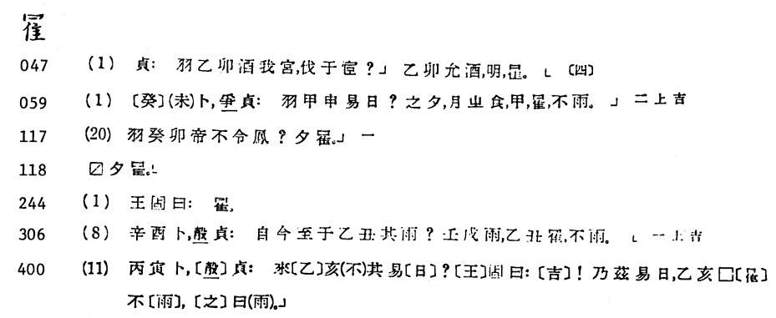

**Fig. 17. *A Concordance to Fascicle Three of the Inscriptions from the Yin Ruins* (1985) p. 121**

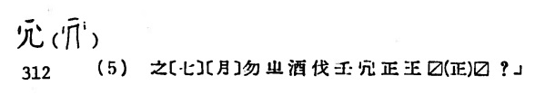

**Fig. 18. *A Concordance to Fascicle Three of the Inscriptions from the Yin Ruins* (1985) p. 144**

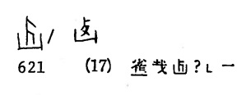

**Fig. 19. *A Concordance to Fascicle Three of the Inscriptions from the Yin Ruins* (1985) p. 147**

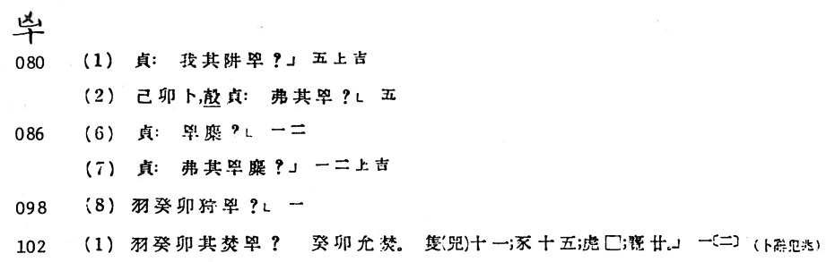

**Fig. 20. *A Concordance to Fascicle Three of the Inscriptions from the Yin Ruins* (1985) p. 147**

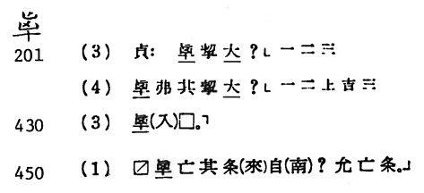

**Fig. 21. *A Concordance to Fascicle Three of the Inscriptions from the Yin Ruins* (1985) p. 148**

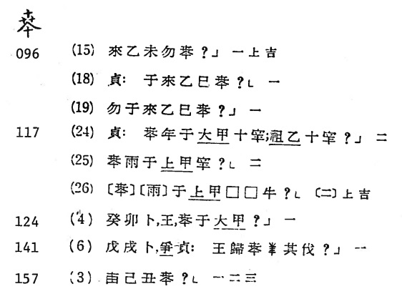

**Fig. 22. *A Concordance to Fascicle Three of the Inscriptions from the Yin Ruins* (1985) p. 156**

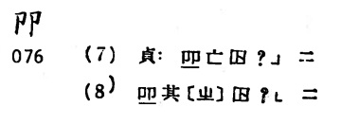

**Fig. 23. *A Concordance to Fascicle Three of the Inscriptions from the Yin Ruins* (1985) p. 158**

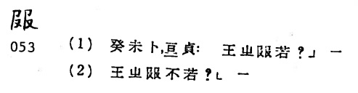

**Fig. 24. *A Concordance to Fascicle Three of the Inscriptions from the Yin Ruins* (1985) p. 161**

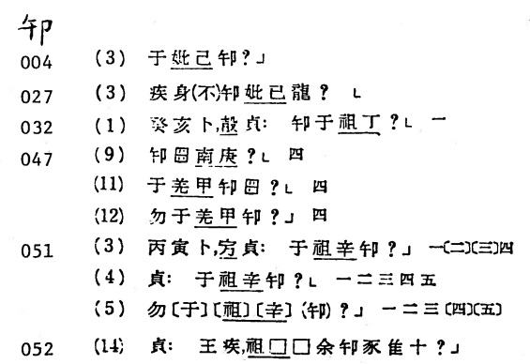

**Fig. 25. *A Concordance to Fascicle Three of the Inscriptions from the Yin Ruins* (1985) p. 165**

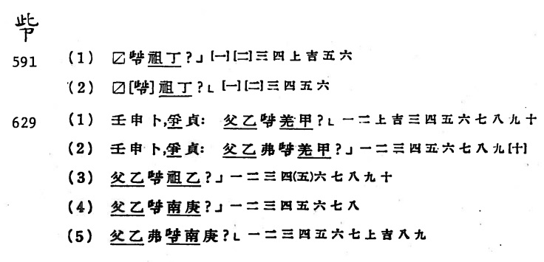

**Fig. 26. *A Concordance to Fascicle Three of the Inscriptions from the Yin Ruins* (1985) p. 175**

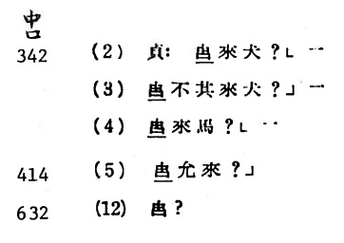

**Fig. 27. *A Concordance to Fascicle Three of the Inscriptions from the Yin Ruins* (1985) p. 175**

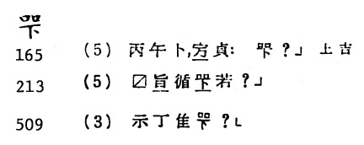

**Fig. 28. *A Concordance to Fascicle Three of the Inscriptions from the Yin Ruins* (1985) p. 176**

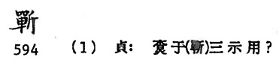

**Fig. 29. *A Concordance to Fascicle Three of the Inscriptions from the Yin Ruins* (1985) p. 176**

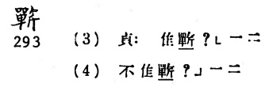

**Fig. 30. *A Concordance to Fascicle Three of the Inscriptions from the Yin Ruins* (1985) p. 176**

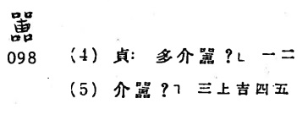

**Fig. 31. *A Concordance to Fascicle Three of the Inscriptions from the Yin Ruins* (1985) p. 178**

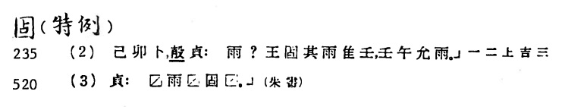

**Fig. 32. *A Concordance to Fascicle Three of the Inscriptions from the Yin Ruins* (1985) p. 181**

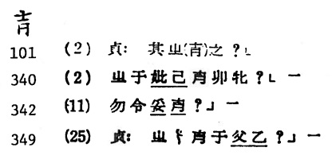

**Fig. 33. *A Concordance to Fascicle Three of the Inscriptions from the Yin Ruins* (1985) p. 182**

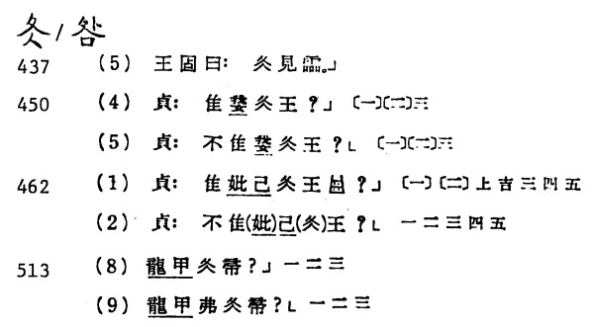

**Fig. 34. *A Concordance to Fascicle Three of the Inscriptions from the Yin Ruins* (1985) p. 182**

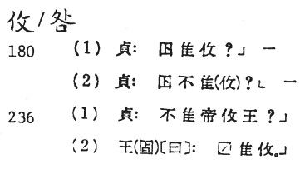

**Fig. 35. *A Concordance to Fascicle Three of the Inscriptions from the Yin Ruins* (1985) p. 183**

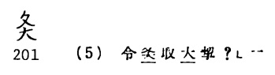

**Fig. 36. *A Concordance to Fascicle Three of the Inscriptions from the Yin Ruins* (1985) p. 183**

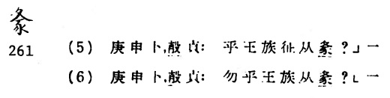

**Fig. 37. *A Concordance to Fascicle Three of the Inscriptions from the Yin Ruins* (1985) p. 188**

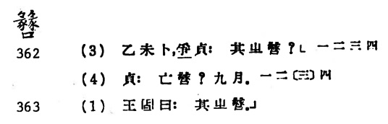

**Fig. 38. *A Concordance to Fascicle Three of the Inscriptions from the Yin Ruins* (1985) p. 189**

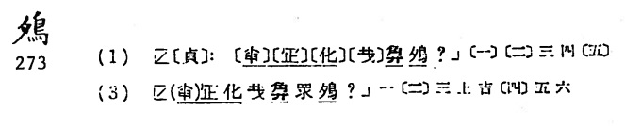

**Fig. 39. *A Concordance to Fascicle Three of the Inscriptions from the Yin Ruins* (1985) p. 191**

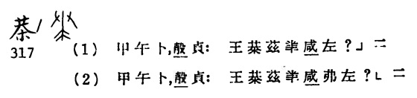

**Fig. 40. *A Concordance to Fascicle Three of the Inscriptions from the Yin Ruins* (1985) p. 194**

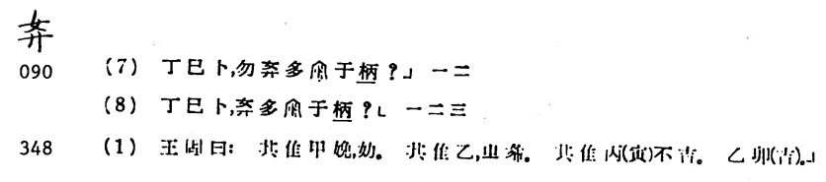

**Fig. 41. *A Concordance to Fascicle Three of the Inscriptions from the Yin Ruins* (1985) p. 194**

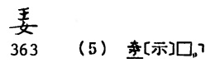

**Fig. 42. *A Concordance to Fascicle Three of the Inscriptions from the Yin Ruins* (1985) p. 195**

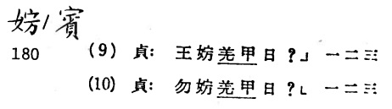

**Fig. 43. *A Concordance to Fascicle Three of the Inscriptions from the Yin Ruins* (1985) p. 195**

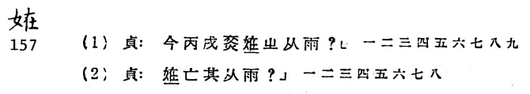

**Fig. 44. *A Concordance to Fascicle Three of the Inscriptions from the Yin Ruins* (1985) p. 196**

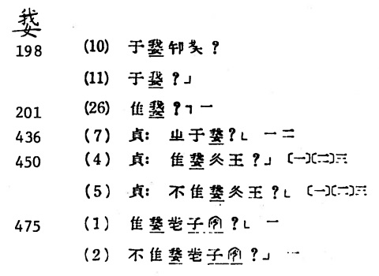

**Fig. 45. *A Concordance to Fascicle Three of the Inscriptions from the Yin Ruins* (1985) p. 197**

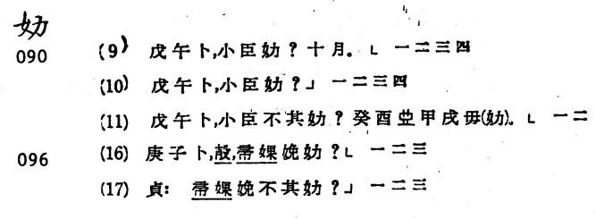

**Fig. 46. *A Concordance to Fascicle Three of the Inscriptions from the Yin Ruins* (1985) p. 199**

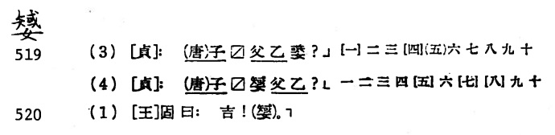

**Fig. 47. *A Concordance to Fascicle Three of the Inscriptions from the Yin Ruins* (1985) p. 200**

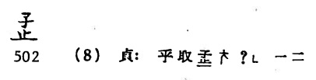

**Fig. 48. *A Concordance to Fascicle Three of the Inscriptions from the Yin Ruins* (1985) p. 200**

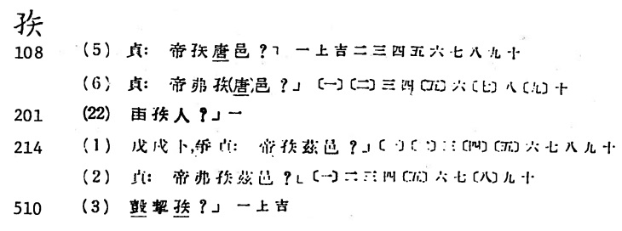

**Fig. 49. *A Concordance to Fascicle Three of the Inscriptions from the Yin Ruins* (1985) p. 202**

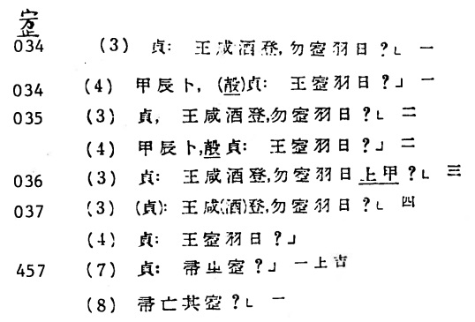

**Fig. 50. *A Concordance to Fascicle Three of the Inscriptions from the Yin Ruins* (1985) p. 203**

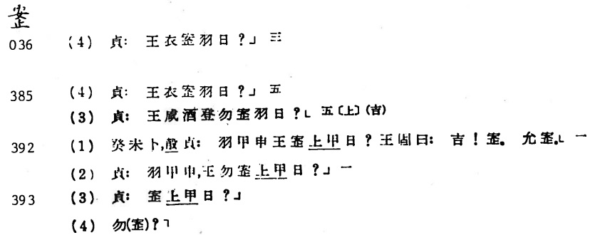

**Fig. 51. *A Concordance to Fascicle Three of the Inscriptions from the Yin Ruins* (1985) p. 203**

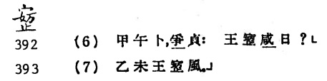

**Fig. 52. *A Concordance to Fascicle Three of the Inscriptions from the Yin Ruins* (1985) p. 207**

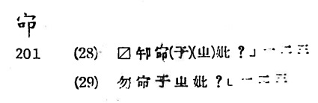

**Fig. 53. *A Concordance to Fascicle Three of the Inscriptions from the Yin Ruins* (1985) p. 207**

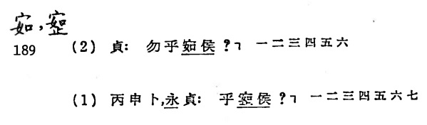

**Fig. 54. *A Concordance to Fascicle Three of the Inscriptions from the Yin Ruins* (1985) p. 208**

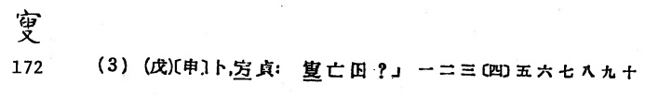

**Fig. 55. *A Concordance to Fascicle Three of the Inscriptions from the Yin Ruins* (1985) p. 208**

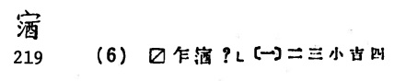

**Fig. 56. *A Concordance to Fascicle Three of the Inscriptions from the Yin Ruins* (1985) p. 211**

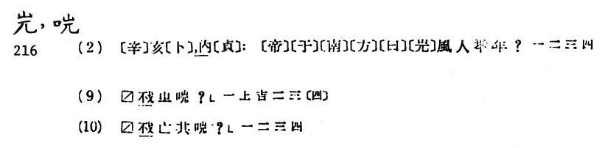

**Fig. 57. *A Concordance to Fascicle Three of the Inscriptions from the Yin Ruins* (1985) p. 216**

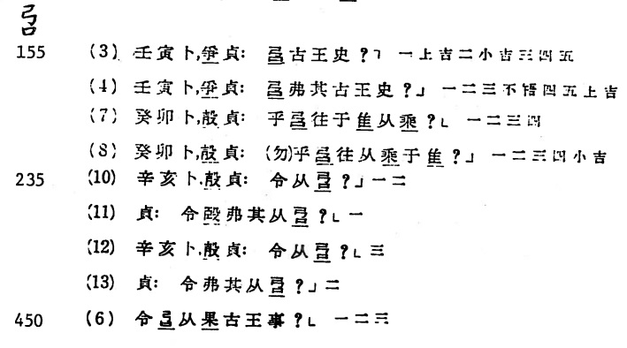

**Fig. 58. *A Concordance to Fascicle Three of the Inscriptions from the Yin Ruins* (1985) p. 221**

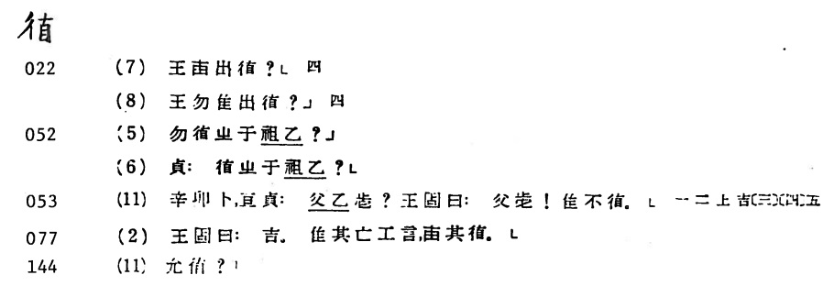

**Fig. 59. *A Concordance to Fascicle Three of the Inscriptions from the Yin Ruins* (1985) p. 222**

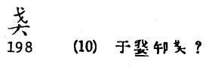

**Fig. 60. *A Concordance to Fascicle Three of the Inscriptions from the Yin Ruins* (1985) p. 222**

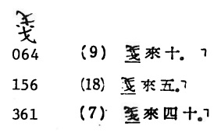

**Fig. 61. *A Concordance to Fascicle Three of the Inscriptions from the Yin Ruins* (1985) p. 223**

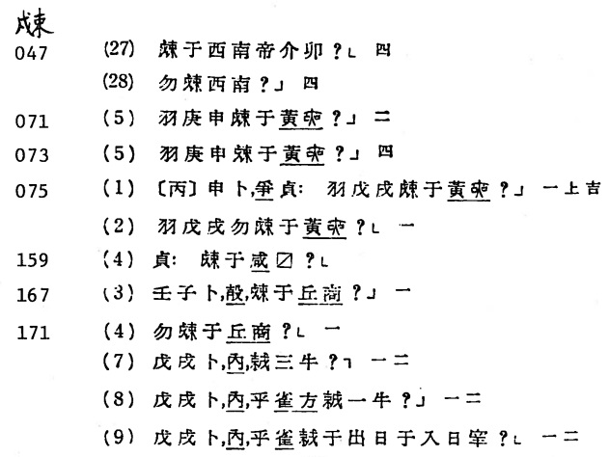

**Fig. 62. *A Concordance to Fascicle Three of the Inscriptions from the Yin Ruins* (1985) p. 235**

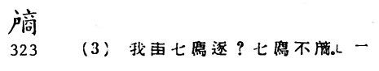

**Fig. 63. *A Concordance to Fascicle Three of the Inscriptions from the Yin Ruins* (1985) p. 240**

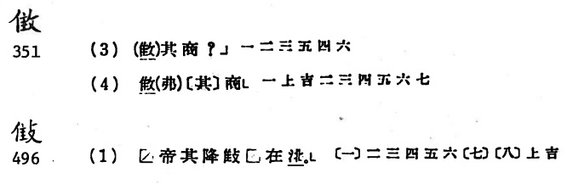

**Fig. 64. *A Concordance to Fascicle Three of the Inscriptions from the Yin Ruins* (1985) p. 240**

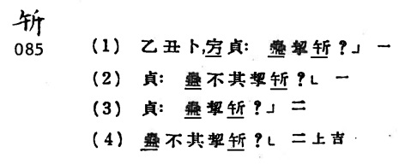

**Fig. 65. *A Concordance to Fascicle Three of the Inscriptions from the Yin Ruins* (1985) p. 256**

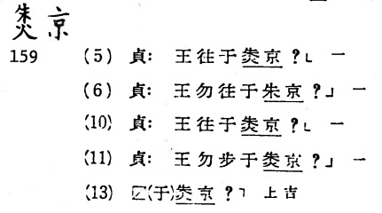

**Fig. 66. *A Concordance to Fascicle Three of the Inscriptions from the Yin Ruins* (1985) p. 257**

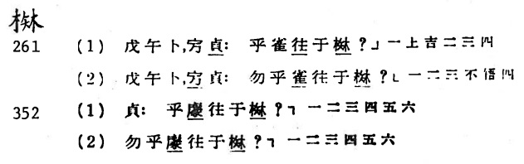

**Fig. 67. *A Concordance to Fascicle Three of the Inscriptions from the Yin Ruins* (1985) p. 257**

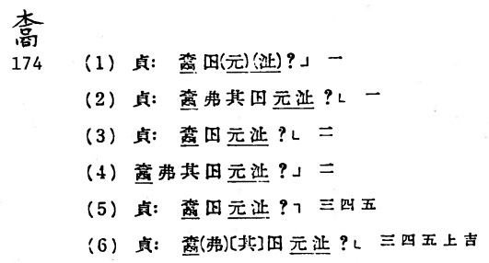

**Fig. 68. *A Concordance to Fascicle Three of the Inscriptions from the Yin Ruins* (1985) p. 258**

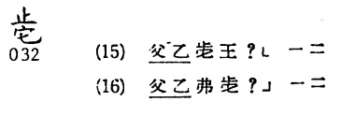

**Fig. 69. *A Concordance to Fascicle Three of the Inscriptions from the Yin Ruins* (1985) p. 263**

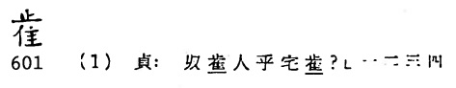

**Fig. 70. *A Concordance to Fascicle Three of the Inscriptions from the Yin Ruins* (1985) p. 263**

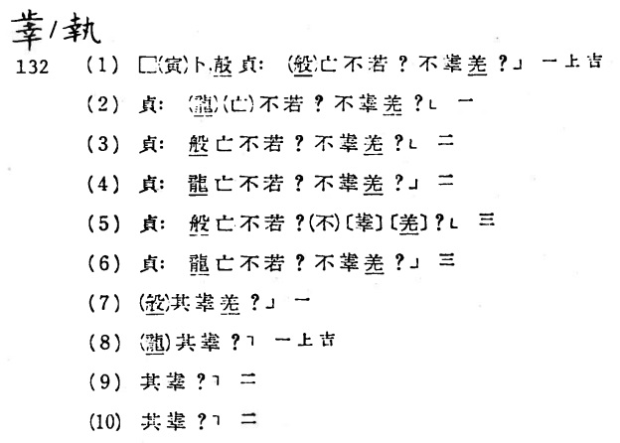

**Fig. 71. *A Concordance to Fascicle Three of the Inscriptions from the Yin Ruins* (1985) p. 263**

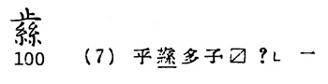

**Fig. 72. *A Concordance to Fascicle Three of the Inscriptions from the Yin Ruins* (1985) p. 270**

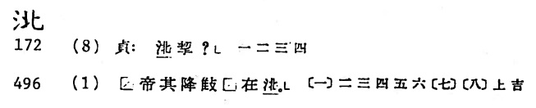

**Fig. 73. *A Concordance to Fascicle Three of the Inscriptions from the Yin Ruins* (1985) p. 273**

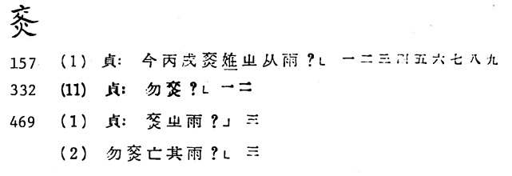

**Fig. 74. *A Concordance to Fascicle Three of the Inscriptions from the Yin Ruins* (1985) p. 281**

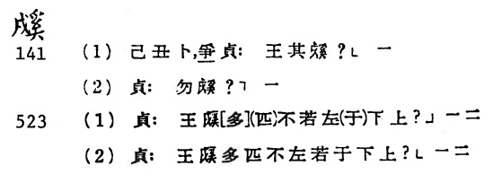

**Fig. 75. *A Concordance to Fascicle Three of the Inscriptions from the Yin Ruins* (1985) p. 282**

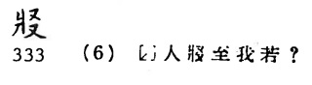

**Fig. 76. *A Concordance to Fascicle Three of the Inscriptions from the Yin Ruins* (1985) p. 282**

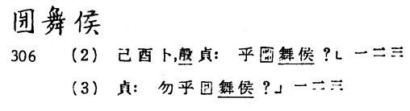

**Fig. 77. *A Concordance to Fascicle Three of the Inscriptions from the Yin Ruins* (1985) p. 288**

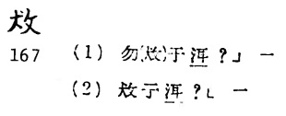

**Fig. 78. *A Concordance to Fascicle Three of the Inscriptions from the Yin Ruins* (1985) p. 316**

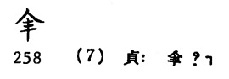

**Fig. 79. *A Concordance to Fascicle Three of the Inscriptions from the Yin Ruins* (1985) p. 322**

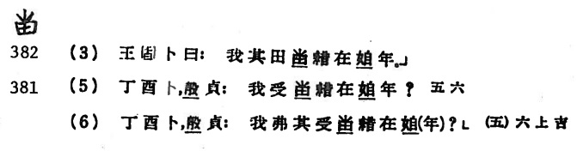

**Fig. 80. *A Concordance to Fascicle Three of the Inscriptions from the Yin Ruins* (1985) p. 326**

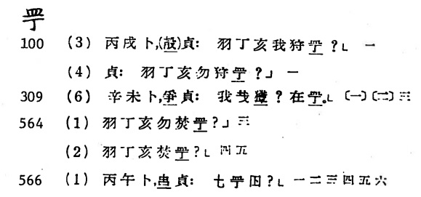

**Fig. 81. *A Concordance to Fascicle Three of the Inscriptions from the Yin Ruins* (1985) p. 327**

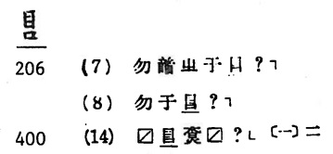

**Fig. 82. *A Concordance to Fascicle Three of the Inscriptions from the Yin Ruins* (1985) p. 329**

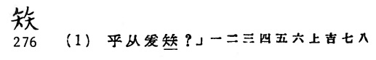

**Fig. 83. *A Concordance to Fascicle Three of the Inscriptions from the Yin Ruins* (1985) p. 329**

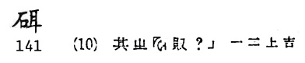

**Fig. 84. *A Concordance to Fascicle Three of the Inscriptions from the Yin Ruins* (1985) p. 332**

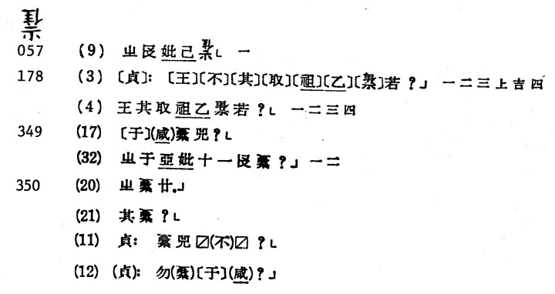

**Fig. 85. *A Concordance to Fascicle Three of the Inscriptions from the Yin Ruins* (1985) p. 333**

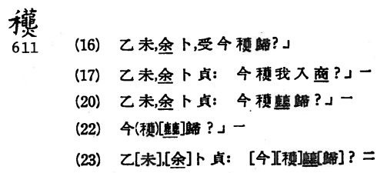

**Fig. 86. *A Concordance to Fascicle Three of the Inscriptions from the Yin Ruins* (1985) p. 333**

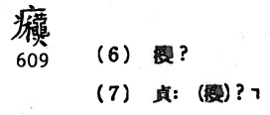

**Fig. 87. *A Concordance to Fascicle Three of the Inscriptions from the Yin Ruins* (1985) p. 335**

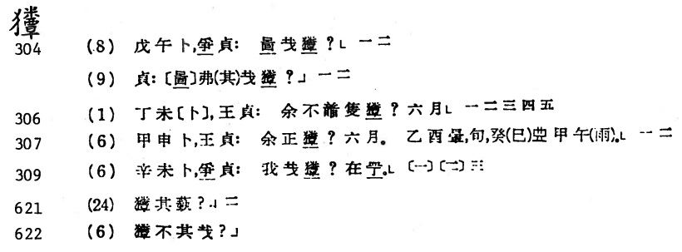

**Fig. 88. *A Concordance to Fascicle Three of the Inscriptions from the Yin Ruins* (1985) p. 336**

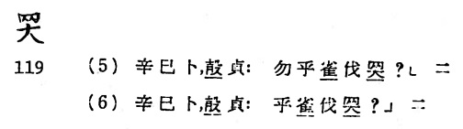

**Fig. 89. *A Concordance to Fascicle Three of the Inscriptions from the Yin Ruins* (1985) p. 337**

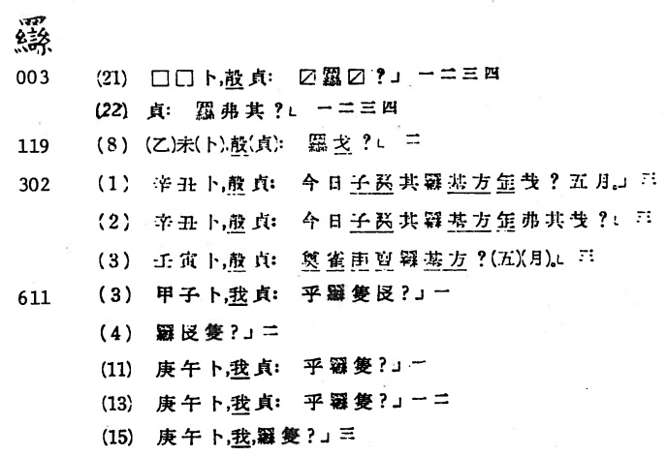

**Fig. 90. *A Concordance to Fascicle Three of the Inscriptions from the Yin Ruins* (1985) p. 341**

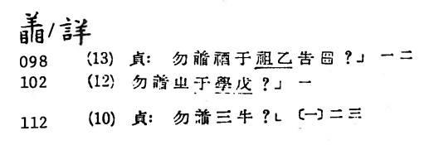

**Fig. 91. *A Concordance to Fascicle Three of the Inscriptions from the Yin Ruins* (1985) p. 343**

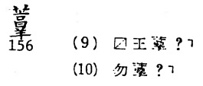

**Fig. 92. *A Concordance to Fascicle Three of the Inscriptions from the Yin Ruins* (1985) p. 353**

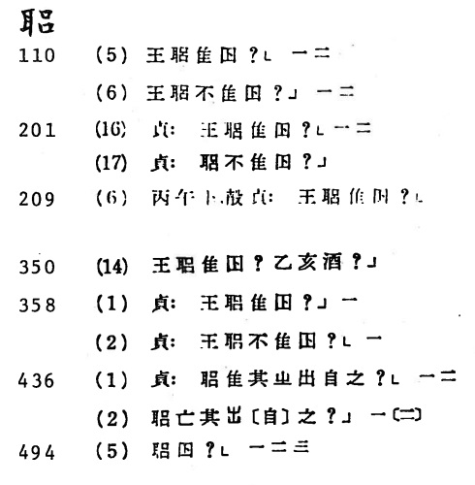

**Fig. 93. *A Concordance to Fascicle Three of the Inscriptions from the Yin Ruins* (1985) p. 357**

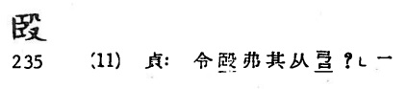

**Fig. 94. *A Concordance to Fascicle Three of the Inscriptions from the Yin Ruins* (1985) p. 359**

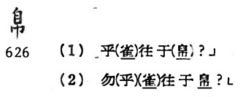

**Fig. 95. *A Concordance to Fascicle Three of the Inscriptions from the Yin Ruins* (1985) p. 359**

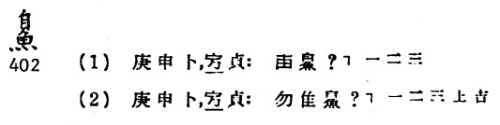

**Fig. 96. *A Concordance to Fascicle Three of the Inscriptions from the Yin Ruins* (1985) p. 372**

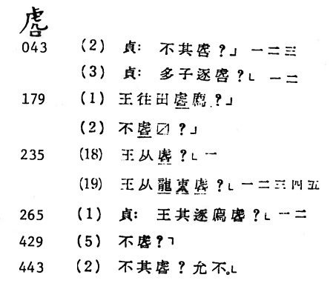

**Fig. 97. *A Concordance to Fascicle Three of the Inscriptions from the Yin Ruins* (1985) p. 372**

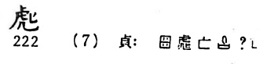

**Fig. 98. *A Concordance to Fascicle Three of the Inscriptions from the Yin Ruins* (1985) p. 372**

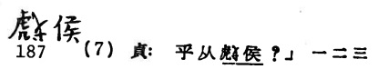

**Fig. 99. *A Concordance to Fascicle Three of the Inscriptions from the Yin Ruins* (1985) p. 374**

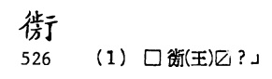

**Fig. 100. *A Concordance to Fascicle Three of the Inscriptions from the Yin Ruins* (1985) p. 374**

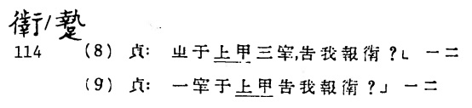

**Fig. 101. *A Concordance to Fascicle Three of the Inscriptions from the Yin Ruins* (1985) p. 376**

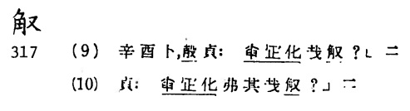

**Fig. 102. *A Concordance to Fascicle Three of the Inscriptions from the Yin Ruins* (1985) p. 376**

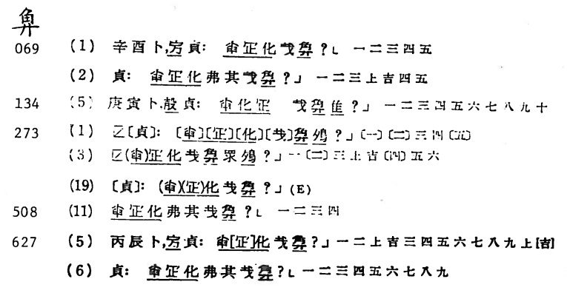

**Fig. 103. *A Concordance to Fascicle Three of the Inscriptions from the Yin Ruins* (1985) p. 377**

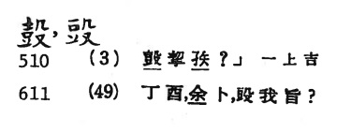

**Fig. 104. *A Concordance to Fascicle Three of the Inscriptions from the Yin Ruins* (1985) p. 380**

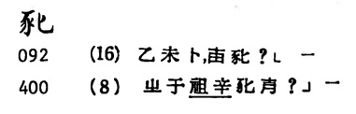

**Fig. 105. *A Concordance to Fascicle Three of the Inscriptions from the Yin Ruins* (1985) p. 380**

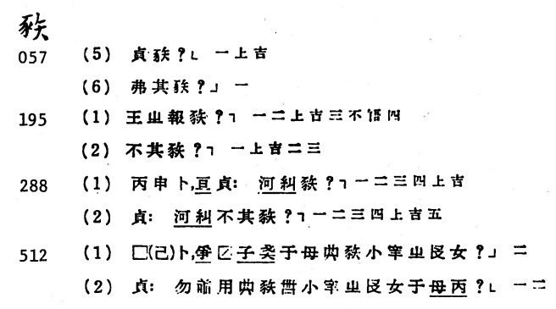

**Fig. 106. *A Concordance to Fascicle Three of the Inscriptions from the Yin Ruins* (1985) p. 381**

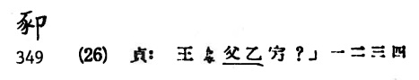

**Fig. 107. *A Concordance to Fascicle Three of the Inscriptions from the Yin Ruins* (1985) p. 382**

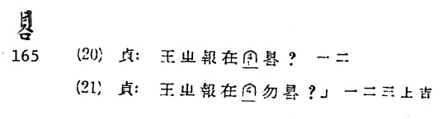

**Fig. 108. *A Concordance to Fascicle Three of the Inscriptions from the Yin Ruins* (1985) p. 382**

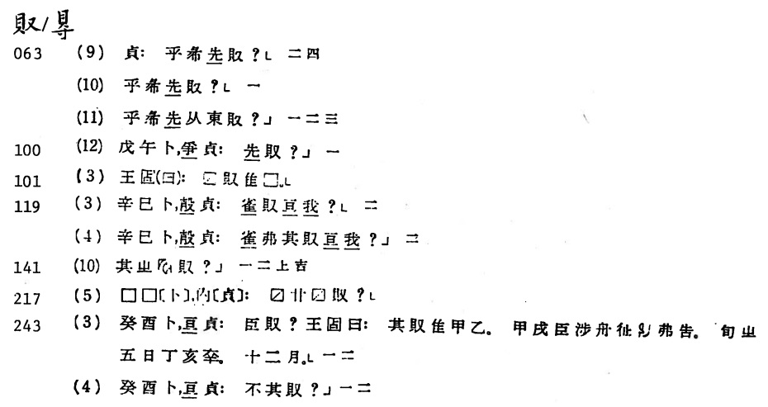

**Fig. 109. *A Concordance to Fascicle Three of the Inscriptions from the Yin Ruins* (1985) p. 384**

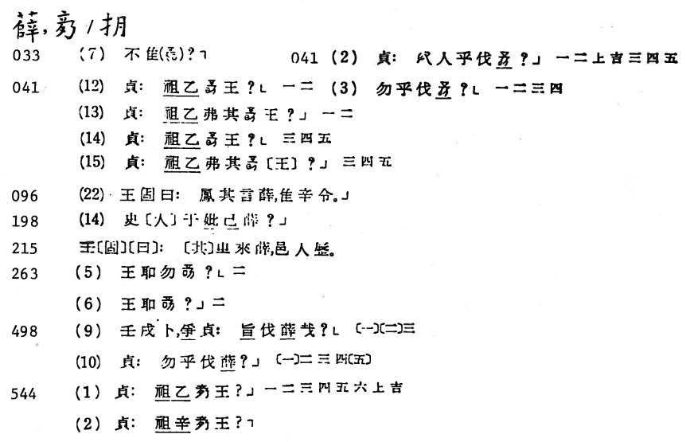

**Fig. 110. *A Concordance to Fascicle Three of the Inscriptions from the Yin Ruins* (1985) p. 393**

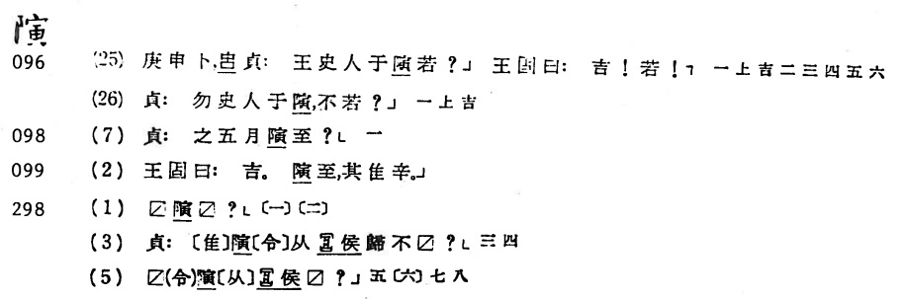

**Fig. 111. *A Concordance to Fascicle Three of the Inscriptions from the Yin Ruins* (1985) p. 412**

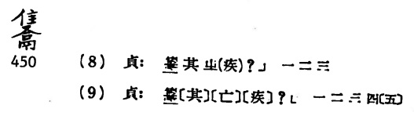

**Fig. 112. *A Concordance to Fascicle Three of the Inscriptions from the Yin Ruins* (1985) p. 424**

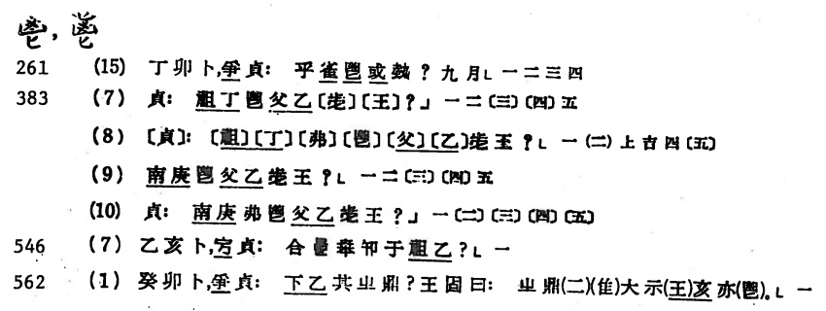

**Fig. 113. *A Concordance to Fascicle Three of the Inscriptions from the Yin Ruins* (1985) p. 603**

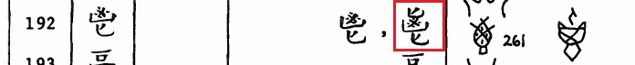

**Fig. 114. *A Concordance to Fascicle Three of the Inscriptions from the Yin Ruins* (1985) p. 425**

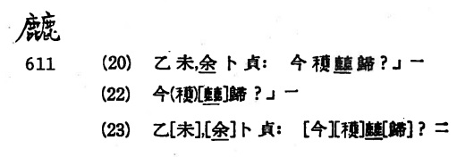

**Fig. 115. *A Concordance to Fascicle Three of the Inscriptions from the Yin Ruins* (1985) p. 427**

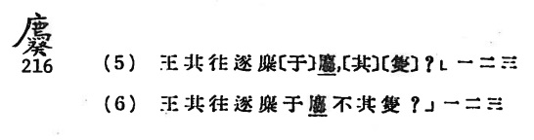

**Fig. 116. *A Concordance to Fascicle Three of the Inscriptions from the Yin Ruins* (1985) p. 430**

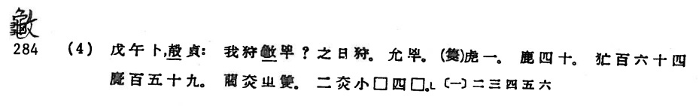

**Fig. 117. *A Concordance to Fascicle Three of the Inscriptions from the Yin Ruins* (1985) p. 430**

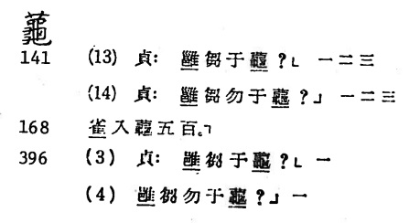

**Fig. 118. *A Concordance to Fascicle Three of the Inscriptions from the Yin Ruins* (1985) p. 430**

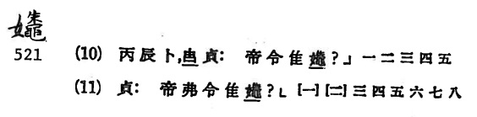

**Fig. 119. *A Concordance to Fascicle Three of the Inscriptions from the Yin Ruins* (1985) p. 431**

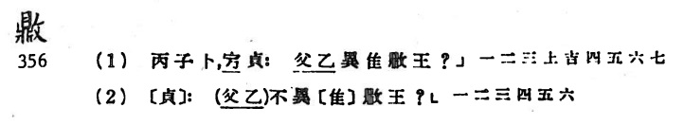

**Fig. 120. *A Concordance to Fascicle Three of the Inscriptions from the Yin Ruins* (1985) p. 433**

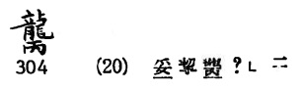

**Fig. 121. *A Concordance to Fascicle Three of the Inscriptions from the Yin Ruins* (1985) p. 434**

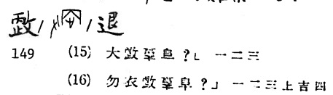

**Fig. 122. *A Concordance to Fascicle Three of the Inscriptions from the Yin Ruins* (1985) p. 434**

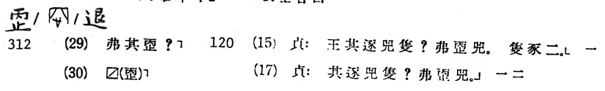

**Fig. 123. *A Concordance to Fascicle Three of the Inscriptions from the Yin Ruins* (1985) p. 443**

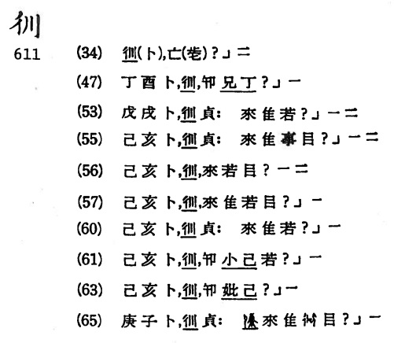

**Fig. 124. *A Concordance to Fascicle Three of the Inscriptions from the Yin Ruins* (1985) p. 513**

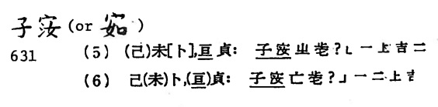

**Fig. 125. *A Concordance to Fascicle Three of the Inscriptions from the Yin Ruins* (1985) p. 516**

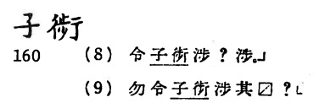

**Fig. 126. *A Concordance to Fascicle Three of the Inscriptions from the Yin Ruins* (1985) p. 516**

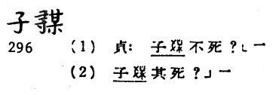

**Fig. 127. *A Concordance to Fascicle Three of the Inscriptions from the Yin Ruins* (1985) p. 521**

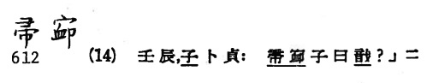

**Fig. 128. *A Concordance to Fascicle Three of the Inscriptions from the Yin Ruins* (1985) p. 521**

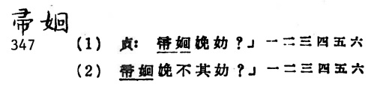

**Fig. 129. *A Concordance to Fascicle Three of the Inscriptions from the Yin Ruins* (1985) p. 521**

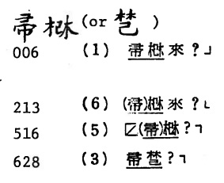

**Fig. 130. *A Concordance to Fascicle Three of the Inscriptions from the Yin Ruins* (1985) p. 542**

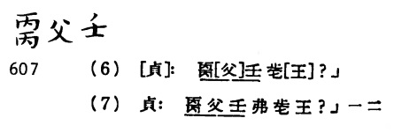

**Fig. 131. *Yinbenji Dingbu yu Shangshi Renwu Zheng* (1985) p. 93**

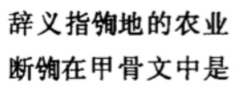

**Fig. 132. *Yinbenji Dingbu yu Shangshi Renwu Zheng* (1985) p. 94**

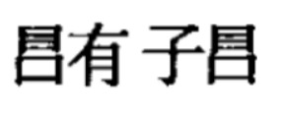

**Fig. 133. *Yinbenji Dingbu yu Shangshi Renwu Zheng* (1985) p. 94**

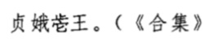

**Fig. 134. *Jiagu Jinwen Tuoben* (2010) p. 9**

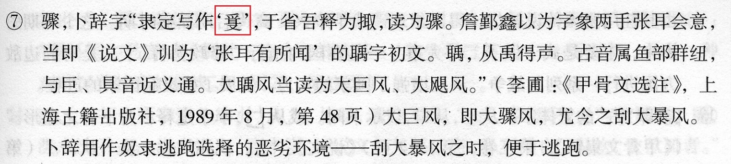

**Fig. 135. *Jiagu Jinwen Tuoben* (2010) p. 9**

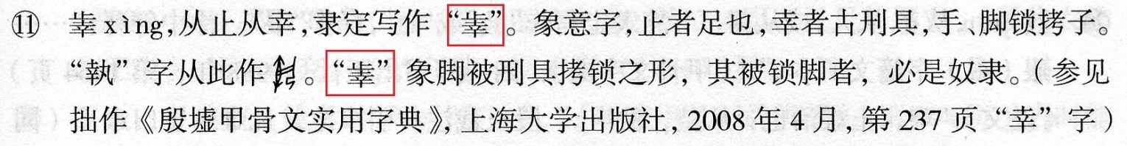

**Fig. 136. *Jiagu Jinwen Tuoben* (2010) p. 10**

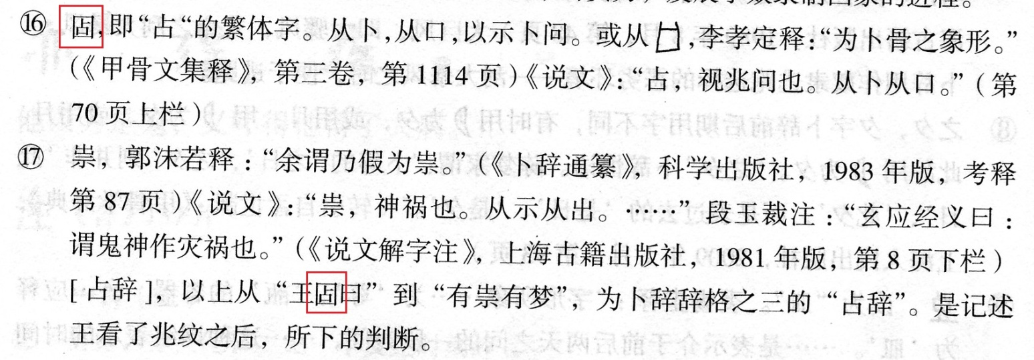

**Fig. 137. *Jiagu Jinwen Tuoben* (2010) p. 10**

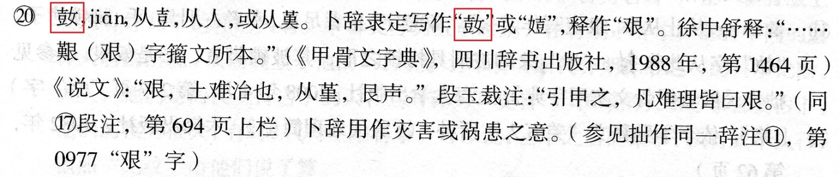

**Fig. 138. *Jiagu Jinwen Tuoben* (2010) p. 11**

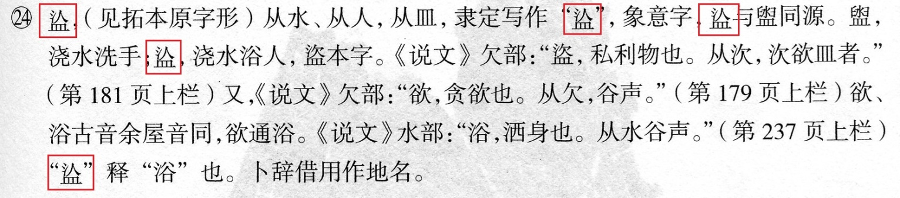

**Fig. 139. *Jiagu Jinwen Tuoben* (2010) p. 16**

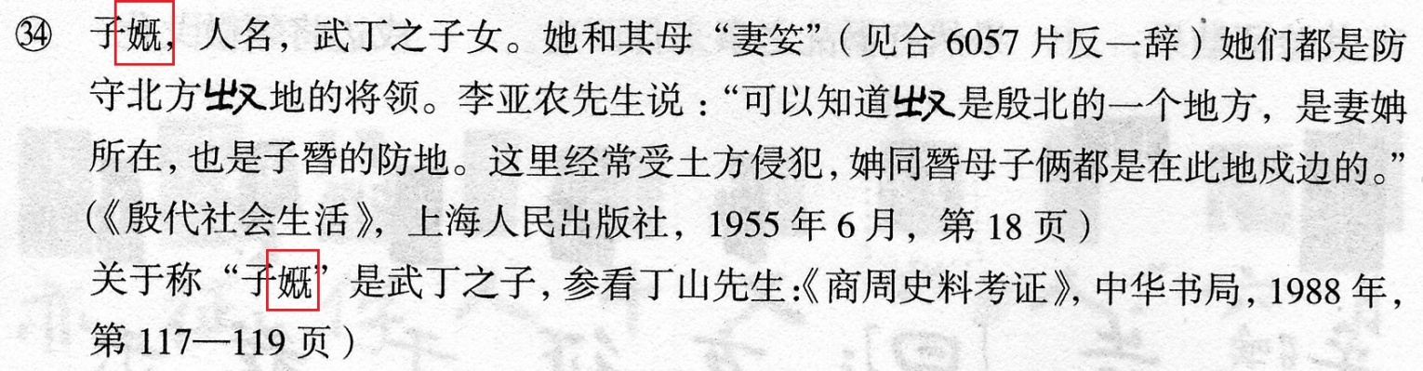

**Fig. 140. *Jiagu Jinwen Tuoben* (2010) p. 17**

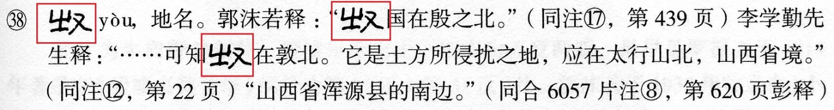

**Fig. 141. *Jiagu Jinwen Tuoben* (2010) p. 25**

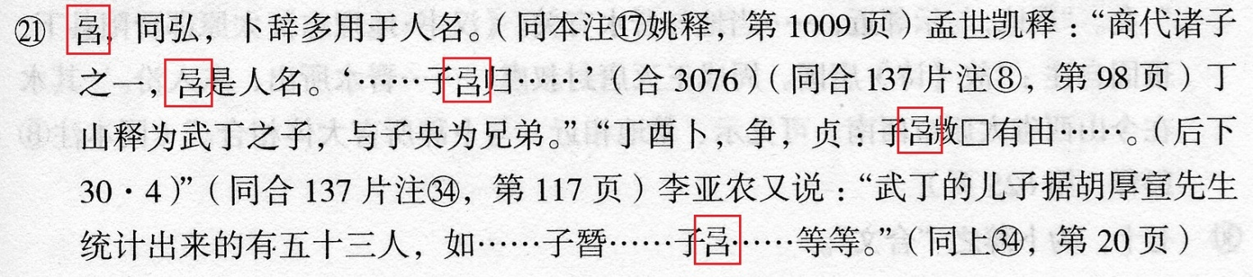

**Fig. 142. *Jiagu Jinwen Tuoben* (2010) p. 26**

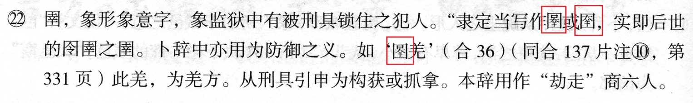

**Fig. 143. *Jiagu Jinwen Tuoben* (2010) p. 26**

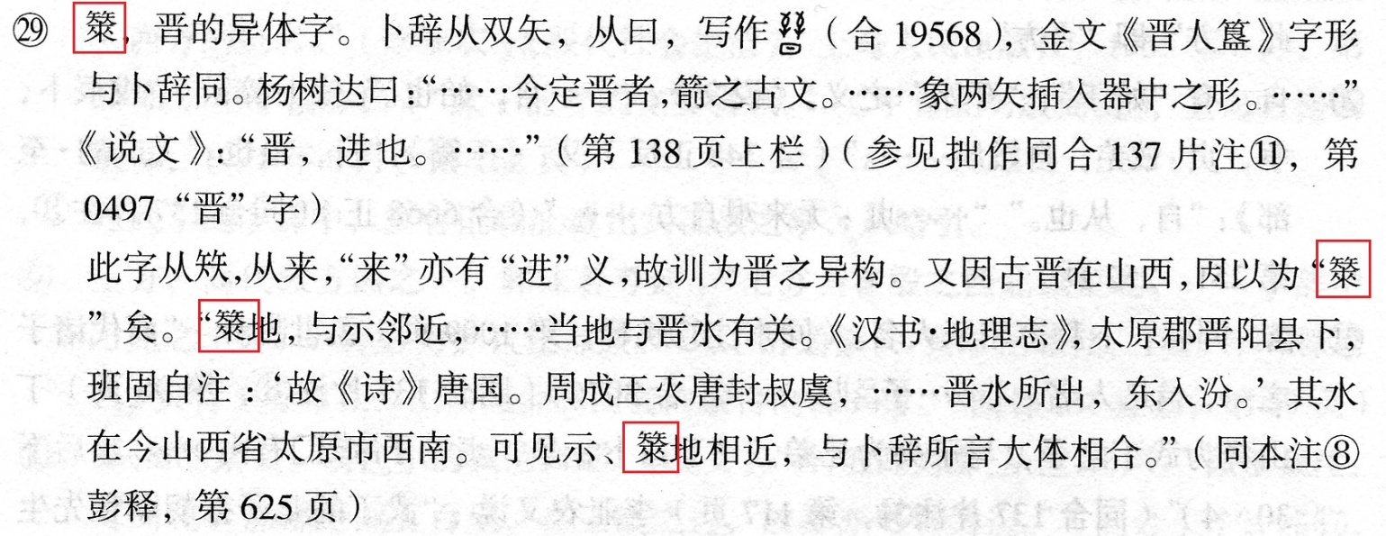

**Fig. 144. *Jiagu Jinwen Tuoben* (2010) p. 30**

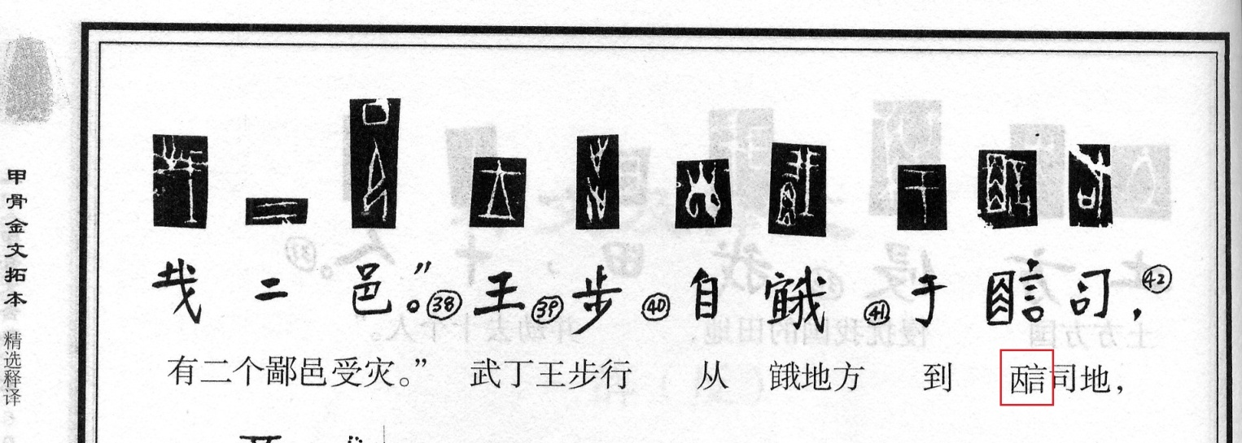

**Fig. 145. *Jiagu Jinwen Tuoben* (2010) p. 31**

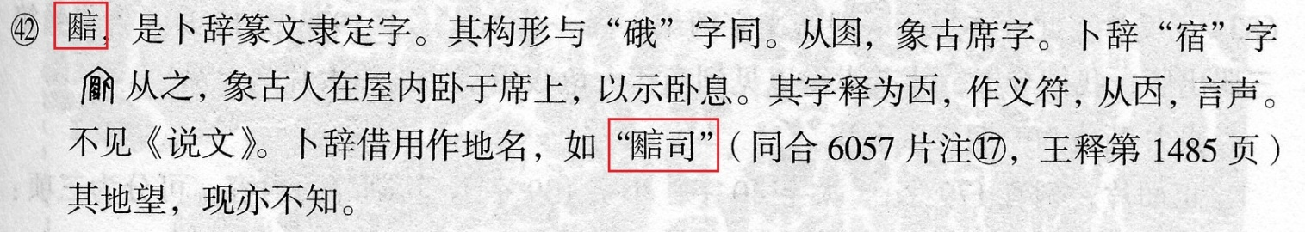

**Fig. 146. *Jiagu Jinwen Tuoben* (2010) p. 42**



**Fig. 147. *Jiagu Jinwen Tuoben* (2010) p. 42**

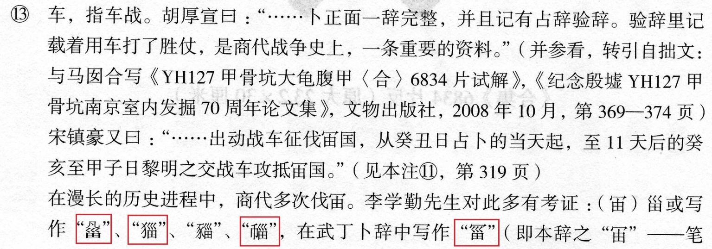

**Fig. 148. *Jiagu Jinwen Tuoben* (2010) p. 43**

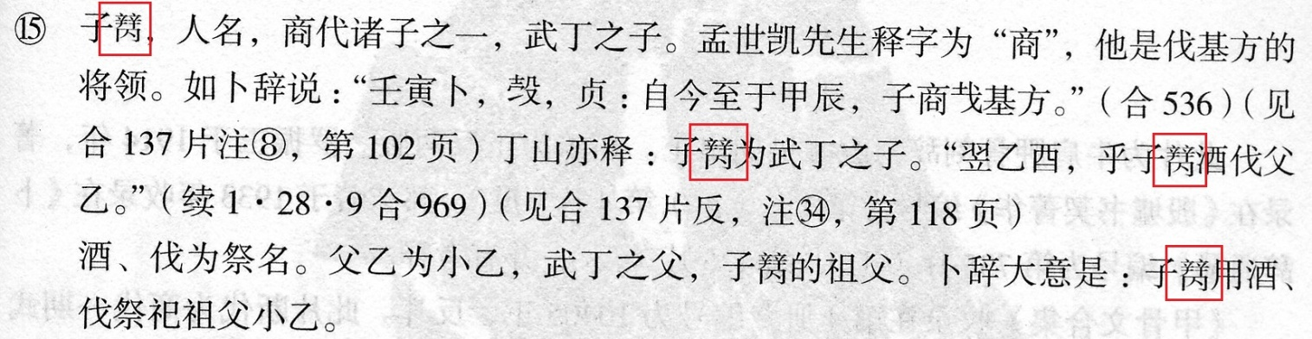

**Fig. 149. *Jiagu Jinwen Tuoben* (2010) p. 43**



**Fig. 150. *Jiagu Jinwen Tuoben* (2010) p. 50**

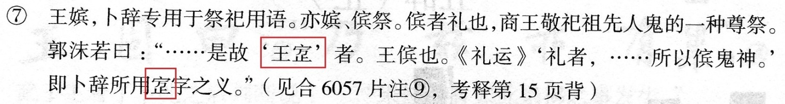

**Fig. 151. *Jiagu Jinwen Tuoben* (2010) p. 50**

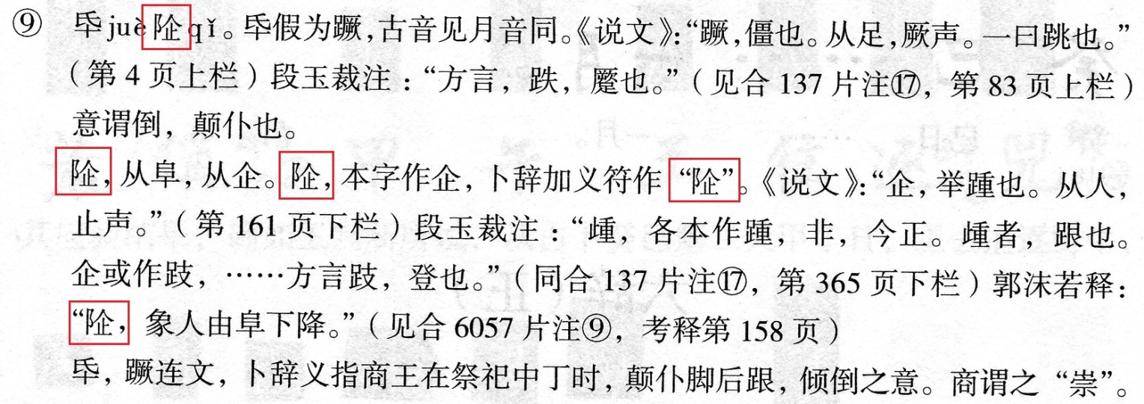

**Fig. 152. *Jiagu Jinwen Tuoben* (2010) p. 51**



**Fig. 153. *Jiagu Jinwen Tuoben* (2010) p. 112**

**Fig. 154. Article in *Zhongguo Wenzi Xuebao* 2003.1 p. 1**

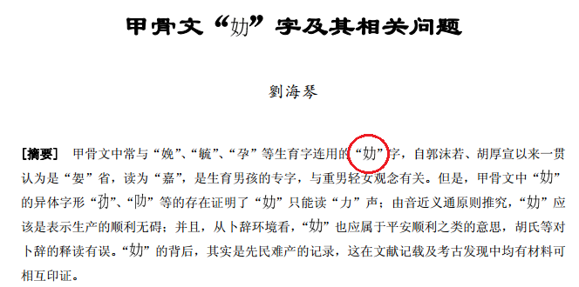

**Fig. 155. Article in *Lanzhou Xuebao* 2009.9 p. 217**

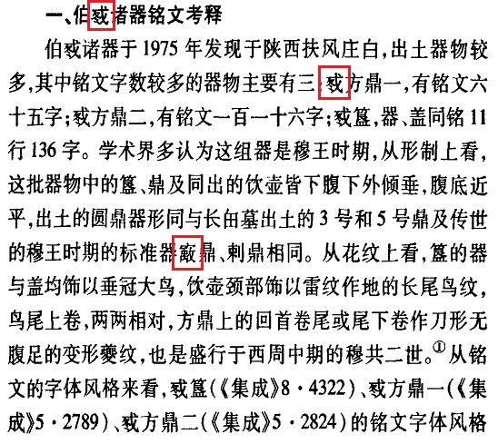

**Fig. 156. *Zhongguo Wenwu Jianshang Cidian* (1991) p. 114**

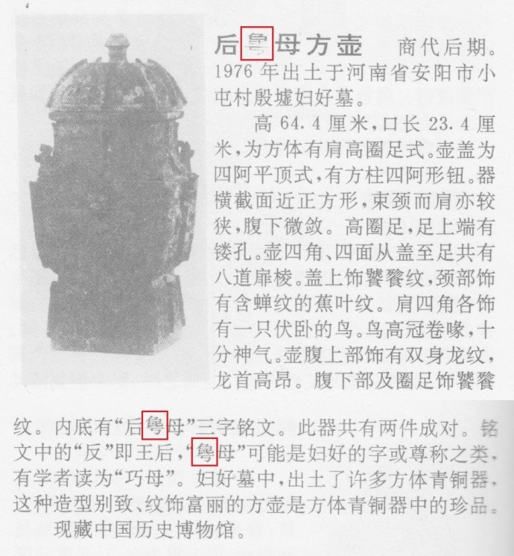

**Fig. 157. *Zhongguo Wenwu Jianshang Cidian* (1991) p. 126**

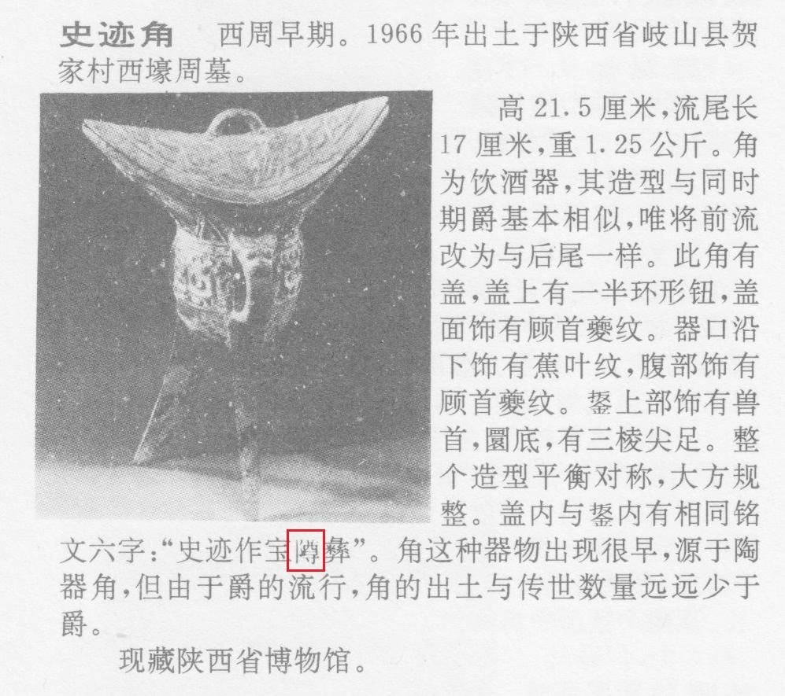

**Fig. 158. *Zhongguo Wenwu Jianshang Cidian* (1991) p. 126**

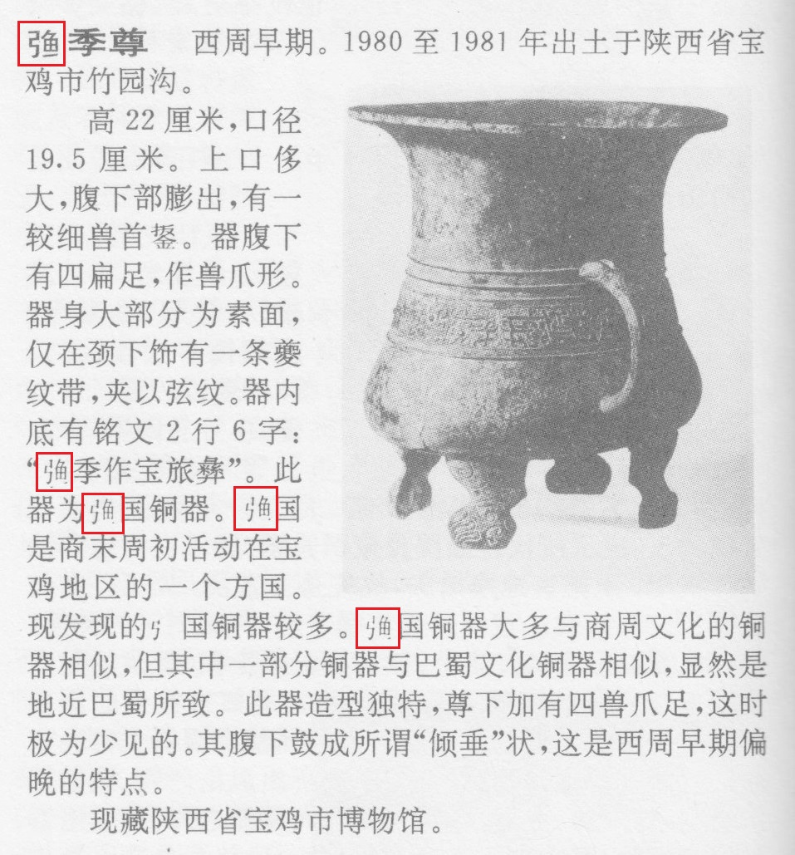

**Fig. 159. *Zhongguo Wenwu Jianshang Cidian* (1991) p. 129**

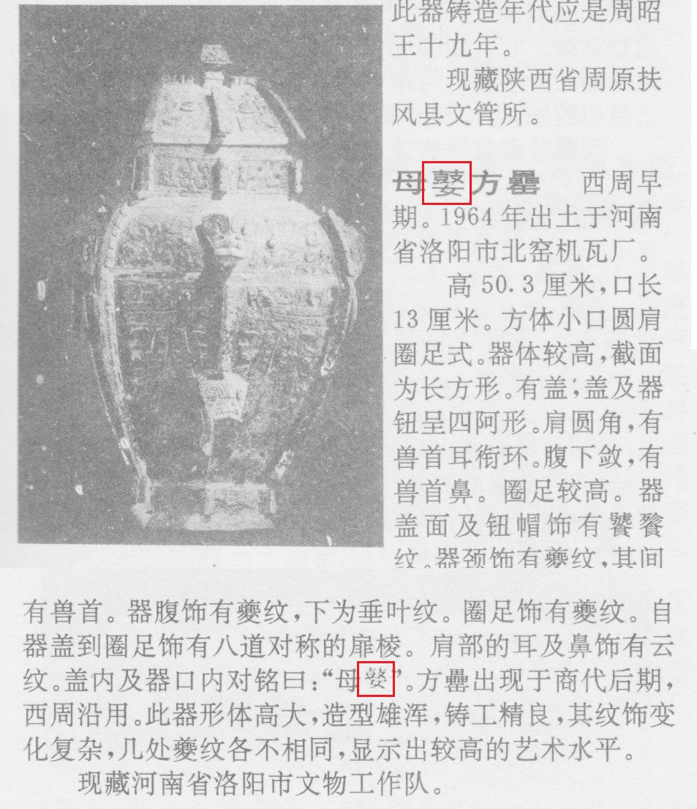

**Fig. 160. *Zhongguo Wenwu Jianshang Cidian* (1991) p. 131**

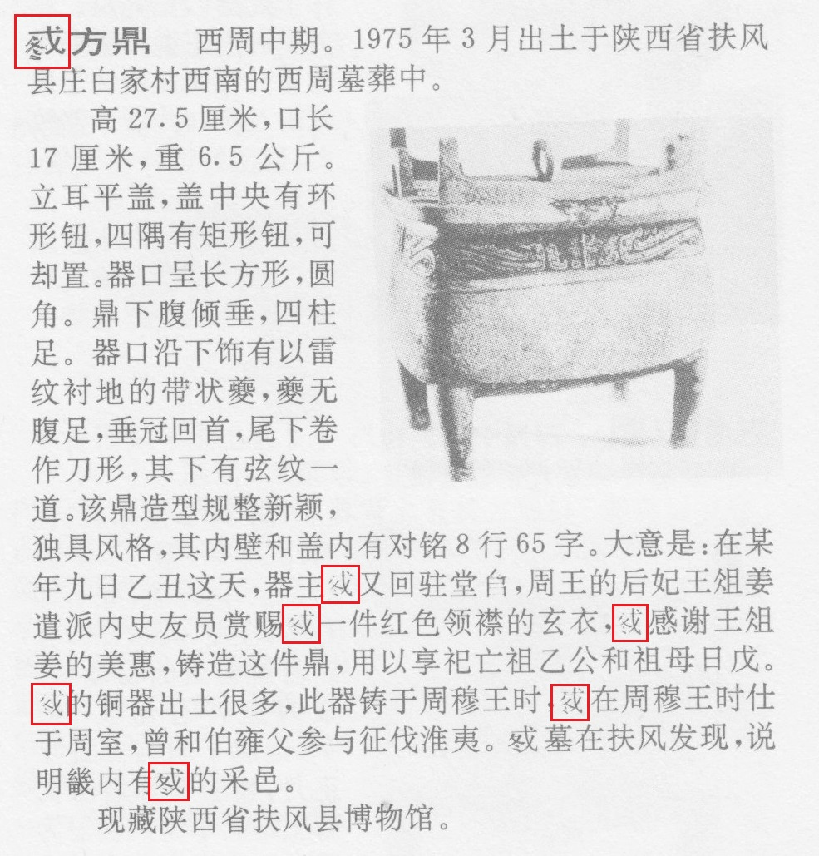

**Fig. 161. *Zhongguo Wenwu Jianshang Cidian* (1991) pp. 133-134**

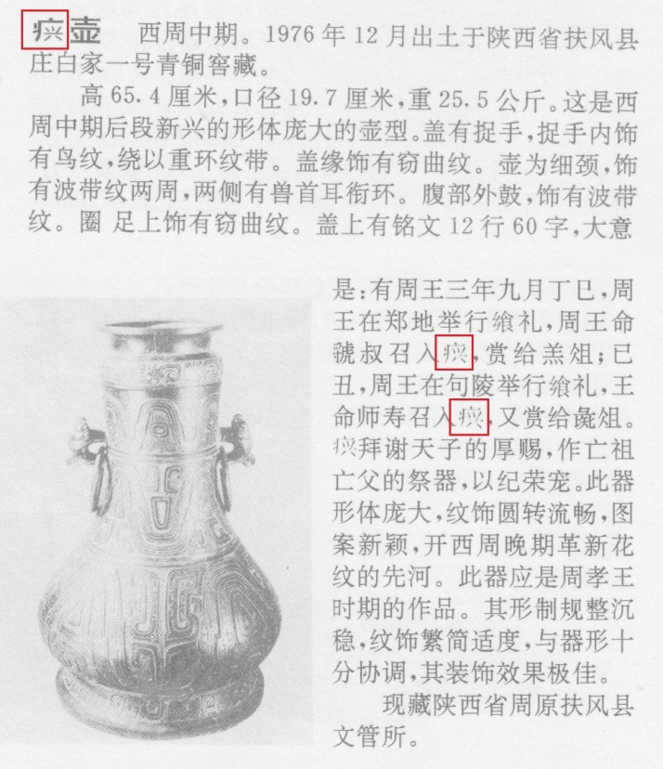

**Fig. 162. *Zhongguo Wenwu Jianshang Cidian* (1991) p. 134**

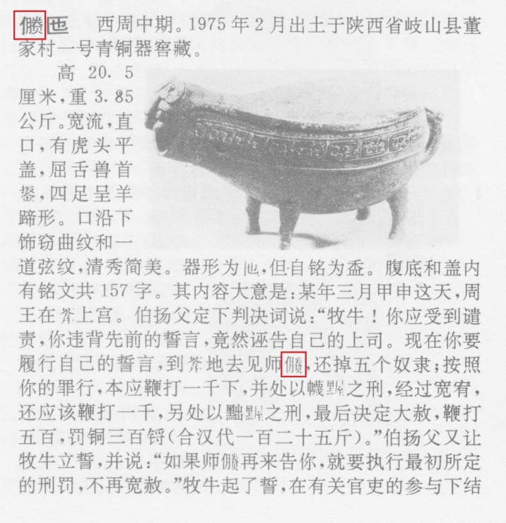

**Fig. 163. *Zhongguo Wenwu Jianshang Cidian* (1991) p. 135**

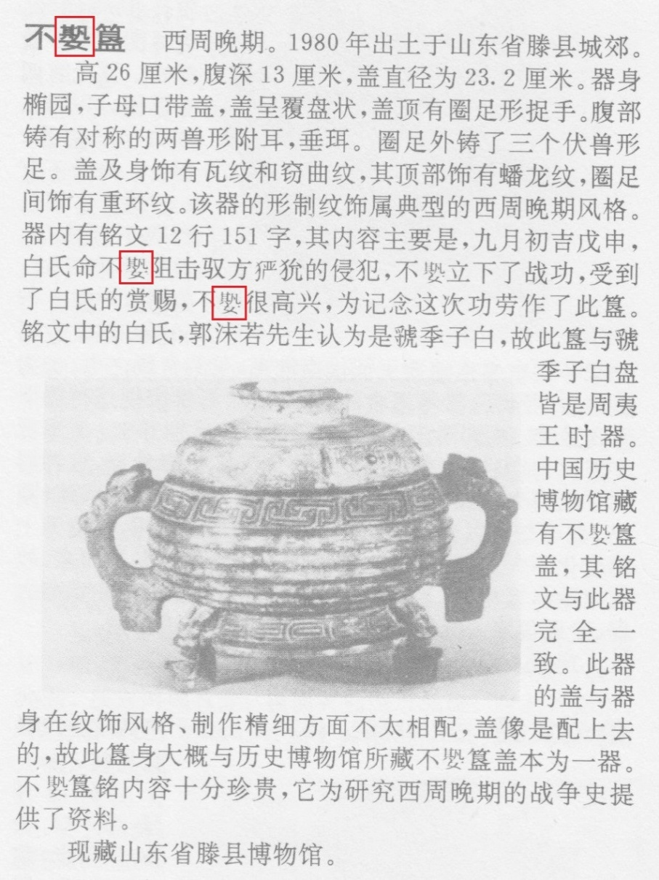

**Fig. 164. *Zhongguo Wenwu Jianshang Cidian* (1991) p. 144**

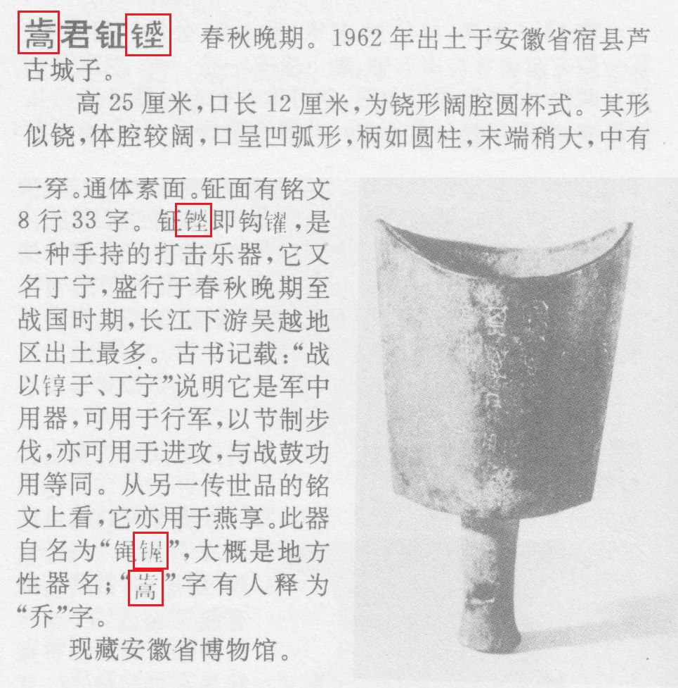

**Fig. 165. *Zhongguo Wenwu Jianshang Cidian* (1991) p. 151**

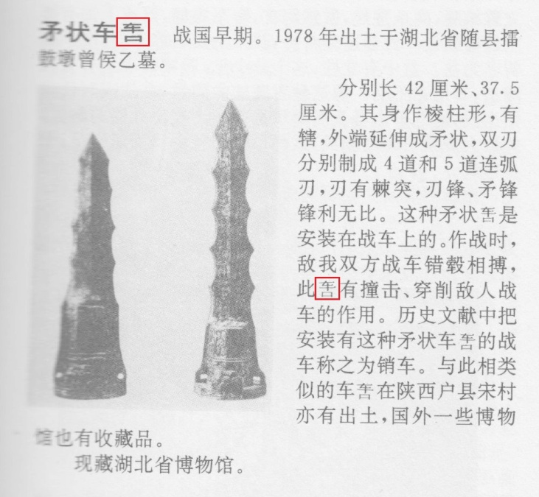

**Fig. 166. *Zhongguo Wenwu Jianshang Cidian* (1991) p. 160**

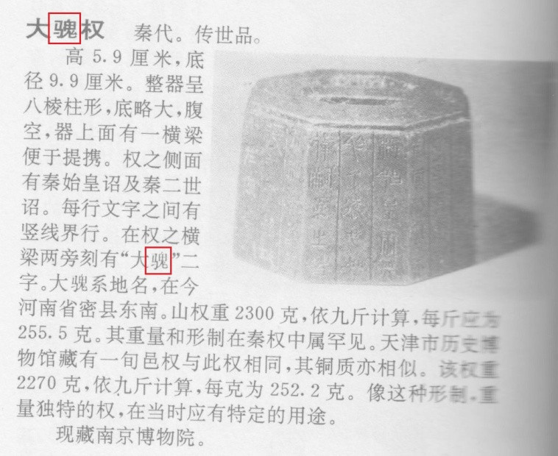

**Fig. 167. Information Card at Capital Museum, Beijing**

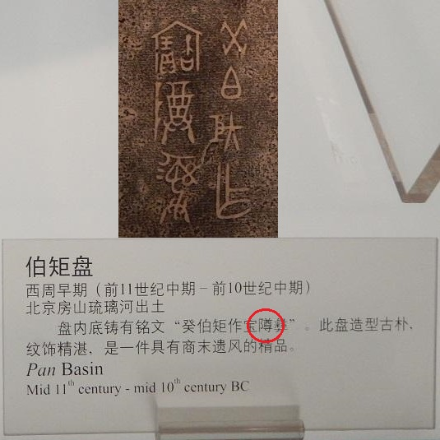

**Fig. 168. *Guditu Lunwenji* (1977) p. 11**

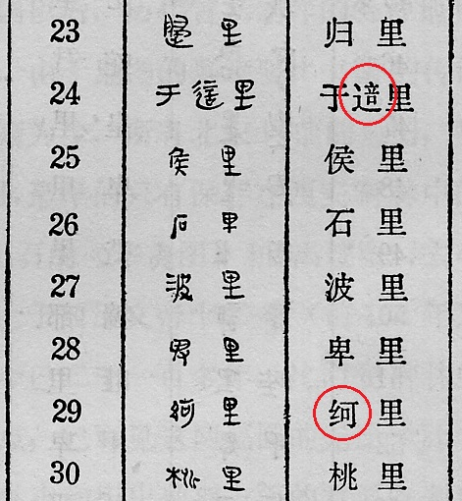

**Fig. 169. *Guditu Lunwenji* (1977) p. 12**

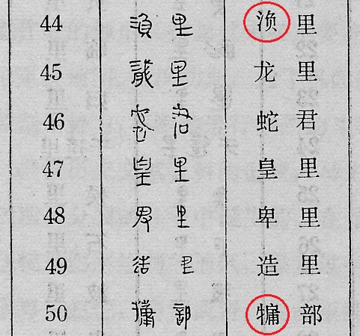

**Fig. 170. *Guditu Lunwenji* (1977) p. 49**

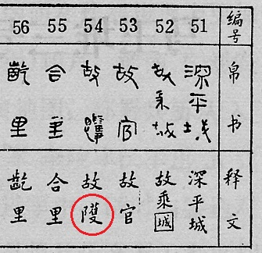

**Fig. 171. Sarah Allan, *Buried Ideas* (2015) p. 119**

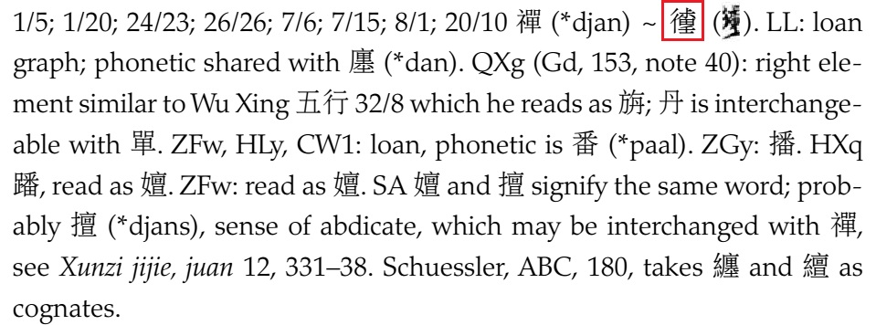

**Fig. 172. Sarah Allan, *Buried Ideas* (2015) p. 119**



**Fig. 173. Sarah Allan, *Buried Ideas* (2015) p. 119**

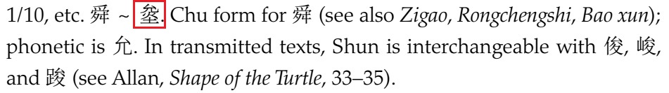

**Fig. 174. Sarah Allan, *Buried Ideas* (2015) p. 119-120**

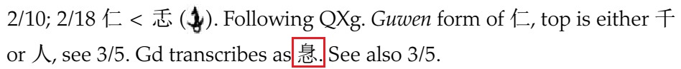

**Fig. 175. Sarah Allan, *Buried Ideas* (2015) p. 120**

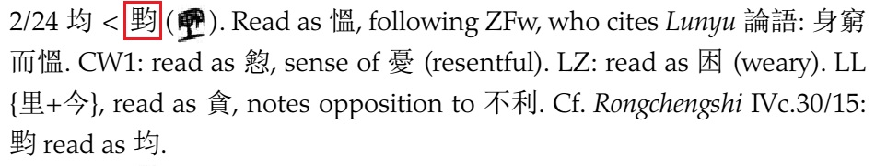

**Fig. 176. Sarah Allan, *Buried Ideas* (2015) p. 120**



**Fig. 177. Sarah Allan, *Buried Ideas* (2015) p. 120**

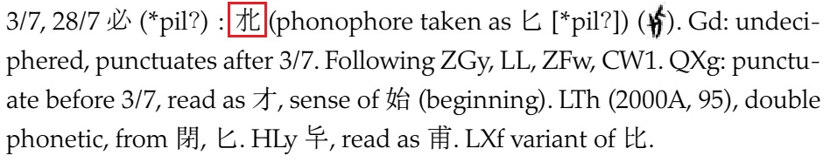

**Fig. 178. Sarah Allan, *Buried Ideas* (2015) p. 121**



**Fig. 179. Sarah Allan, *Buried Ideas* (2015) p. 122**



**Fig. 180. Sarah Allan, *Buried Ideas* (2015) p. 122**

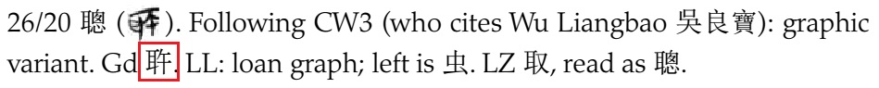

**Fig. 181. Sarah Allan, *Buried Ideas* (2015) p. 123**

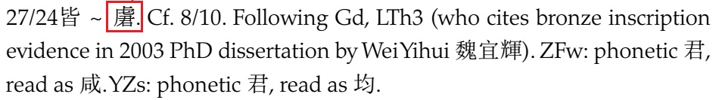

**Fig. 182. Sarah Allan, *Buried Ideas* (2015) p. 124**

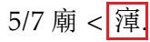

**Fig. 183. Sarah Allan, *Buried Ideas* (2015) p. 124**



**Fig. 184. Sarah Allan, *Buried Ideas* (2015) p. 124**

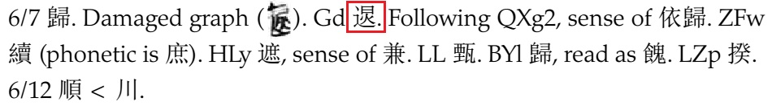

**Fig. 185. Sarah Allan, *Buried Ideas* (2015) p. 125**

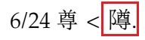

**Fig. 186. Sarah Allan, *Buried Ideas* (2015) p. 125**

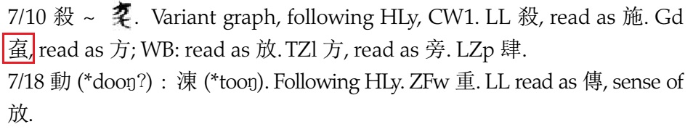

**Fig. 187. Sarah Allan, *Buried Ideas* (2015) p. 125**

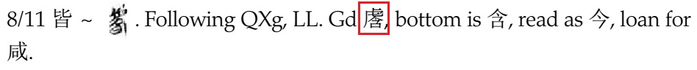

**Fig. 188. Sarah Allan, *Buried Ideas* (2015) p. 127**



**Fig. 189. Sarah Allan, *Buried Ideas* (2015) p. 128**

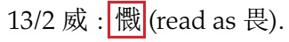

**Fig. 190. Sarah Allan, *Buried Ideas* (2015) p. 128**



**Fig. 191. Sarah Allan, *Buried Ideas* (2015) p. 129**



**Fig. 192. Sarah Allan, *Buried Ideas* (2015) p. 171**

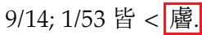

**Fig. 193. Sarah Allan, *Buried Ideas* (2015) p. 171**



**Fig. 194. Sarah Allan, *Buried Ideas* (2015) p. 171**



**Fig. 195. Sarah Allan, *Buried Ideas* (2015) p. 171**



**Fig. 196. Sarah Allan, *Buried Ideas* (2015) p. 172**



**Fig. 197. Sarah Allan, *Buried Ideas* (2015) p. 172**



**Fig. 198. Sarah Allan, *Buried Ideas* (2015) p. 172**

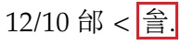

**Fig. 199. Sarah Allan, *Buried Ideas* (2015) p. 172**

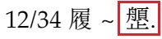

**Fig. 200. Sarah Allan, *Buried Ideas* (2015) p. 172**



**Fig. 201. Sarah Allan, *Buried Ideas* (2015) p. 172**

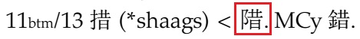

**Fig. 202. Sarah Allan, *Buried Ideas* (2015) p. 173**

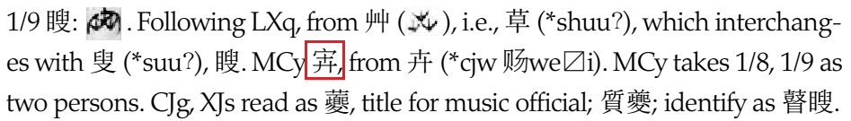

**Fig. 203. Sarah Allan, *Buried Ideas* (2015) p. 173**

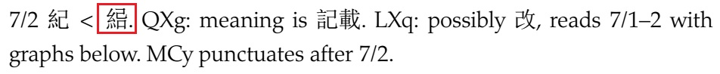

**Fig. 204. Sarah Allan, *Buried Ideas* (2015) p. 173**

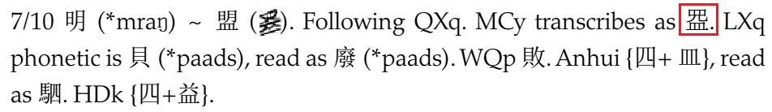

**Fig. 205. Sarah Allan, *Buried Ideas* (2015) p. 173**



**Fig. 206. Sarah Allan, *Buried Ideas* (2015) p. 174**



**Fig. 207. Sarah Allan, *Buried Ideas* (2015) p. 174**

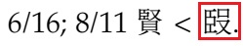

**Fig. 208. Sarah Allan, *Buried Ideas* (2015) p. 176**

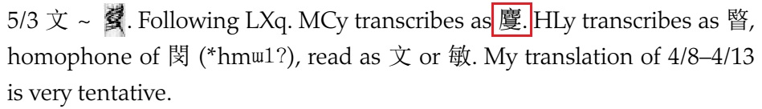

**Fig. 209. Sarah Allan, *Buried Ideas* (2015) p. 177**

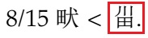

**Fig. 210. Sarah Allan, *Buried Ideas* (2015) p. 177**

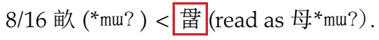

**Fig. 211. Sarah Allan, *Buried Ideas* (2015) p. 225**



**Fig. 212. Sarah Allan, *Buried Ideas* (2015) p. 226**

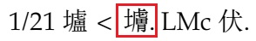

**Fig. 213. Sarah Allan, *Buried Ideas* (2015) p. 226**

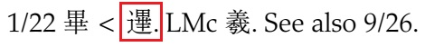

**Fig. 214. Sarah Allan, *Buried Ideas* (2015) p. 226**



**Fig. 215. Sarah Allan, *Buried Ideas* (2015) p. 226**

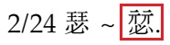

**Fig. 216. Sarah Allan, *Buried Ideas* (2015) p. 226**

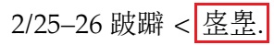

**Fig. 217. Sarah Allan, *Buried Ideas* (2015) p. 226**

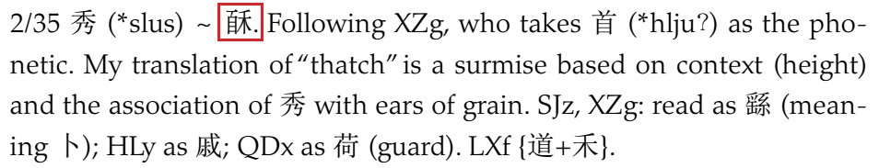

**Fig. 218. Sarah Allan, *Buried Ideas* (2015) p. 226**



**Fig. 219. Sarah Allan, *Buried Ideas* (2015) p. 227**

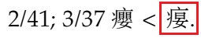

**Fig. 220. Sarah Allan, *Buried Ideas* (2015) p. 227**



**Fig. 221. Sarah Allan, *Buried Ideas* (2015) p. 227**



**Fig. 222. Sarah Allan, *Buried Ideas* (2015) p. 228**



**Fig. 223. Sarah Allan, *Buried Ideas* (2015) p. 228**



**Fig. 224. Sarah Allan, *Buried Ideas* (2015) p. 228**



**Fig. 225. Sarah Allan, *Buried Ideas* (2015) p. 229**

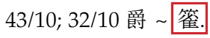

**Fig. 226. Sarah Allan, *Buried Ideas* (2015) p. 229**

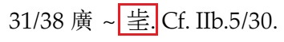

**Fig. 227. Sarah Allan, *Buried Ideas* (2015) p. 229**

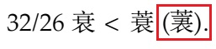

**Fig. 228. Sarah Allan, *Buried Ideas* (2015) p. 230**



**Fig. 229. Sarah Allan, *Buried Ideas* (2015) p. 230**

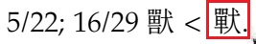

**Fig. 230. Sarah Allan, *Buried Ideas* (2015) p. 230**

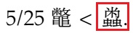

**Fig. 231. Sarah Allan, *Buried Ideas* (2015) p. 232**



**Fig. 232. Sarah Allan, *Buried Ideas* (2015) p. 232**

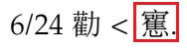

**Fig. 233. Sarah Allan, *Buried Ideas* (2015) p. 232**



**Fig. 234. Sarah Allan, *Buried Ideas* (2015) p. 232**



**Fig. 235. Sarah Allan, *Buried Ideas* (2015) p. 233**

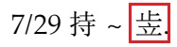

**Fig. 236. Sarah Allan, *Buried Ideas* (2015) p. 233**

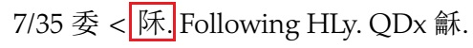

**Fig. 237. Sarah Allan, *Buried Ideas* (2015) p. 233**

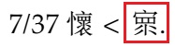

**Fig. 238. Sarah Allan, *Buried Ideas* (2015) p. 234**

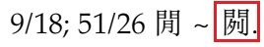

**Fig. 239. Sarah Allan, *Buried Ideas* (2015) p. 234**

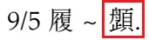

**Fig. 240. Sarah Allan, *Buried Ideas* (2015) p. 234**

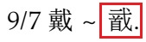

**Fig. 241. Sarah Allan, *Buried Ideas* (2015) p. 235**

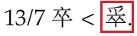

**Fig. 242. Sarah Allan, *Buried Ideas* (2015) p. 236**



**Fig. 243. Sarah Allan, *Buried Ideas* (2015) p. 236**



**Fig. 244. Sarah Allan, *Buried Ideas* (2015) p. 237**

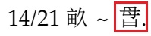

**Fig. 245. Sarah Allan, *Buried Ideas* (2015) p. 237**



**Fig. 246. Sarah Allan, *Buried Ideas* (2015) p. 237**



**Fig. 247. Sarah Allan, *Buried Ideas* (2015) p. 237**



**Fig. 248. Sarah Allan, *Buried Ideas* (2015) p. 238**

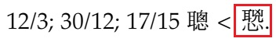

**Fig. 249. Sarah Allan, *Buried Ideas* (2015) p. 239**

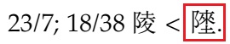

**Fig. 250. Sarah Allan, *Buried Ideas* (2015) p. 239**

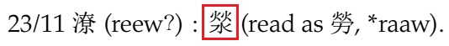

**Fig. 251. Sarah Allan, *Buried Ideas* (2015) p. 239**

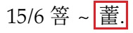

**Fig. 252. Sarah Allan, *Buried Ideas* (2015) p. 240**

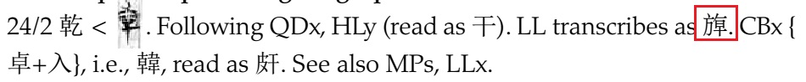

**Fig. 253. Sarah Allan, *Buried Ideas* (2015) p. 240**



**Fig. 254. Sarah Allan, *Buried Ideas* (2015) p. 240**

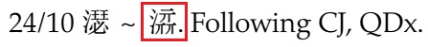

**Fig. 255. Sarah Allan, *Buried Ideas* (2015) p. 240**

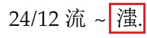

**Fig. 256. Sarah Allan, *Buried Ideas* (2015) p. 241**

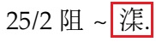

**Fig. 257. Sarah Allan, *Buried Ideas* (2015) p. 241**

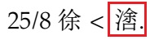

**Fig. 258. Sarah Allan, *Buried Ideas* (2015) p. 241**

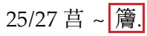

**Fig. 259. Sarah Allan, *Buried Ideas* (2015) p. 241**



**Fig. 260. Sarah Allan, *Buried Ideas* (2015) p. 241**

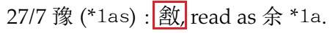

**Fig. 261. Sarah Allan, *Buried Ideas* (2015) p. 241**



**Fig. 262. Sarah Allan, *Buried Ideas* (2015) p. 242**

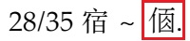

**Fig. 263. Sarah Allan, *Buried Ideas* (2015) p. 242**

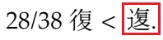

**Fig. 264. Sarah Allan, *Buried Ideas* (2015) p. 243**



**Fig. 265. Sarah Allan, *Buried Ideas* (2015) p. 243**



**Fig. 266. Sarah Allan, *Buried Ideas* (2015) p. 243**

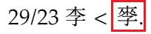

**Fig. 267. Sarah Allan, *Buried Ideas* (2015) p. 243**

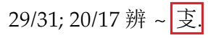

**Fig. 268. Sarah Allan, *Buried Ideas* (2015) p. 243**

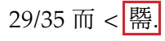

**Fig. 269. Sarah Allan, *Buried Ideas* (2015) p. 243**

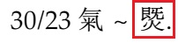

**Fig. 270. Sarah Allan, *Buried Ideas* (2015) p. 244**



**Fig. 271. Sarah Allan, *Buried Ideas* (2015) p. 244**

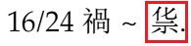

**Fig. 272. Sarah Allan, *Buried Ideas* (2015) p. 244**



**Fig. 273. Sarah Allan, *Buried Ideas* (2015) p. 244**

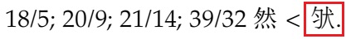

**Fig. 274. Sarah Allan, *Buried Ideas* (2015) p. 245**

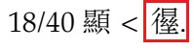

**Fig. 275. Sarah Allan, *Buried Ideas* (2015) p. 246**



**Fig. 276. Sarah Allan, *Buried Ideas* (2015) p. 246**

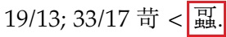

**Fig. 277. Sarah Allan, *Buried Ideas* (2015) p. 246**

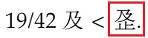

**Fig. 278. Sarah Allan, *Buried Ideas* (2015) p. 246**



**Fig. 279. Sarah Allan, *Buried Ideas* (2015) p. 247**



**Fig. 280. Sarah Allan, *Buried Ideas* (2015) p. 247**

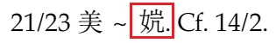

**Fig. 281. Sarah Allan, *Buried Ideas* (2015) p. 247**

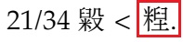

**Fig. 282. Sarah Allan, *Buried Ideas* (2015) p. 247**



**Fig. 283. Sarah Allan, *Buried Ideas* (2015) p. 247**

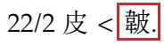

**Fig. 284. Sarah Allan, *Buried Ideas* (2015) p. 247**

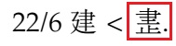

**Fig. 285. Sarah Allan, *Buried Ideas* (2015) p. 247**



**Fig. 286. Sarah Allan, *Buried Ideas* (2015) p. 248**



**Fig. 287. Sarah Allan, *Buried Ideas* (2015) p. 248**

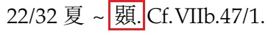

**Fig. 288. Sarah Allan, *Buried Ideas* (2015) p. 248**

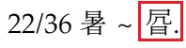

**Fig. 289. Sarah Allan, *Buried Ideas* (2015) p. 250**

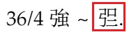

**Fig. 290. Sarah Allan, *Buried Ideas* (2015) p. 250**

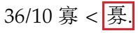

**Fig. 291. Sarah Allan, *Buried Ideas* (2015) p. 251**



**Fig. 292. Sarah Allan, *Buried Ideas* (2015) p. 251**

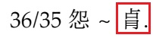

**Fig. 293. Sarah Allan, *Buried Ideas* (2015) p. 251**



**Fig. 294. Sarah Allan, *Buried Ideas* (2015) p. 251**

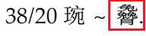

**Fig. 295. Sarah Allan, *Buried Ideas* (2015) p. 251**

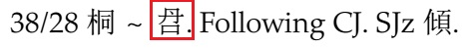

**Fig. 296. Sarah Allan, *Buried Ideas* (2015) p. 251**

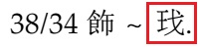

**Fig. 297. Sarah Allan, *Buried Ideas* (2015) p. 251**

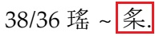

**Fig. 298. Sarah Allan, *Buried Ideas* (2015) p. 251**

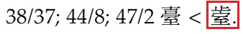

**Fig. 299. Sarah Allan, *Buried Ideas* (2015) p. 252**



**Fig. 300. Sarah Allan, *Buried Ideas* (2015) p. 252**



**Fig. 301. Sarah Allan, *Buried Ideas* (2015) p. 253**

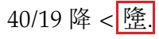

**Fig. 302. Sarah Allan, *Buried Ideas* (2015) p. 253**

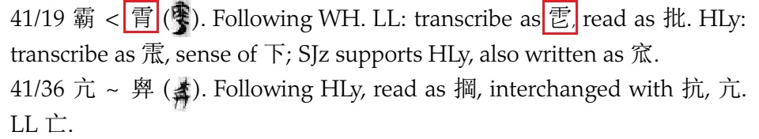

**Fig. 303. Sarah Allan, *Buried Ideas* (2015) p. 254**

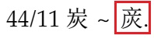

**Fig. 304. Sarah Allan, *Buried Ideas* (2015) p. 254**

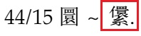

**Fig. 305. Sarah Allan, *Buried Ideas* (2015) p. 254**

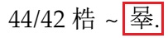

**Fig. 306. Sarah Allan, *Buried Ideas* (2015) p. 254**



**Fig. 307. Sarah Allan, *Buried Ideas* (2015) p. 255**

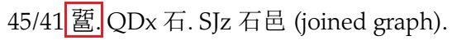

**Fig. 308. Sarah Allan, *Buried Ideas* (2015) p. 255**



**Fig. 309. Sarah Allan, *Buried Ideas* (2015) p. 255**



**Fig. 310. Sarah Allan, *Buried Ideas* (2015) p. 256**

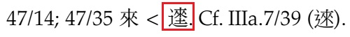

**Fig. 311. Sarah Allan, *Buried Ideas* (2015) p. 257**

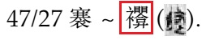

**Fig. 312. Sarah Allan, *Buried Ideas* (2015) p. 257**

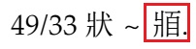

**Fig. 313. Sarah Allan, *Buried Ideas* (2015) p. 259**

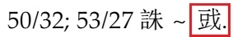

**Fig. 314. Sarah Allan, *Buried Ideas* (2015) p. 259**

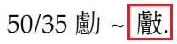

**Fig. 315. Sarah Allan, *Buried Ideas* (2015) p. 259**

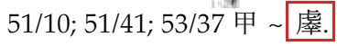

**Fig. 316. Sarah Allan, *Buried Ideas* (2015) p. 259**

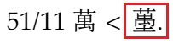

**Fig. 317. Sarah Allan, *Buried Ideas* (2015) p. 259**

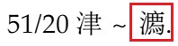

**Fig. 318. Sarah Allan, *Buried Ideas* (2015) p. 259**



**Fig. 319. Sarah Allan, *Buried Ideas* (2015) p. 259**

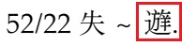

**Fig. 320. Sarah Allan, *Buried Ideas* (2015) p. 259**

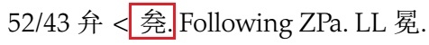

**Fig. 321. Sarah Allan, *Buried Ideas* (2015) p. 260**



**Fig. 322. Sarah Allan, *Buried Ideas* (2015) p. 305**

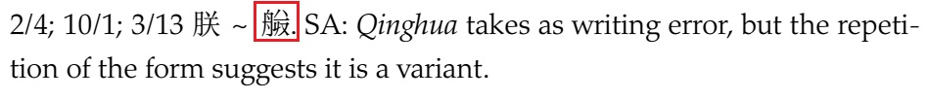

**Fig. 323. Sarah Allan, *Buried Ideas* (2015) p. 306**

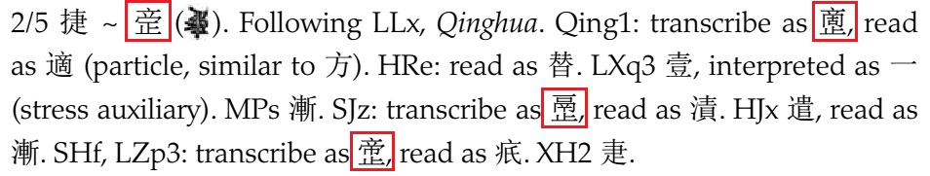

**Fig. 324. Sarah Allan, *Buried Ideas* (2015) p. 306**

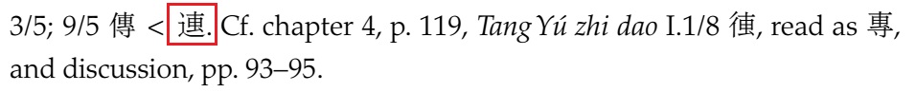

**Fig. 325. Sarah Allan, *Buried Ideas* (2015) p. 306**

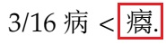

**Fig. 326. Sarah Allan, *Buried Ideas* (2015) p. 307**

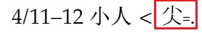

**Fig. 327. Sarah Allan, *Buried Ideas* (2015) p. 307**

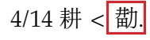

**Fig. 328. Sarah Allan, *Buried Ideas* (2015) p. 308**

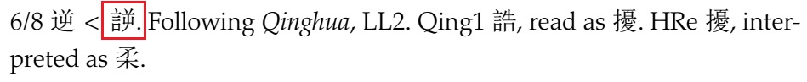

**Fig. 329. Sarah Allan, *Buried Ideas* (2015) p. 309**



**Fig. 330. Sarah Allan, *Buried Ideas* (2015) p. 310**

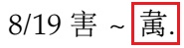

**Fig. 331. Sarah Allan, *Buried Ideas* (2015) p. 310**

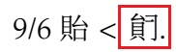

**Fig. 332. Sarah Allan, "When Red Pigeons Gathered on Tang's House" (*JRAS* v.25 no.3) p. 419**

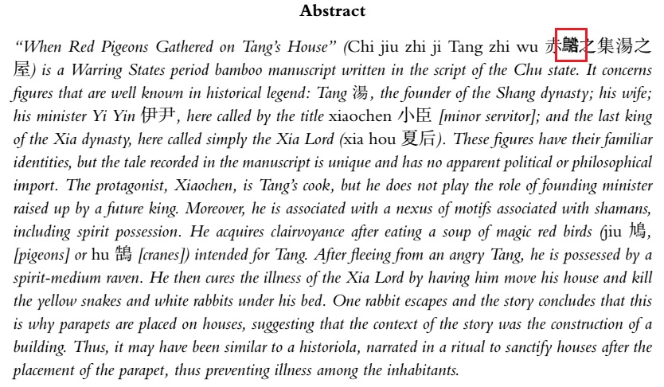

**Fig. 333. Sarah Allan, "When Red Pigeons Gathered on Tang's House" (*JRAS* v.25 no.3) p. 425**

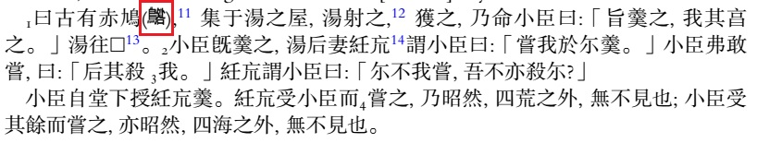

**Fig. 334. Sarah Allan, "When Red Pigeons Gathered on Tang's House" (*JRAS* v.25 no.3) p. 425**



**Fig. 335. Sarah Allan, "When Red Pigeons Gathered on Tang's House" (*JRAS* v.25 no.3) p. 426**

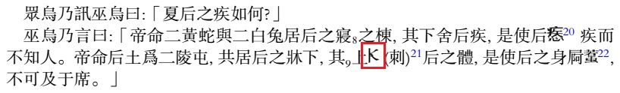

**Fig. 336. Matthia L. Richter, *The Embodied Text* (2013) p. 36**

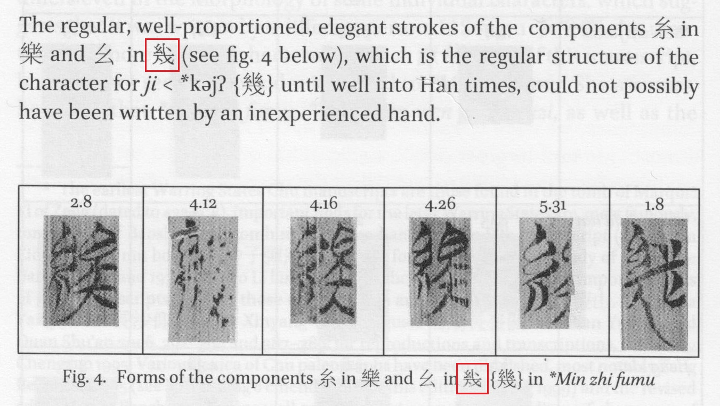

**Fig. 337. Matthia L. Richter, *The Embodied Text* (2013) p. 41**

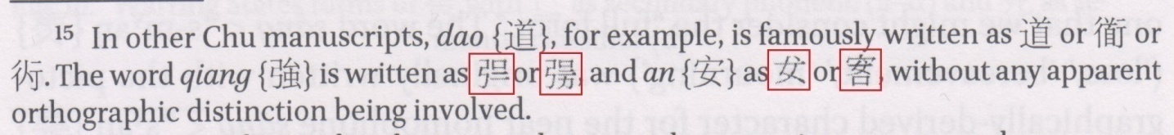

**Fig. 338. Matthia L. Richter, *The Embodied Text* (2013) p. 75**

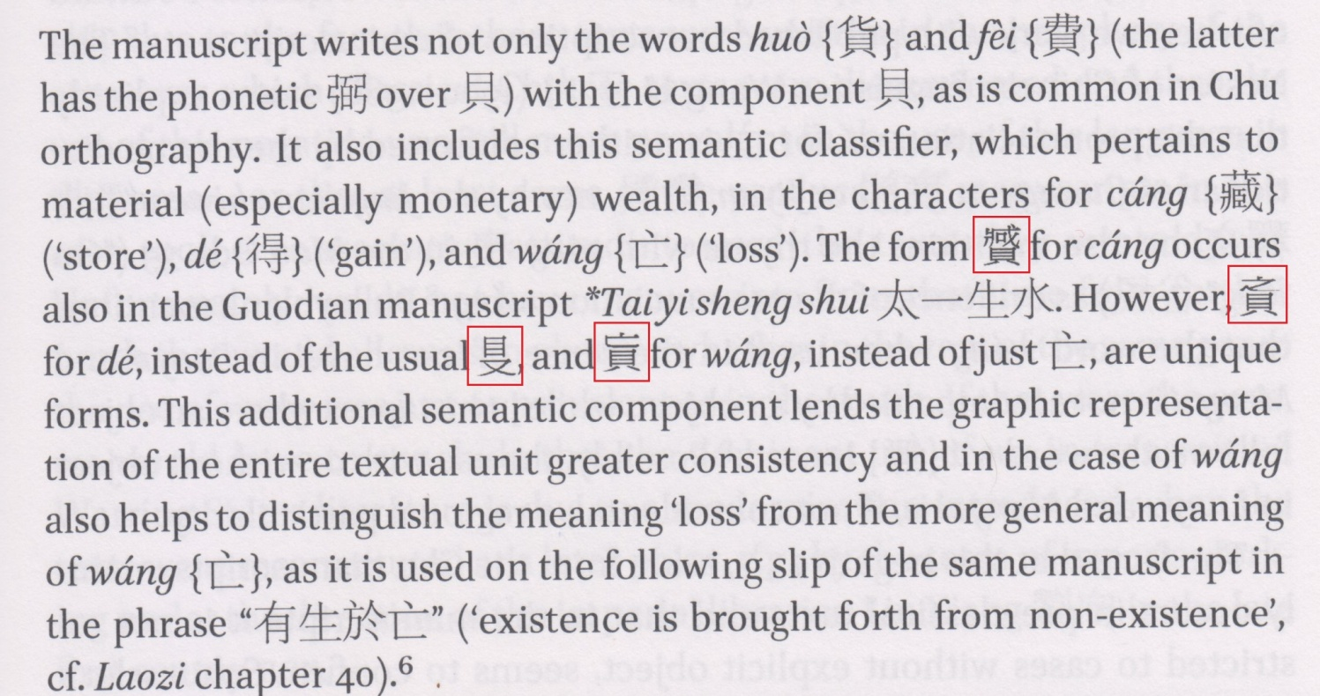

**Fig. 339. Matthia L. Richter, *The Embodied Text* (2013) p. 120**

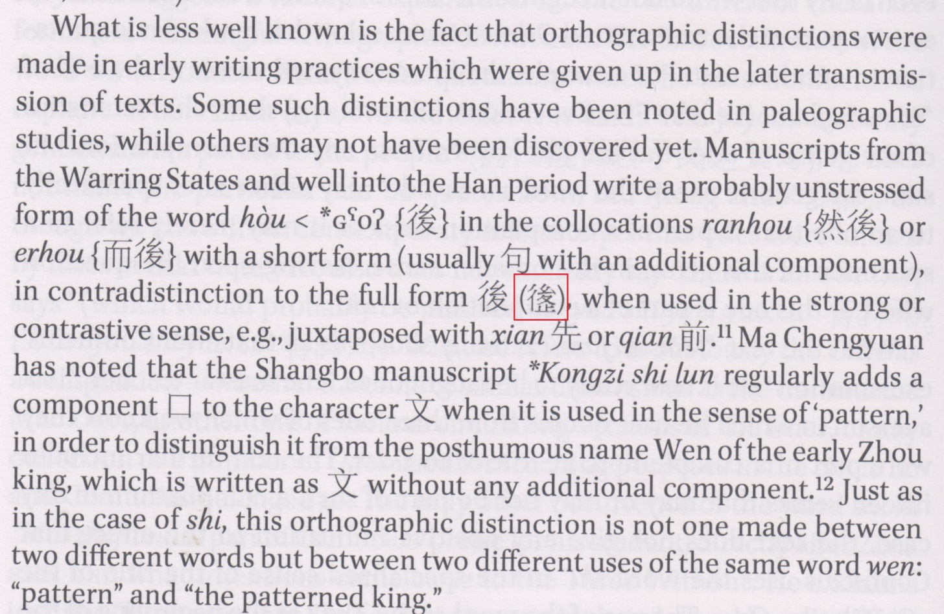

**Fig. 340. Matthia L. Richter, *The Embodied Text* (2013) p. 122**

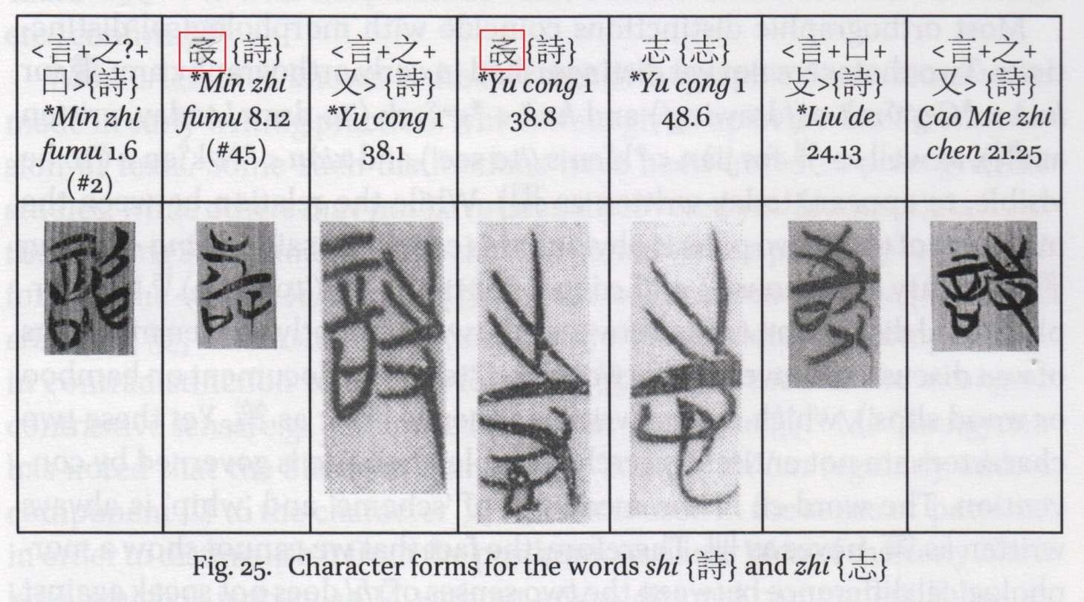

**Fig. 341. *Zhongguo Dabaike Quanshu* (1978-1993) v. 29 p. 365**

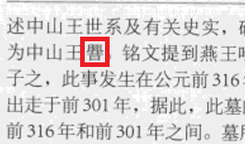

**Fig. 342. *Wenjiao Ziliao* (2013 no. 32) p. 43**

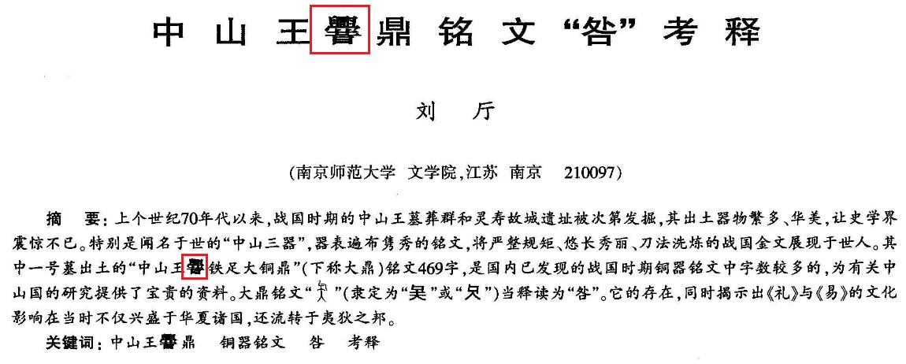

**Fig. 343. Li Fanwen, *Xia-Han Zidian* (2008) p. 130 entry #0762**

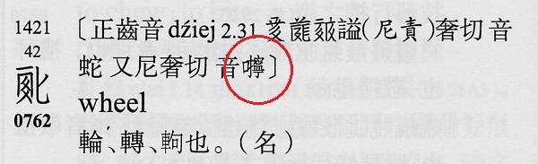

**Fig. 344. Li Fanwen, *Xia-Han Zidian* (2008) p. 130 entry #0764**

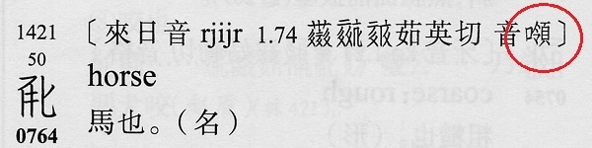

**Fig. 345. Li Fanwen, *Xia-Han Zidian* (2008) p. 346 entry #2086**

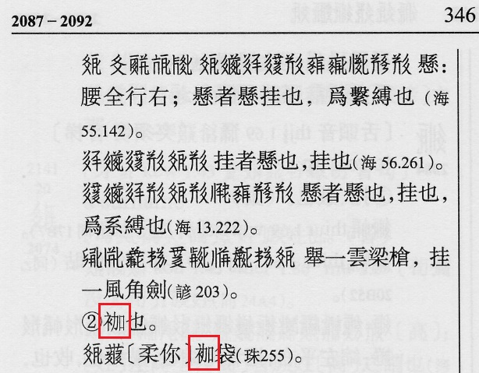

**Fig. 346.** *Fan-Han Heshi Zhangzhongzhu* p. 15b

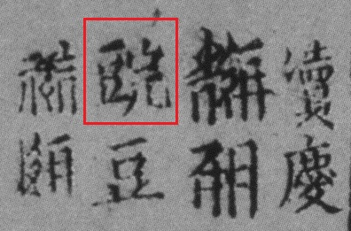

**Fig. 347.** *Fan-Han Heshi Zhangzhongzhu* p. 22a

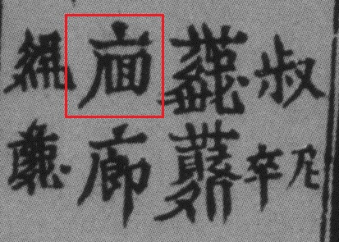

**Fig. 348. Article in *Xixia Studies* vol. 8 p. 30**

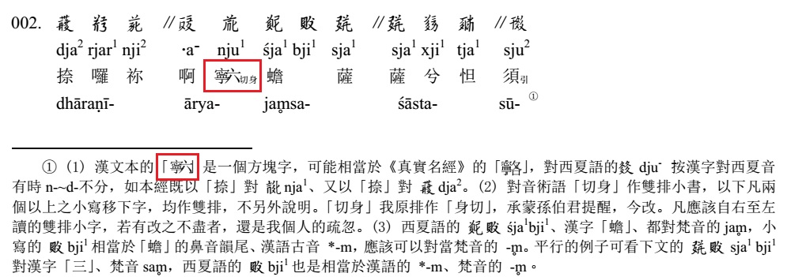

**Fig. 349. Article in *Xixia Studies* vol. 8 p. 38**

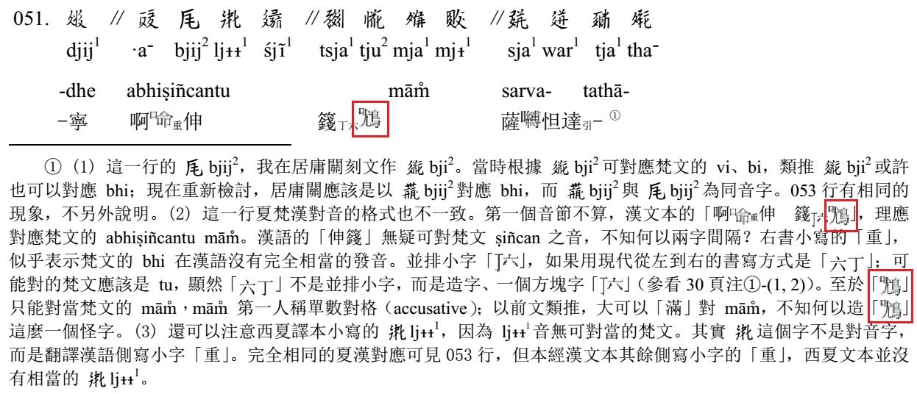

**Fig. 350. *Baisigou Xixia Fangta* p. 221**

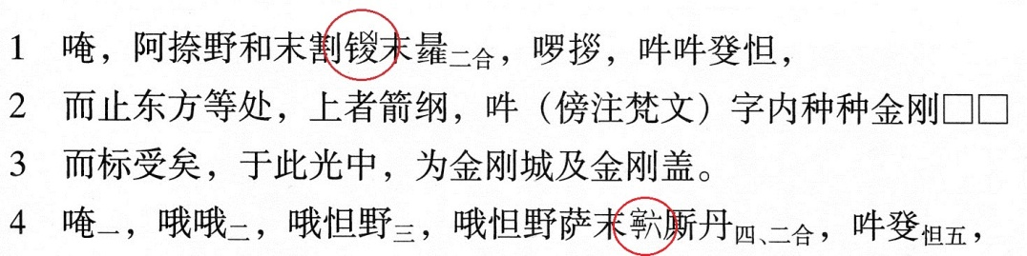

**Fig. 351. *Baisigou Xixia Fangta* p. 221**

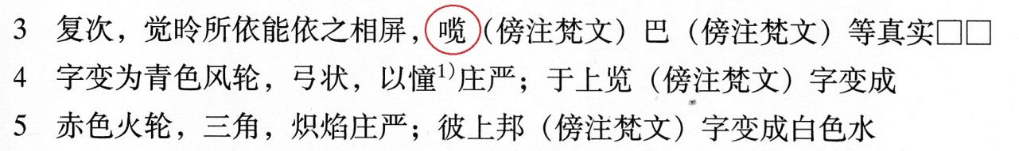

**Fig. 352. *Baisigou Xixia Fangta* p. 223**

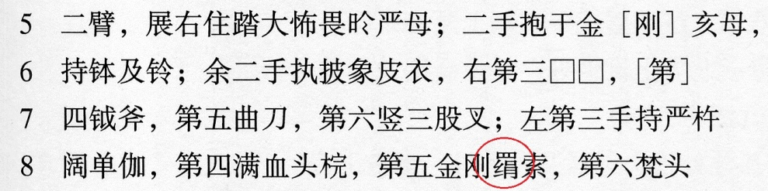

**Fig. 353. Epitaph of Yelü Renxian 耶律仁先 in Chinggeltei, *Qidan Xiaozi Shidu Wenti* (Tokyo, 2002) p. 189**

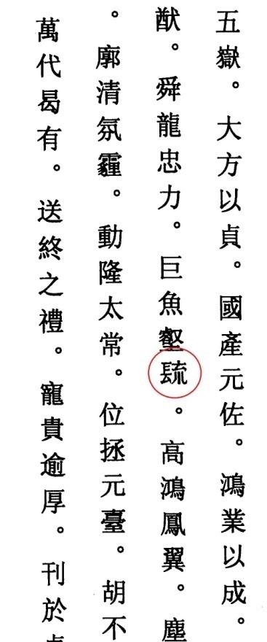

**Fig. 354. Hanyu Da Zidian v. 1 p. 4**

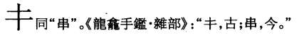

**Fig. 355. Hanyu Da Zidian v. 1 p. 32**

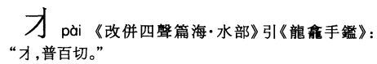

**Fig. 356. Hanyu Da Zidian v. 1 p. 75**

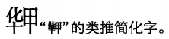

**Fig. 357. Hanyu Da Zidian v. 1 p. 78**

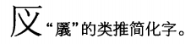

**Fig. 358. Hanyu Da Zidian v. 1 p. 82**

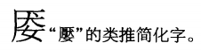

**Fig. 359. Hanyu Da Zidian v. 1 p. 83**

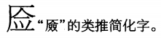

**Fig. 360. Hanyu Da Zidian v. 1 p. 84**

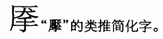

**Fig. 361. Hanyu Da Zidian v. 1 p. 100**

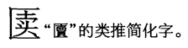

**Fig. 362. Hanyu Da Zidian v. 1 p. 101**

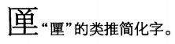

**Fig. 363. Hanyu Da Zidian v. 1 p. 157**

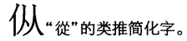

**Fig. 364. Hanyu Da Zidian v. 1 p. 162**

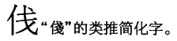

**Fig. 365. Hanyu Da Zidian v. 1 p. 181**

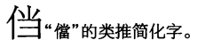

**Fig. 366. Hanyu Da Zidian v. 1 p. 185**

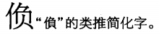

**Fig. 367. Hanyu Da Zidian v. 1 p. 201**

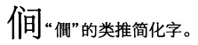

**Fig. 368. Hanyu Da Zidian v. 1 p. 201**

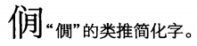

**Fig. 369. Hanyu Da Zidian v. 1 p. 209**

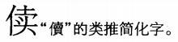

**Fig. 370. Hanyu Da Zidian v. 1 p. 224**

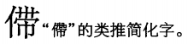

**Fig. 371. Hanyu Da Zidian v. 1 p. 229**

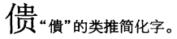

**Fig. 372. Hanyu Da Zidian v. 1 p. 241**

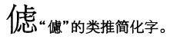

**Fig. 373. Hanyu Da Zidian v. 1 p. 258**

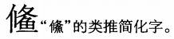

**Fig. 374. Hanyu Da Zidian v. 1 p. 259**

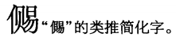

**Fig. 375. Hanyu Da Zidian v. 1 p. 277**

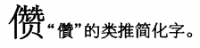

**Fig. 376. Hanyu Da Zidian v. 1 p. 301**

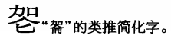

**Fig. 377. Hanyu Da Zidian v. 1 p. 326**

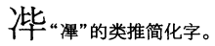

**Fig. 378. Hanyu Da Zidian v. 1 p. 328**

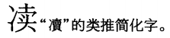

**Fig. 379. Hanyu Da Zidian v. 1 p. 356**

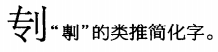

**Fig. 380. Hanyu Da Zidian v. 1 p. 372**

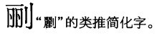

**Fig. 381. Hanyu Da Zidian v. 1 p. 410**

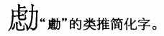

**Fig. 382. Hanyu Da Zidian v. 1 p. 434**

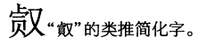

**Fig. 383. Hanyu Da Zidian v. 1 p. 453**

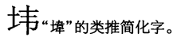

**Fig. 384. Hanyu Da Zidian v. 1 p. 454**

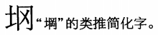

**Fig. 385. Hanyu Da Zidian v. 1 p. 468**

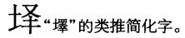

**Fig. 386. Hanyu Da Zidian v. 1 p. 471**

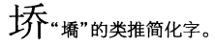

**Fig. 387. Hanyu Da Zidian v. 1 p. 478**

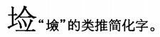

**Fig. 388. Hanyu Da Zidian v. 1 p. 494**

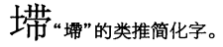

**Fig. 389. Hanyu Da Zidian v. 1 p. 506**

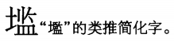

**Fig. 390. Hanyu Da Zidian v. 1 p. 518**

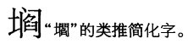

**Fig. 391. Hanyu Da Zidian v. 1 p. 518**

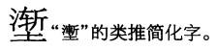

**Fig. 392. Hanyu Da Zidian v. 2 p. 662**

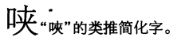

**Fig. 393. Hanyu Da Zidian v. 2 p. 694**

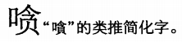

**Fig. 394. Hanyu Da Zidian v. 2 p. 704**

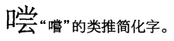

**Fig. 395. Hanyu Da Zidian v. 2 p. 710**

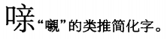

**Fig. 396. Hanyu Da Zidian v. 2 p. 719**

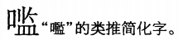

**Fig. 397. Hanyu Da Zidian v. 2 p. 742**

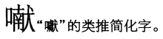

**Fig. 398. Hanyu Da Zidian v. 2 p. 755**

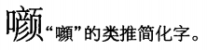

**Fig. 399. Hanyu Da Zidian v. 2 p. 757**

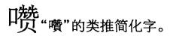

**Fig. 400. Hanyu Da Zidian v. 2 p. 788**

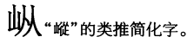

**Fig. 401. Hanyu Da Zidian v. 2 p. 791**

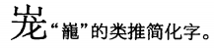

**Fig. 402. Hanyu Da Zidian v. 2 p. 791**

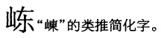

**Fig. 403. Hanyu Da Zidian v. 2 p. 791**

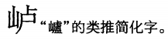

**Fig. 404. Hanyu Da Zidian v. 2 p. 791**

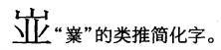

**Fig. 405. Hanyu Da Zidian v. 2 p. 795**

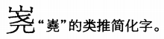

**Fig. 406. Hanyu Da Zidian v. 2 p. 795**

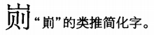

**Fig. 407. Hanyu Da Zidian v. 2 p. 796**

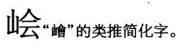

**Fig. 408. Hanyu Da Zidian v. 2 p. 797**

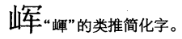

**Fig. 409. Hanyu Da Zidian v. 2 p. 797**

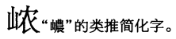

**Fig. 410. Hanyu Da Zidian v. 2 p. 798**

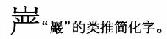

**Fig. 411. Hanyu Da Zidian v. 2 p. 815**

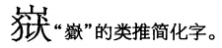

**Fig. 412. Hanyu Da Zidian v. 2 p. 826**

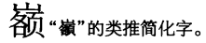

**Fig. 413. Hanyu Da Zidian v. 2 p. 827**

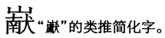

**Fig. 414. Hanyu Da Zidian v. 2 p. 834**

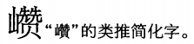

**Fig. 415. Hanyu Da Zidian v. 2 p. 843**

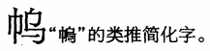

**Fig. 416. Hanyu Da Zidian v. 2 p. 844**

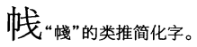

**Fig. 417. Hanyu Da Zidian v. 2 p. 860**

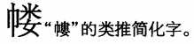

**Fig. 418. Hanyu Da Zidian v. 2 p. 867**

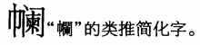

**Fig. 419. Hanyu Da Zidian v. 2 p. 914**

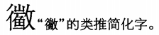

**Fig. 420. Hanyu Da Zidian v. 2 p. 947**

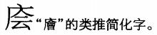

**Fig. 421. Hanyu Da Zidian v. 2 p. 956**

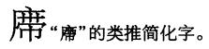

**Fig. 422. Hanyu Da Zidian v. 2 p. 957**

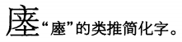

**Fig. 423. Hanyu Da Zidian v. 2 p. 959**

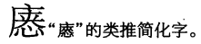

**Fig. 424. Hanyu Da Zidian v. 2 p. 983**

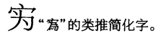

**Fig. 425. Hanyu Da Zidian v. 2 p. 1088**

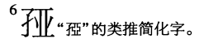

**Fig. 426. Hanyu Da Zidian v. 2 p. 1102**

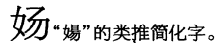

**Fig. 427. Hanyu Da Zidian v. 2 p. 1103**

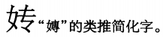

**Fig. 428. Hanyu Da Zidian v. 2 p. 1108**

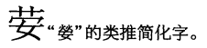

**Fig. 429. Hanyu Da Zidian v. 2 p. 1133**

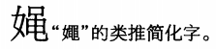

**Fig. 430. Hanyu Da Zidian v. 2 p. 1159**

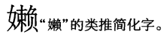

**Fig. 431. Hanyu Da Zidian v. 2 p. 1180**

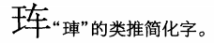

**Fig. 432. Hanyu Da Zidian v. 2 p. 1190**

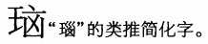

**Fig. 433. Hanyu Da Zidian v. 2 p. 1192**

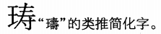

**Fig. 434. Hanyu Da Zidian v. 2 p. 1203**

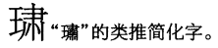

**Fig. 435. Hanyu Da Zidian v. 3 p. 1244**

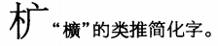

**Fig. 436. Hanyu Da Zidian v. 3 p. 1256**

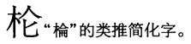

**Fig. 437. Hanyu Da Zidian v. 3 p. 1264**

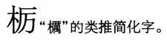

**Fig. 438. Hanyu Da Zidian v. 3 p. 1265**

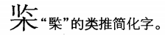

**Fig. 439. Hanyu Da Zidian v. 3 p. 1272**

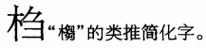

**Fig. 440. Hanyu Da Zidian v. 3 p. 1274**

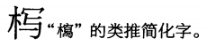

**Fig. 441. Hanyu Da Zidian v. 3 p. 1276**

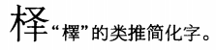

**Fig. 442. Hanyu Da Zidian v. 3 p. 1281**

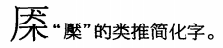

**Fig. 443. Hanyu Da Zidian v. 3 p. 1285**

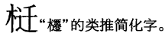

**Fig. 444. Hanyu Da Zidian v. 3 p. 1292**

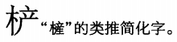

**Fig. 445. Hanyu Da Zidian v. 3 p. 1294**

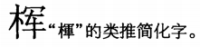

**Fig. 446. Hanyu Da Zidian v. 3 p. 1294**

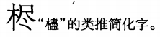

**Fig. 447. Hanyu Da Zidian v. 3 p. 1300**

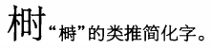

**Fig. 448. Hanyu Da Zidian v. 3 p. 1329**

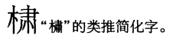

**Fig. 449. Hanyu Da Zidian v. 3 p. 1332**

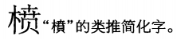

**Fig. 450. Hanyu Da Zidian v. 3 p. 1333**

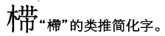

**Fig. 451. Hanyu Da Zidian v. 3 p. 1351**

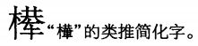

**Fig. 452. Hanyu Da Zidian v. 3 p. 1367**

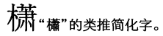

**Fig. 453. Hanyu Da Zidian v. 3 p. 1377**

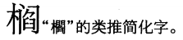

**Fig. 454. Hanyu Da Zidian v. 3 p. 1379**

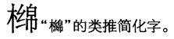

**Fig. 455. Hanyu Da Zidian v. 3 p. 1395**

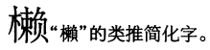

**Fig. 456. Hanyu Da Zidian v. 3 p. 1400**

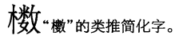

**Fig. 457. Hanyu Da Zidian v. 3 p. 1426**

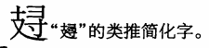

**Fig. 458. Hanyu Da Zidian v. 3 p. 1436**

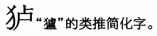

**Fig. 459. Hanyu Da Zidian v. 3 p. 1440**

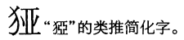

**Fig. 460. Hanyu Da Zidian v. 3 p. 1442**

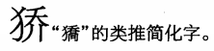

**Fig. 461. Hanyu Da Zidian v. 3 p. 1444**

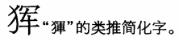

**Fig. 462. Hanyu Da Zidian v. 3 p. 1446**

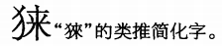

**Fig. 463. Hanyu Da Zidian v. 3 p. 1447**

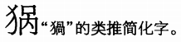

**Fig. 464. Hanyu Da Zidian v. 3 p. 1447**

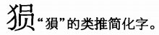

**Fig. 465. Hanyu Da Zidian v. 3 p. 1449**

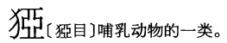

**Fig. 466. Hanyu Da Zidian v. 3 p. 1450**

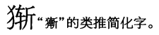

**Fig. 467. Hanyu Da Zidian v. 3 p. 1454**

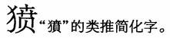

**Fig. 468. Hanyu Da Zidian v. 3 p. 1464**

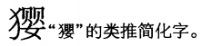

**Fig. 469. Hanyu Da Zidian v. 3 p. 1475**

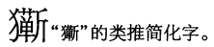

**Fig. 470. Hanyu Da Zidian v. 3 p. 1523**

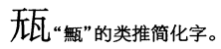

**Fig. 471. Hanyu Da Zidian v. 3 p. 1528**

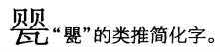

**Fig. 472. Hanyu Da Zidian v. 3 p. 1531**

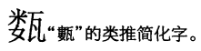

**Fig. 473. Hanyu Da Zidian v. 3 p. 1553**

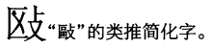

**Fig. 474. Hanyu Da Zidian v. 3 p. 1560**

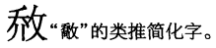

**Fig. 475. Hanyu Da Zidian v. 3 p. 1620**

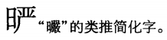

**Fig. 476. Hanyu Da Zidian v. 3 p. 1641**

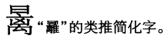

**Fig. 477. Hanyu Da Zidian v. 3 p. 1642**

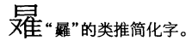

**Fig. 478. Hanyu Da Zidian v. 3 p. 1680**

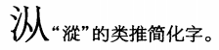

**Fig. 479. Hanyu Da Zidian v. 3 p. 1695**

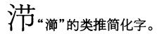

**Fig. 480. Hanyu Da Zidian v. 3 p. 1696**

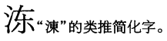

**Fig. 481. Hanyu Da Zidian v. 3 p. 1708**

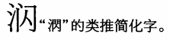

**Fig. 482. Hanyu Da Zidian v. 3 p. 1715**

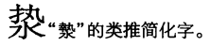

**Fig. 483. Hanyu Da Zidian v. 3 p. 1715**

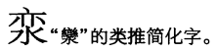

**Fig. 484. Hanyu Da Zidian v. 3 p. 1720**

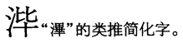

**Fig. 485. Hanyu Da Zidian v. 3 p. 1722**

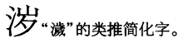

**Fig. 486. Hanyu Da Zidian v. 3 p. 1723**

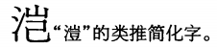

**Fig. 487. Hanyu Da Zidian v. 3 p. 1731**

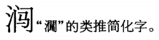

**Fig. 488. Hanyu Da Zidian v. 3 p. 1746**

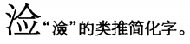

**Fig. 489. Hanyu Da Zidian v. 3 p. 1750**

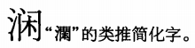

**Fig. 490. Hanyu Da Zidian v. 3 p. 1758**

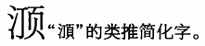

**Fig. 491. Hanyu Da Zidian v. 3 p. 1793**

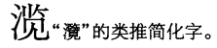

**Fig. 492. Hanyu Da Zidian v. 3 p. 1804**

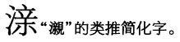

**Fig. 493. Hanyu Da Zidian v. 3 p. 1806**

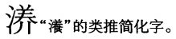

**Fig. 494. Hanyu Da Zidian v. 3 p. 1812**

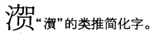

**Fig. 495. Hanyu Da Zidian v. 3 p. 1838**

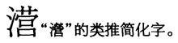

**Fig. 496. Hanyu Da Zidian v. 3 p. 1848**

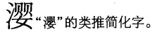

**Fig. 497. Hanyu Da Zidian v. 3 p. 1857**

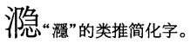

**Fig. 498. Hanyu Da Zidian v. 3 p. 1875**

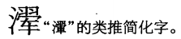

**Fig. 499. Hanyu Da Zidian v. 3 p. 1885**

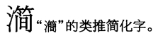

**Fig. 500. Hanyu Da Zidian v. 3 p. 1897**

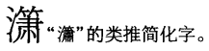

**Fig. 501. Hanyu Da Zidian v. 3 p. 1898**

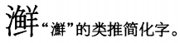

**Fig. 502. Hanyu Da Zidian v. 3 p. 1906**

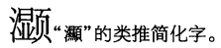

**Fig. 503. Hanyu Da Zidian v. 4 p. 1943**

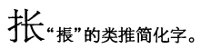

**Fig. 504. Hanyu Da Zidian v. 4 p. 1947**

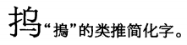

**Fig. 505. Hanyu Da Zidian v. 4 p. 1965**

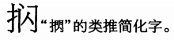

**Fig. 506. Hanyu Da Zidian v. 4 p. 1985**

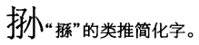

**Fig. 507. Hanyu Da Zidian v. 4 p. 1987**

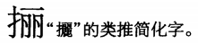

**Fig. 508. Hanyu Da Zidian v. 4 p. 1990**

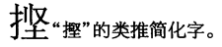

**Fig. 509. Hanyu Da Zidian v. 4 p. 1996**

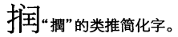

**Fig. 510. Hanyu Da Zidian v. 4 p. 2000**

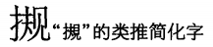

**Fig. 511. Hanyu Da Zidian v. 4 p. 2005**

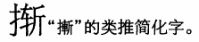

**Fig. 512. Hanyu Da Zidian v. 4 p. 2024**

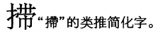

**Fig. 513. Hanyu Da Zidian v. 4 p. 2029**

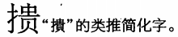

**Fig. 514. Hanyu Da Zidian v. 4 p. 2090**

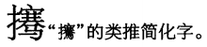

**Fig. 515. Hanyu Da Zidian v. 4 p. 2091**

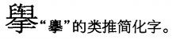

**Fig. 516. Hanyu Da Zidian v. 4 p. 2116**

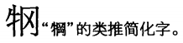

**Fig. 517. Hanyu Da Zidian v. 4 p. 2121**

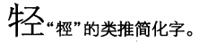

**Fig. 518. Hanyu Da Zidian v. 4 p. 2122**

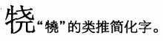

**Fig. 519. Hanyu Da Zidian v. 4 p. 2131**

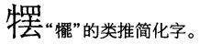

**Fig. 520. Hanyu Da Zidian v. 4 p. 2140**

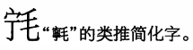

**Fig. 521. Hanyu Da Zidian v. 4 p. 2147**

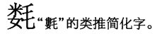

**Fig. 522. Hanyu Da Zidian v. 4 p. 2148**

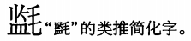

**Fig. 523. Hanyu Da Zidian v. 4 p. 2160**

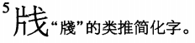

**Fig. 524. Hanyu Da Zidian v. 4 p. 2194**

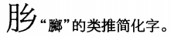

**Fig. 525. Hanyu Da Zidian v. 4 p. 2194**

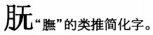

**Fig. 526. Hanyu Da Zidian v. 4 p. 2216**

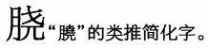

**Fig. 527. Hanyu Da Zidian v. 4 p. 2238**

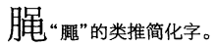

**Fig. 528. Hanyu Da Zidian v. 4 p. 2243**

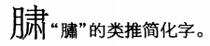

**Fig. 529. Hanyu Da Zidian v. 4 p. 2275**

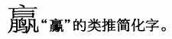

**Fig. 530. Hanyu Da Zidian v. 4 p. 2290**

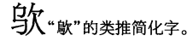

**Fig. 531. Hanyu Da Zidian v. 4 p. 2294**

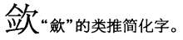

**Fig. 532. Hanyu Da Zidian v. 4 p. 2298**

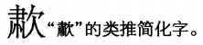

**Fig. 533. Hanyu Da Zidian v. 4 p. 2332**

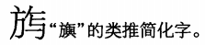

**Fig. 534. Hanyu Da Zidian v. 4 p. 2340**

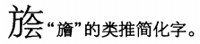

**Fig. 535. Hanyu Da Zidian v. 4 p. 2349**

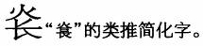

**Fig. 536. Hanyu Da Zidian v. 4 p. 2355**

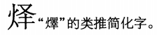

**Fig. 537. Hanyu Da Zidian v. 4 p. 2370**

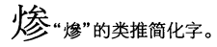

**Fig. 538. Hanyu Da Zidian v. 4 p. 2373**

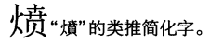

**Fig. 539. Hanyu Da Zidian v. 4 p. 2432**

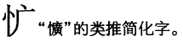

**Fig. 540. Hanyu Da Zidian v. 4 p. 2436**

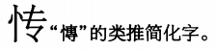

**Fig. 541. Hanyu Da Zidian v. 4 p. 2438**

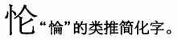

**Fig. 542. Hanyu Da Zidian v. 4 p. 2451**

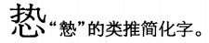

**Fig. 543. Hanyu Da Zidian v. 4 p. 2452**

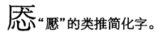

**Fig. 544. Hanyu Da Zidian v. 4 p. 2460**

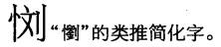

**Fig. 545. Hanyu Da Zidian v. 4 p. 2462**

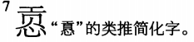

**Fig. 546. Hanyu Da Zidian v. 4 p. 2469**

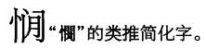

**Fig. 547. Hanyu Da Zidian v. 4 p. 2473**

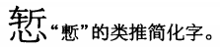

**Fig. 548. Hanyu Da Zidian v. 4 p. 2479**

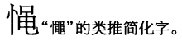

**Fig. 549. Hanyu Da Zidian v. 4 p. 2479**

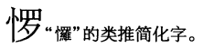

**Fig. 550. Hanyu Da Zidian v. 4 p. 2480**

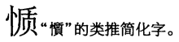

**Fig. 551. Hanyu Da Zidian v. 4 p. 2484**

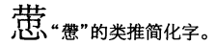

**Fig. 552. Hanyu Da Zidian v. 4 p. 2501**

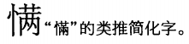

**Fig. 553. Hanyu Da Zidian v. 4 p. 2502**

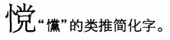

**Fig. 554. Hanyu Da Zidian v. 4 p. 2518**

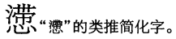

**Fig. 555. Hanyu Da Zidian v. 4 p. 2525**

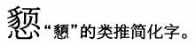

**Fig. 556. Hanyu Da Zidian v. 4 p. 2550**

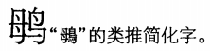

**Fig. 557. Hanyu Da Zidian v. 5 p. 2555**

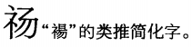

**Fig. 558. Hanyu Da Zidian v. 5 p. 2566**

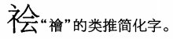

**Fig. 559. Hanyu Da Zidian v. 5 p. 2581**

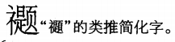

**Fig. 560. Hanyu Da Zidian v. 5 p. 2588**

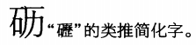

**Fig. 561. Hanyu Da Zidian v. 5 p. 2591**

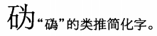

**Fig. 562. Hanyu Da Zidian v. 5 p. 2592**

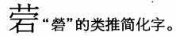

**Fig. 563. Hanyu Da Zidian v. 5 p. 2592**

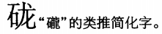

**Fig. 564. Hanyu Da Zidian v. 5 p. 2597**

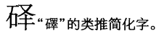

**Fig. 565. Hanyu Da Zidian v. 5 p. 2598**

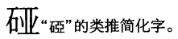

**Fig. 566. Hanyu Da Zidian v. 5 p. 2602**

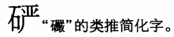

**Fig. 567. Hanyu Da Zidian v. 5 p. 2604**

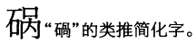

**Fig. 568. Hanyu Da Zidian v. 5 p. 2606**

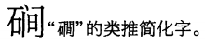

**Fig. 569. Hanyu Da Zidian v. 5 p. 2608**

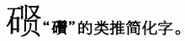

**Fig. 570. Hanyu Da Zidian v. 5 p. 2616**

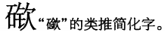

**Fig. 571. Hanyu Da Zidian v. 5 p. 2619**

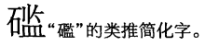

**Fig. 572. Hanyu Da Zidian v. 5 p. 2622**

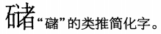

**Fig. 573. Hanyu Da Zidian v. 5 p. 2650**

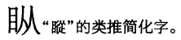

**Fig. 574. Hanyu Da Zidian v. 5 p. 2653**

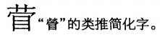

**Fig. 575. Hanyu Da Zidian v. 5 p. 2657**

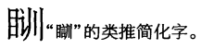

**Fig. 576. Hanyu Da Zidian v. 5 p. 2662**

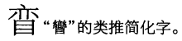

**Fig. 577. Hanyu Da Zidian v. 5 p. 2665**

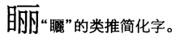

**Fig. 578. Hanyu Da Zidian v. 5 p. 2665**

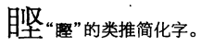

**Fig. 579. Hanyu Da Zidian v. 5 p. 2668**

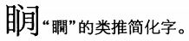

**Fig. 580. Hanyu Da Zidian v. 5 p. 2669**

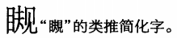

**Fig. 581. Hanyu Da Zidian v. 5 p. 2673**

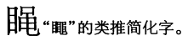

**Fig. 582. Hanyu Da Zidian v. 5 p. 2683**

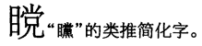

**Fig. 583. Hanyu Da Zidian v. 5 p. 2749**

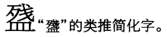

**Fig. 584. Hanyu Da Zidian v. 5 p. 2757**

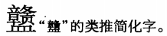

**Fig. 585. Hanyu Da Zidian v. 5 p. 2765**

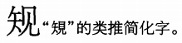

**Fig. 586. Hanyu Da Zidian v. 5 p. 2769**

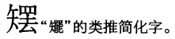

**Fig. 587. Hanyu Da Zidian v. 5 p. 2775**

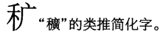

**Fig. 588. Hanyu Da Zidian v. 5 p. 2788**

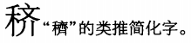

**Fig. 589. Hanyu Da Zidian v. 5 p. 2811**

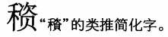

**Fig. 590. Hanyu Da Zidian v. 5 p. 2834**

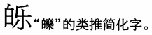

**Fig. 591. Hanyu Da Zidian v. 5 p. 2850**

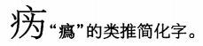

**Fig. 592. Hanyu Da Zidian v. 5 p. 2859**

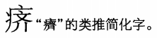

**Fig. 593. Hanyu Da Zidian v. 5 p. 2872**

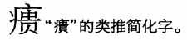

**Fig. 594. Hanyu Da Zidian v. 5 p. 2879**

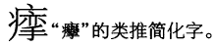

**Fig. 595. Hanyu Da Zidian v. 5 p. 2905**

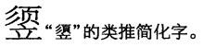

**Fig. 596. Hanyu Da Zidian v. 5 p. 2915**

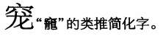

**Fig. 597. Hanyu Da Zidian v. 5 p. 2922**

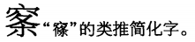

**Fig. 598. Hanyu Da Zidian v. 5 p. 2926**

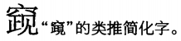

**Fig. 599. Hanyu Da Zidian v. 5 p. 2948**

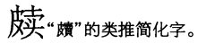

**Fig. 600. Hanyu Da Zidian v. 5 p. 2948**

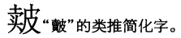

**Fig. 601. Hanyu Da Zidian v. 5 p. 3013**

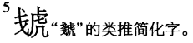

**Fig. 602. Hanyu Da Zidian v. 5 p. 3029**

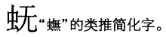

**Fig. 603. Hanyu Da Zidian v. 5 p. 3030**

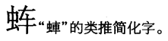

**Fig. 604. Hanyu Da Zidian v. 5 p. 3030**

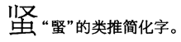

**Fig. 605. Hanyu Da Zidian v. 5 p. 3032**

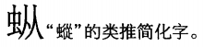

**Fig. 606. Hanyu Da Zidian v. 5 p. 3032**

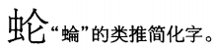

**Fig. 607. Hanyu Da Zidian v. 5 p. 3033**

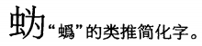

**Fig. 608. Hanyu Da Zidian v. 5 p. 3034**

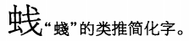

**Fig. 609. Hanyu Da Zidian v. 5 p. 3035**

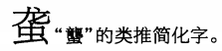

**Fig. 610. Hanyu Da Zidian v. 5 p. 3039**

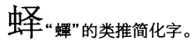

**Fig. 611. Hanyu Da Zidian v. 5 p. 3039**

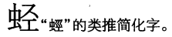

**Fig. 612. Hanyu Da Zidian v. 5 p. 3041**

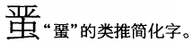

**Fig. 613. Hanyu Da Zidian v. 5 p. 3041**

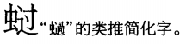

**Fig. 614. Hanyu Da Zidian v. 5 p. 3042**

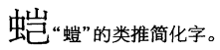

**Fig. 615. Hanyu Da Zidian v. 5 p. 3052**

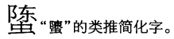

**Fig. 616. Hanyu Da Zidian v. 5 p. 3053**

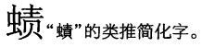

**Fig. 617. Hanyu Da Zidian v. 5 p. 3055**

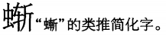

**Fig. 618. Hanyu Da Zidian v. 5 p. 3062**

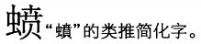

**Fig. 619. Hanyu Da Zidian v. 5 p. 3081**

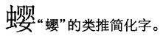

**Fig. 620. Hanyu Da Zidian v. 5 p. 3085**

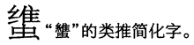

**Fig. 621. Hanyu Da Zidian v. 5 p. 3121**

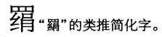

**Fig. 622. Hanyu Da Zidian v. 5 p. 3130**

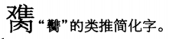

**Fig. 623. Hanyu Da Zidian v. 5 p. 3134**

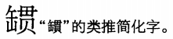

**Fig. 624. Hanyu Da Zidian v. 5 p. 3142**

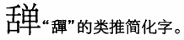

**Fig. 625. Hanyu Da Zidian v. 5 p. 3146**

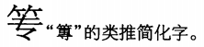

**Fig. 626. Hanyu Da Zidian v. 5 p. 3151**

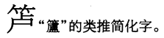

**Fig. 627. Hanyu Da Zidian v. 5 p. 3160**

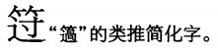

**Fig. 628. Hanyu Da Zidian v. 5 p. 3164**

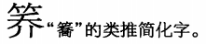

**Fig. 629. Hanyu Da Zidian v. 5 p. 3168**

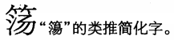

**Fig. 630. Hanyu Da Zidian v. 5 p. 3168**

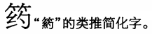

**Fig. 631. Hanyu Da Zidian v. 5 p. 3191**

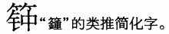

**Fig. 632. Hanyu Da Zidian v. 5 p. 3200**

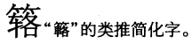

**Fig. 633. Hanyu Da Zidian v. 5 p. 3235**

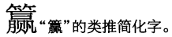

**Fig. 634. Hanyu Da Zidian v. 6 p. 3261**

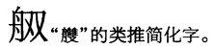

**Fig. 635. Hanyu Da Zidian v. 6 p. 3262**

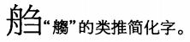

**Fig. 636. Hanyu Da Zidian v. 6 p. 3267**

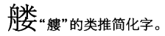

**Fig. 637. Hanyu Da Zidian v. 6 p. 3280**

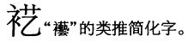

**Fig. 638. Hanyu Da Zidian v. 6 p. 3285**

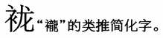

**Fig. 639. Hanyu Da Zidian v. 6 p. 3291**

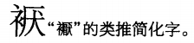

**Fig. 640. Hanyu Da Zidian v. 6 p. 3293**

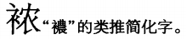

**Fig. 641. Hanyu Da Zidian v. 6 p. 3297**

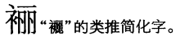

**Fig. 642. Hanyu Da Zidian v. 6 p. 3304**

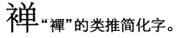

**Fig. 643. Hanyu Da Zidian v. 6 p. 3305**

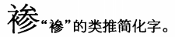

**Fig. 644. Hanyu Da Zidian v. 6 p. 3331**

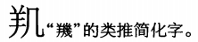

**Fig. 645. Hanyu Da Zidian v. 6 p. 3343**

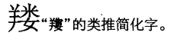

**Fig. 646. Hanyu Da Zidian v. 6 p. 3350**

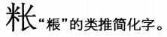

**Fig. 647. Hanyu Da Zidian v. 6 p. 3372**

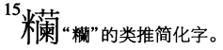

**Fig. 648. Hanyu Da Zidian v. 6 p. 3383**

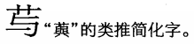

**Fig. 649. Hanyu Da Zidian v. 6 p. 3386**

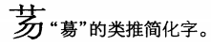

**Fig. 650. Hanyu Da Zidian v. 6 p. 3388**

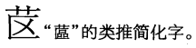

**Fig. 651. Hanyu Da Zidian v. 6 p. 3392**

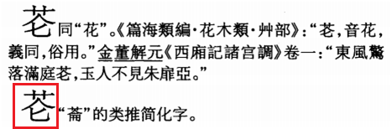

**Fig. 652. Hanyu Da Zidian v. 6 p. 3400**

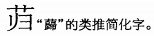

**Fig. 653. Hanyu Da Zidian v. 6 p. 3409**

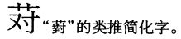

**Fig. 654. Hanyu Da Zidian v. 6 p. 3411**

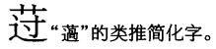

**Fig. 655. Hanyu Da Zidian v. 6 p. 3414**

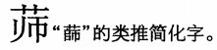

**Fig. 656. Hanyu Da Zidian v. 6 p. 3416**

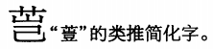

**Fig. 657. Hanyu Da Zidian v. 6 p. 3418**

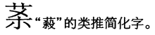

**Fig. 658. Hanyu Da Zidian v. 6 p. 3419**

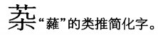

**Fig. 659. Hanyu Da Zidian v. 6 p. 3419**

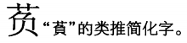

**Fig. 660. Hanyu Da Zidian v. 6 p. 3419**

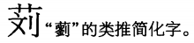

**Fig. 661. Hanyu Da Zidian v. 6 p. 3422**

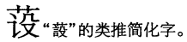

**Fig. 662. Hanyu Da Zidian v. 6 p. 3437**

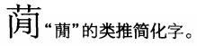

**Fig. 663. Hanyu Da Zidian v. 6 p. 3438**

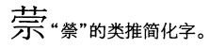

**Fig. 664. Hanyu Da Zidian v. 6 p. 3440**

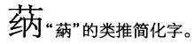

**Fig. 665. Hanyu Da Zidian v. 6 p. 3440**

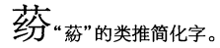

**Fig. 666. Hanyu Da Zidian v. 6 p. 3444**

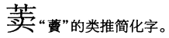

**Fig. 667. Hanyu Da Zidian v. 6 p. 3445**

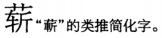

**Fig. 668. Hanyu Da Zidian v. 6 p. 3456**

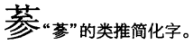

**Fig. 669. Hanyu Da Zidian v. 6 p. 3456**

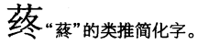

**Fig. 670. Hanyu Da Zidian v. 6 p. 3457**

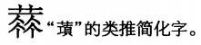

The wrong glyph is used for this character in the head entry and indexes.

**Fig. 671. Hanyu Da Zidian v. 6 p. 3457**

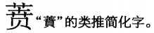

**Fig. 672. Hanyu Da Zidian v. 6 p. 3465**

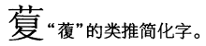

**Fig. 673. Hanyu Da Zidian v. 6 p. 3479**

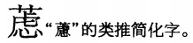

**Fig. 674. Hanyu Da Zidian v. 6 p. 3480**

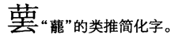

**Fig. 675. Hanyu Da Zidian v. 6 p. 3492**

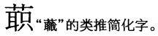

**Fig. 676. Hanyu Da Zidian v. 6 p. 3519**

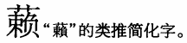

**Fig. 677. Hanyu Da Zidian v. 6 p. 3549**

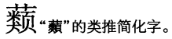

**Fig. 678. Hanyu Da Zidian v. 6 p. 3555**

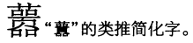

**Fig. 679. Hanyu Da Zidian v. 6 p. 3568**

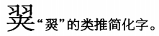

**Fig. 680. Hanyu Da Zidian v. 6 p. 3569**

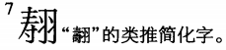

**Fig. 681. Hanyu Da Zidian v. 6 p. 3592**

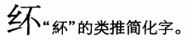

**Fig. 682. Hanyu Da Zidian v. 6 p. 3596**

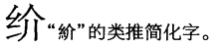

**Fig. 683. Hanyu Da Zidian v. 6 p. 3601**

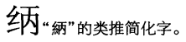

**Fig. 684. Hanyu Da Zidian v. 6 p. 3606**

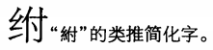

**Fig. 685. Hanyu Da Zidian v. 6 p. 3607**

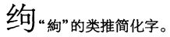

**Fig. 686. Hanyu Da Zidian v. 6 p. 3608**

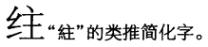

**Fig. 687. Hanyu Da Zidian v. 6 p. 3608**

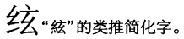

**Fig. 688. Hanyu Da Zidian v. 6 p. 3609**

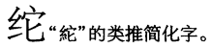

**Fig. 689. Hanyu Da Zidian v. 6 p. 3610**

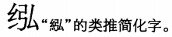

**Fig. 690. Hanyu Da Zidian v. 6 p. 3615**

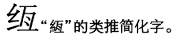

**Fig. 691. Hanyu Da Zidian v. 6 p. 3615**

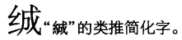

**Fig. 692. Hanyu Da Zidian v. 6 p. 3615**

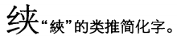

**Fig. 693. Hanyu Da Zidian v. 6 p. 3615**

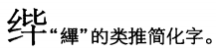

**Fig. 694. Hanyu Da Zidian v. 6 p. 3617**

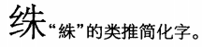

**Fig. 695. Hanyu Da Zidian v. 6 p. 3617**

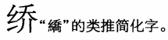

**Fig. 696. Hanyu Da Zidian v. 6 p. 3620**

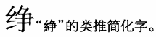

**Fig. 697. Hanyu Da Zidian v. 6 p. 3622**

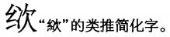

**Fig. 698. Hanyu Da Zidian v. 6 p. 3623**

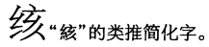

**Fig. 699. Hanyu Da Zidian v. 6 p. 3624**

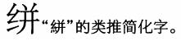

**Fig. 700. Hanyu Da Zidian v. 6 p. 3626**

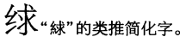

**Fig. 701. Hanyu Da Zidian v. 6 p. 3626**

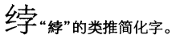

**Fig. 702. Hanyu Da Zidian v. 6 p. 3627**

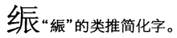

**Fig. 703. Hanyu Da Zidian v. 6 p. 3630**

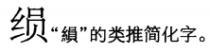

**Fig. 704. Hanyu Da Zidian v. 6 p. 3632**

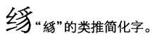

**Fig. 705. Hanyu Da Zidian v. 6 p. 3632**

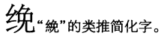

**Fig. 706. Hanyu Da Zidian v. 6 p. 3632**

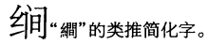

**Fig. 707. Hanyu Da Zidian v. 6 p. 3633**

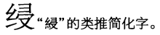

**Fig. 708. Hanyu Da Zidian v. 6 p. 3636**

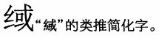

**Fig. 709. Hanyu Da Zidian v. 6 p. 3636**

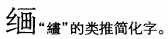

**Fig. 710. Hanyu Da Zidian v. 6 p. 3638**

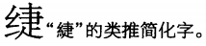

**Fig. 711. Hanyu Da Zidian v. 6 p. 3638**

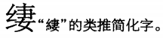

**Fig. 712. Hanyu Da Zidian v. 6 p. 3640**

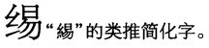

**Fig. 713. Hanyu Da Zidian v. 6 p. 3642**

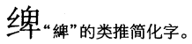

**Fig. 714. Hanyu Da Zidian v. 6 p. 3643**

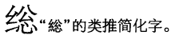

**Fig. 715. Hanyu Da Zidian v. 6 p. 3644**

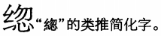

**Fig. 716. Hanyu Da Zidian v. 6 p. 3646**

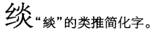

**Fig. 717. Hanyu Da Zidian v. 6 p. 3648**

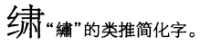

**Fig. 718. Hanyu Da Zidian v. 6 p. 3648**

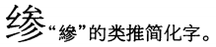

**Fig. 719. Hanyu Da Zidian v. 6 p. 3649**

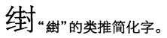

**Fig. 720. Hanyu Da Zidian v. 6 p. 3652**

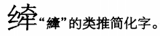

**Fig. 721. Hanyu Da Zidian v. 6 p. 3657**

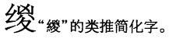

**Fig. 722. Hanyu Da Zidian v. 6 p. 3657**

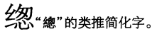

**Fig. 723. Hanyu Da Zidian v. 6 p. 3658**

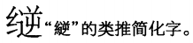

**Fig. 724. Hanyu Da Zidian v. 6 p. 3662**

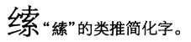

**Fig. 725. Hanyu Da Zidian v. 6 p. 3663**

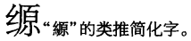

**Fig. 726. Hanyu Da Zidian v. 6 p. 3663**

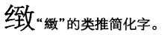

**Fig. 727. Hanyu Da Zidian v. 6 p. 3668**

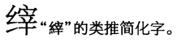

**Fig. 728. Hanyu Da Zidian v. 6 p. 3677**

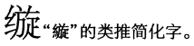

**Fig. 729. Hanyu Da Zidian v. 6 p. 3678**

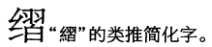

**Fig. 730. Hanyu Da Zidian v. 6 p. 3680**

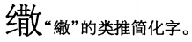

**Fig. 731. Hanyu Da Zidian v. 6 p. 3680**

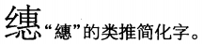

**Fig. 732. Hanyu Da Zidian v. 6 p. 3682**

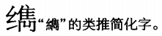

**Fig. 733. Hanyu Da Zidian v. 6 p. 3684**

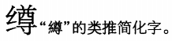

**Fig. 734. Hanyu Da Zidian v. 6 p. 3685**

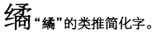

**Fig. 735. Hanyu Da Zidian v. 6 p. 3687**

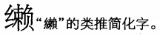

**Fig. 736. Hanyu Da Zidian v. 6 p. 3691**

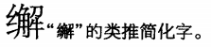

**Fig. 737. Hanyu Da Zidian v. 6 p. 3693**

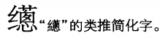

**Fig. 738. Hanyu Da Zidian v. 6 p. 3694**

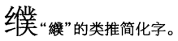

**Fig. 739. Hanyu Da Zidian v. 6 p. 3696**

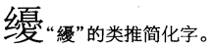

**Fig. 740. Hanyu Da Zidian v. 6 p. 3715**

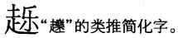

**Fig. 741. Hanyu Da Zidian v. 6 p. 3717**

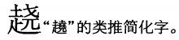

**Fig. 742. Hanyu Da Zidian v. 6 p. 3717**

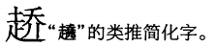

**Fig. 743. Hanyu Da Zidian v. 6 p. 3723**

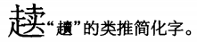

**Fig. 744. Hanyu Da Zidian v. 6 p. 3746**

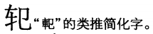

**Fig. 745. Hanyu Da Zidian v. 6 p. 3748**

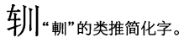

**Fig. 746. Hanyu Da Zidian v. 6 p. 3749**

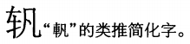

**Fig. 747. Hanyu Da Zidian v. 6 p. 3749**

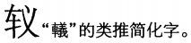

**Fig. 748. Hanyu Da Zidian v. 6 p. 3749**

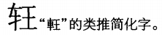

**Fig. 749. Hanyu Da Zidian v. 6 p. 3749**

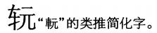

**Fig. 750. Hanyu Da Zidian v. 6 p. 3750**

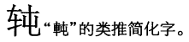

**Fig. 751. Hanyu Da Zidian v. 6 p. 3751**

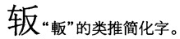

**Fig. 752. Hanyu Da Zidian v. 6 p. 3752**

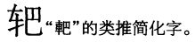

**Fig. 753. Hanyu Da Zidian v. 6 p. 3752**

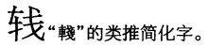

**Fig. 754. Hanyu Da Zidian v. 6 p. 3753**

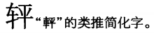

**Fig. 755. Hanyu Da Zidian v. 6 p. 3753**

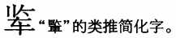

**Fig. 756. Hanyu Da Zidian v. 6 p. 3756**

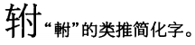

**Fig. 757. Hanyu Da Zidian v. 6 p. 3757**

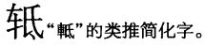

**Fig. 758. Hanyu Da Zidian v. 6 p. 3758**

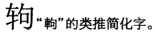

**Fig. 759. Hanyu Da Zidian v. 6 p. 3758**

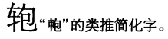

**Fig. 760. Hanyu Da Zidian v. 6 p. 3759**

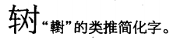

**Fig. 761. Hanyu Da Zidian v. 6 p. 3762**

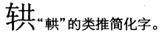

**Fig. 762. Hanyu Da Zidian v. 6 p. 3763**

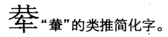

**Fig. 763. Hanyu Da Zidian v. 6 p. 3764**

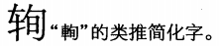

**Fig. 764. Hanyu Da Zidian v. 6 p. 3771**

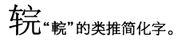

**Fig. 765. Hanyu Da Zidian v. 6 p. 3771**

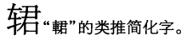

**Fig. 766. Hanyu Da Zidian v. 6 p. 3771**

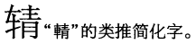

**Fig. 767. Hanyu Da Zidian v. 6 p. 3772**

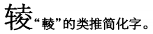

**Fig. 768. Hanyu Da Zidian v. 6 p. 3772**

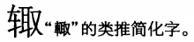

**Fig. 769. Hanyu Da Zidian v. 6 p. 3772**

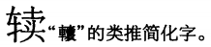

**Fig. 770. Hanyu Da Zidian v. 6 p. 3773**

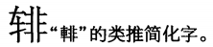

**Fig. 771. Hanyu Da Zidian v. 6 p. 3774**

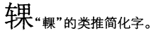

**Fig. 772. Hanyu Da Zidian v. 6 p. 3776**

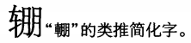

**Fig. 773. Hanyu Da Zidian v. 6 p. 3777**

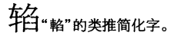

**Fig. 774. Hanyu Da Zidian v. 6 p. 3778**

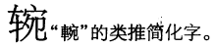

**Fig. 775. Hanyu Da Zidian v. 6 p. 3780**

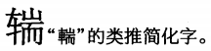

**Fig. 776. Hanyu Da Zidian v. 6 p. 3781**

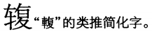

**Fig. 777. Hanyu Da Zidian v. 6 p. 3783**

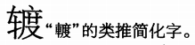

**Fig. 778. Hanyu Da Zidian v. 6 p. 3784**

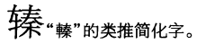

**Fig. 779. Hanyu Da Zidian v. 6 p. 3785**

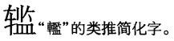

**Fig. 780. Hanyu Da Zidian v. 6 p. 3788**

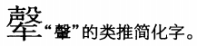

**Fig. 781. Hanyu Da Zidian v. 6 p. 3789**

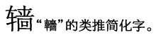

**Fig. 782. Hanyu Da Zidian v. 6 p. 3792**

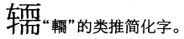

**Fig. 783. Hanyu Da Zidian v. 6 p. 3793**

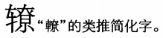

**Fig. 784. Hanyu Da Zidian v. 6 p. 3794**

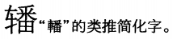

**Fig. 785. Hanyu Da Zidian v. 6 p. 3794**

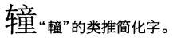

**Fig. 786. Hanyu Da Zidian v. 6 p. 3795**

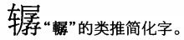

**Fig. 787. Hanyu Da Zidian v. 6 p. 3795**

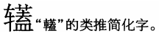

**Fig. 788. Hanyu Da Zidian v. 6 p. 3795**

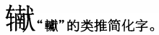

**Fig. 789. Hanyu Da Zidian v. 6 p. 3795**

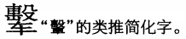

**Fig. 790. Hanyu Da Zidian v. 6 p. 3797**

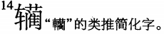

**Fig. 791. Hanyu Da Zidian v. 6 p. 3798**

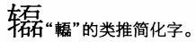

**Fig. 792. Hanyu Da Zidian v. 6 p. 3798**

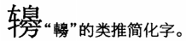

**Fig. 793. Hanyu Da Zidian v. 6 p. 3817**

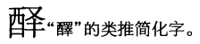

**Fig. 794. Hanyu Da Zidian v. 6 p. 3831**

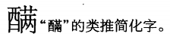

**Fig. 795. Hanyu Da Zidian v. 6 p. 3832**

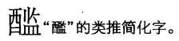

**Fig. 796. Hanyu Da Zidian v. 6 p. 3847**

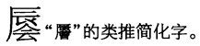

**Fig. 797. Hanyu Da Zidian v. 6 p. 3855**

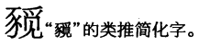

**Fig. 798. Hanyu Da Zidian v. 6 p. 3857**

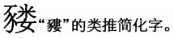

**Fig. 799. Hanyu Da Zidian v. 7 p. 3864**

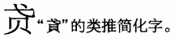

**Fig. 800. Hanyu Da Zidian v. 7 p. 3866**

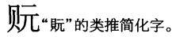

**Fig. 801. Hanyu Da Zidian v. 7 p. 3874**

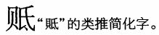

**Fig. 802. Hanyu Da Zidian v. 7 p. 3891**

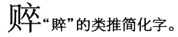

**Fig. 803. Hanyu Da Zidian v. 7 p. 3892**

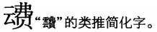

**Fig. 804. Hanyu Da Zidian v. 7 p. 3894**

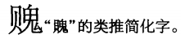

**Fig. 805. Hanyu Da Zidian v. 7 p. 3895**

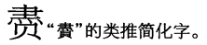

**Fig. 806. Hanyu Da Zidian v. 7 p. 3896**

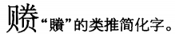

**Fig. 807. Hanyu Da Zidian v. 7 p. 3896**

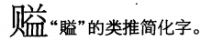

**Fig. 808. Hanyu Da Zidian v. 7 p. 3899**

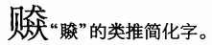

**Fig. 809. Hanyu Da Zidian v. 7 p. 3901**

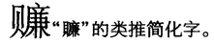

**Fig. 810. Hanyu Da Zidian v. 7 p. 3902**

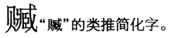

**Fig. 811. Hanyu Da Zidian v. 7 p. 3903**

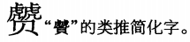

**Fig. 812. Hanyu Da Zidian v. 7 p. 3909**

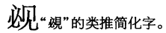

**Fig. 813. Hanyu Da Zidian v. 7 p. 3911**

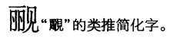

**Fig. 814. Hanyu Da Zidian v. 7 p. 3911**

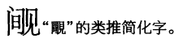

**Fig. 815. Hanyu Da Zidian v. 7 p. 3915**

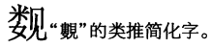

**Fig. 816. Hanyu Da Zidian v. 7 p. 3917**

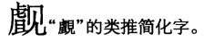

**Fig. 817. Hanyu Da Zidian v. 7 p. 3918**

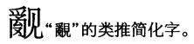

**Fig. 818. Hanyu Da Zidian v. 7 p. 3918**

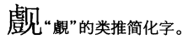

**Fig. 819. Hanyu Da Zidian v. 7 p. 3936**

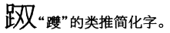

**Fig. 820. Hanyu Da Zidian v. 7 p. 3946**

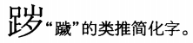

**Fig. 821. Hanyu Da Zidian v. 7 p. 3952**

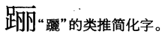

**Fig. 822. Hanyu Da Zidian v. 7 p. 3952**

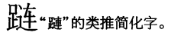

**Fig. 823. Hanyu Da Zidian v. 7 p. 3967**

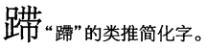

**Fig. 824. Hanyu Da Zidian v. 7 p. 3967**

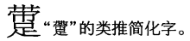

**Fig. 825. Hanyu Da Zidian v. 7 p. 3968**

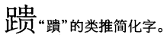

**Fig. 826. Hanyu Da Zidian v. 7 p. 4005**

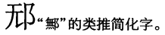

**Fig. 827. Hanyu Da Zidian v. 7 p. 4008**

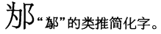

**Fig. 828. Hanyu Da Zidian v. 7 p. 4030**

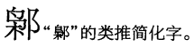

**Fig. 829. Hanyu Da Zidian v. 7 p. 4035**

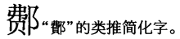

**Fig. 830. Hanyu Da Zidian v. 7 p. 4064**

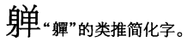

**Fig. 831. Hanyu Da Zidian v. 7 p. 4070**

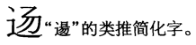

**Fig. 832. Hanyu Da Zidian v. 7 p. 4082**

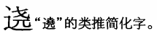

**Fig. 833. Hanyu Da Zidian v. 7 p. 4112**

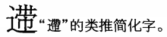

**Fig. 834. Hanyu Da Zidian v. 7 p. 4159**

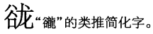

**Fig. 835. Hanyu Da Zidian v. 7 p. 4160**

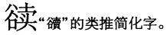

**Fig. 836. Hanyu Da Zidian v. 7 p. 4179**

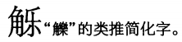

**Fig. 837. Hanyu Da Zidian v. 7 p. 4180**

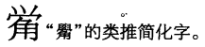

**Fig. 838. Hanyu Da Zidian v. 7 p. 4184**

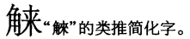

**Fig. 839. Hanyu Da Zidian v. 7 p. 4185**

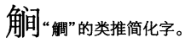

**Fig. 840. Hanyu Da Zidian v. 7 p. 4189**

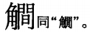

**Fig. 841. Hanyu Da Zidian v. 7 p. 4196**

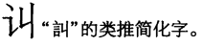

**Fig. 842. Hanyu Da Zidian v. 7 p. 4201**

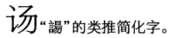

**Fig. 843. Hanyu Da Zidian v. 7 p. 4202**

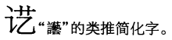

**Fig. 844. Hanyu Da Zidian v. 7 p. 4202**

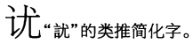

**Fig. 845. Hanyu Da Zidian v. 7 p. 4203**

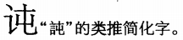

**Fig. 846. Hanyu Da Zidian v. 7 p. 4203**

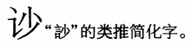

**Fig. 847. Hanyu Da Zidian v. 7 p. 4206**

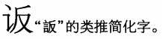

**Fig. 848. Hanyu Da Zidian v. 7 p. 4208**

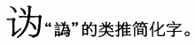

**Fig. 849. Hanyu Da Zidian v. 7 p. 4208**

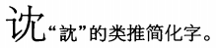

**Fig. 850. Hanyu Da Zidian v. 7 p. 4210**

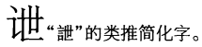

**Fig. 851. Hanyu Da Zidian v. 7 p. 4210**

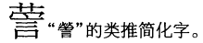

**Fig. 852. Hanyu Da Zidian v. 7 p. 4210**

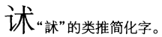

**Fig. 853. Hanyu Da Zidian v. 7 p. 4212**

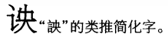

**Fig. 854. Hanyu Da Zidian v. 7 p. 4212**

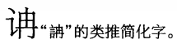

**Fig. 855. Hanyu Da Zidian v. 7 p. 4212**

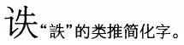

**Fig. 856. Hanyu Da Zidian v. 7 p. 4214**

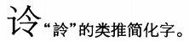

**Fig. 857. Hanyu Da Zidian v. 7 p. 4215**

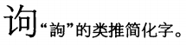

**Fig. 858. Hanyu Da Zidian v. 7 p. 4215**

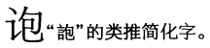

**Fig. 859. Hanyu Da Zidian v. 7 p. 4216**

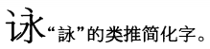

**Fig. 860. Hanyu Da Zidian v. 7 p. 4217**

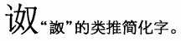

**Fig. 861. Hanyu Da Zidian v. 7 p. 4218**

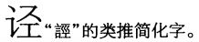

**Fig. 862. Hanyu Da Zidian v. 7 p. 4222**

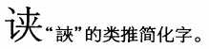

**Fig. 863. Hanyu Da Zidian v. 7 p. 4226**

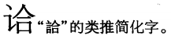

**Fig. 864. Hanyu Da Zidian v. 7 p. 4228**

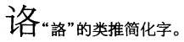

**Fig. 865. Hanyu Da Zidian v. 7 p. 4229**

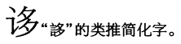

**Fig. 866. Hanyu Da Zidian v. 7 p. 4229**

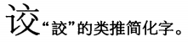

**Fig. 867. Hanyu Da Zidian v. 7 p. 4234**

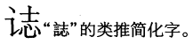

**Fig. 868. Hanyu Da Zidian v. 7 p. 4234**

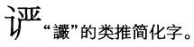

**Fig. 869. Hanyu Da Zidian v. 7 p. 4235**

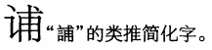

**Fig. 870. Hanyu Da Zidian v. 7 p. 4235**

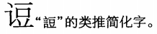

**Fig. 871. Hanyu Da Zidian v. 7 p. 4237**

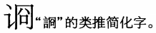

**Fig. 872. Hanyu Da Zidian v. 7 p. 4237**

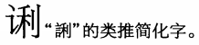

**Fig. 873. Hanyu Da Zidian v. 7 p. 4243**

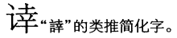

**Fig. 874. Hanyu Da Zidian v. 7 p. 4244**

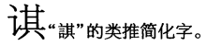

**Fig. 875. Hanyu Da Zidian v. 7 p. 4245**

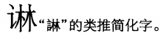

**Fig. 876. Hanyu Da Zidian v. 7 p. 4246**

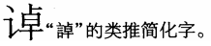

**Fig. 877. Hanyu Da Zidian v. 7 p. 4247**

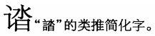

**Fig. 878. Hanyu Da Zidian v. 7 p. 4248**

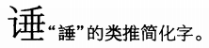

**Fig. 879. Hanyu Da Zidian v. 7 p. 4248**

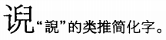

**Fig. 880. Hanyu Da Zidian v. 7 p. 4255**

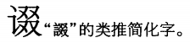

**Fig. 881. Hanyu Da Zidian v. 7 p. 4267**

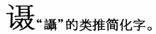

**Fig. 882. Hanyu Da Zidian v. 7 p. 4268**

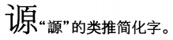

**Fig. 883. Hanyu Da Zidian v. 7 p. 4270**

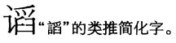

**Fig. 884. Hanyu Da Zidian v. 7 p. 4270**

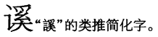

**Fig. 885. Hanyu Da Zidian v. 7 p. 4271**

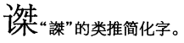

**Fig. 886. Hanyu Da Zidian v. 7 p. 4271**

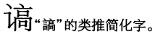

**Fig. 887. Hanyu Da Zidian v. 7 p. 4275**

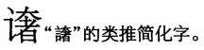

**Fig. 888. Hanyu Da Zidian v. 7 p. 4275**

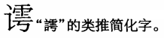

**Fig. 889. Hanyu Da Zidian v. 7 p. 4277**

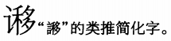

**Fig. 890. Hanyu Da Zidian v. 7 p. 4277**

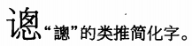

**Fig. 891. Hanyu Da Zidian v. 7 p. 4279**

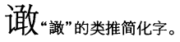

**Fig. 892. Hanyu Da Zidian v. 7 p. 4279**

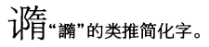

**Fig. 893. Hanyu Da Zidian v. 7 p. 4279**

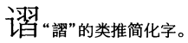

**Fig. 894. Hanyu Da Zidian v. 7 p. 4283**

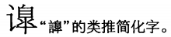

**Fig. 895. Hanyu Da Zidian v. 7 p. 4286**

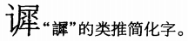

**Fig. 896. Hanyu Da Zidian v. 7 p. 4290**

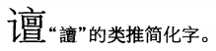

**Fig. 897. Hanyu Da Zidian v. 7 p. 4290**

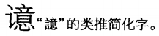

**Fig. 898. Hanyu Da Zidian v. 7 p. 4291**

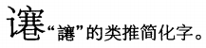

**Fig. 899. Hanyu Da Zidian v. 7 p. 4292**

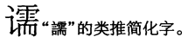

**Fig. 900. Hanyu Da Zidian v. 7 p. 4293**

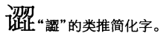

**Fig. 901. Hanyu Da Zidian v. 7 p. 4294**

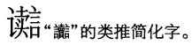

**Fig. 902. Hanyu Da Zidian v. 7 p. 4326**

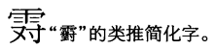

**Fig. 903. Hanyu Da Zidian v. 7 p. 4334**

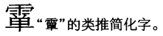

**Fig. 904. Hanyu Da Zidian v. 7 p. 4361**

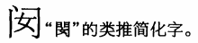

**Fig. 905. Hanyu Da Zidian v. 7 p. 4364**

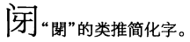

**Fig. 906. Hanyu Da Zidian v. 7 p. 4367**

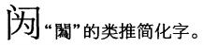

**Fig. 907. Hanyu Da Zidian v. 7 p. 4368**

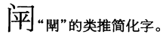

**Fig. 908. Hanyu Da Zidian v. 7 p. 4377**

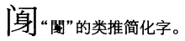

**Fig. 909. Hanyu Da Zidian v. 7 p. 4382**

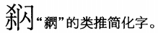

**Fig. 910. Hanyu Da Zidian v. 7 p. 4386**

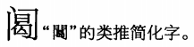

**Fig. 911. Hanyu Da Zidian v. 7 p. 4386**

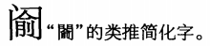

**Fig. 912. Hanyu Da Zidian v. 7 p. 4391**

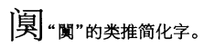

**Fig. 913. Hanyu Da Zidian v. 7 p. 4393**

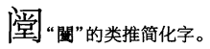

**Fig. 914. Hanyu Da Zidian v. 7 p. 4397**

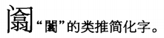

**Fig. 915. Hanyu Da Zidian v. 7 p. 4399**

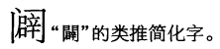

**Fig. 916. Hanyu Da Zidian v. 7 p. 4444**

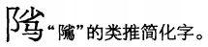

**Fig. 917. Hanyu Da Zidian v. 7 p. 4456**

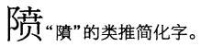

**Fig. 918. Hanyu Da Zidian v. 8 p. 4488**

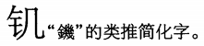

**Fig. 919. Hanyu Da Zidian v. 8 p. 4488**

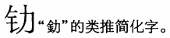

**Fig. 920. Hanyu Da Zidian v. 8 p. 4489**

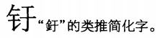

**Fig. 921. Hanyu Da Zidian v. 8 p. 4490**

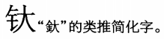

**Fig. 922. Hanyu Da Zidian v. 8 p. 4490**

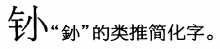

**Fig. 923. Hanyu Da Zidian v. 8 p. 4492**

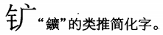

**Fig. 924. Hanyu Da Zidian v. 8 p. 4493**

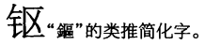

**Fig. 925. Hanyu Da Zidian v. 8 p. 4493**

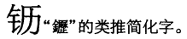

**Fig. 926. Hanyu Da Zidian v. 8 p. 4495**

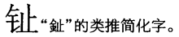

**Fig. 927. Hanyu Da Zidian v. 8 p. 4495**

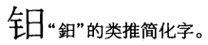

**Fig. 928. Hanyu Da Zidian v. 8 p. 4496**

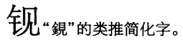

**Fig. 929. Hanyu Da Zidian v. 8 p. 4501**

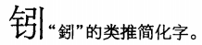

**Fig. 930. Hanyu Da Zidian v. 8 p. 4504**

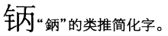

**Fig. 931. Hanyu Da Zidian v. 8 p. 4504**

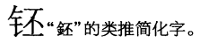

**Fig. 932. Hanyu Da Zidian v. 8 p. 4504**

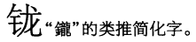

**Fig. 933. Hanyu Da Zidian v. 8 p. 4507**

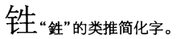

**Fig. 934. Hanyu Da Zidian v. 8 p. 4507**

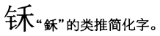

**Fig. 935. Hanyu Da Zidian v. 8 p. 4508**

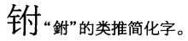

**Fig. 936. Hanyu Da Zidian v. 8 p. 4510**

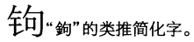

**Fig. 937. Hanyu Da Zidian v. 8 p. 4511**

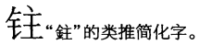

**Fig. 938. Hanyu Da Zidian v. 8 p. 4513**

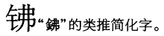

**Fig. 939. Hanyu Da Zidian v. 8 p. 4515**

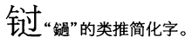

**Fig. 940. Hanyu Da Zidian v. 8 p. 4516**

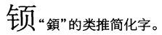

**Fig. 941. Hanyu Da Zidian v. 8 p. 4516**

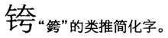

**Fig. 942. Hanyu Da Zidian v. 8 p. 4517**

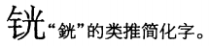

**Fig. 943. Hanyu Da Zidian v. 8 p. 4517**

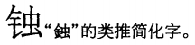

**Fig. 944. Hanyu Da Zidian v. 8 p. 4518**

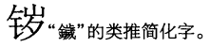

**Fig. 945. Hanyu Da Zidian v. 8 p. 4520**

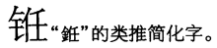

**Fig. 946. Hanyu Da Zidian v. 8 p. 4521**

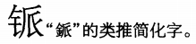

**Fig. 947. Hanyu Da Zidian v. 8 p. 4522**

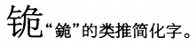

**Fig. 948. Hanyu Da Zidian v. 8 p. 4523**

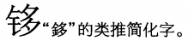

**Fig. 949. Hanyu Da Zidian v. 8 p. 4525**

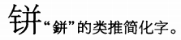

**Fig. 950. Hanyu Da Zidian v. 8 p. 4527**

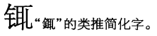

**Fig. 951. Hanyu Da Zidian v. 8 p. 4527**

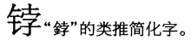

**Fig. 952. Hanyu Da Zidian v. 8 p. 4531**

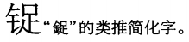

**Fig. 953. Hanyu Da Zidian v. 8 p. 4532**

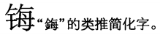

**Fig. 954. Hanyu Da Zidian v. 8 p. 4533**

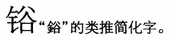

**Fig. 955. Hanyu Da Zidian v. 8 p. 4533**

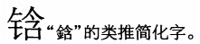

**Fig. 956. Hanyu Da Zidian v. 8 p. 4535**

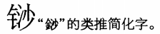

**Fig. 957. Hanyu Da Zidian v. 8 p. 4536**

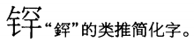

**Fig. 958. Hanyu Da Zidian v. 8 p. 4541**

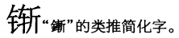

**Fig. 959. Hanyu Da Zidian v. 8 p. 4544**

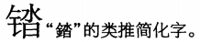

**Fig. 960. Hanyu Da Zidian v. 8 p. 4546**

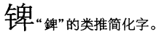

**Fig. 961. Hanyu Da Zidian v. 8 p. 4547**

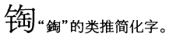

**Fig. 962. Hanyu Da Zidian v. 8 p. 4549**

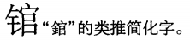

**Fig. 963. Hanyu Da Zidian v. 8 p. 4552**

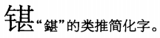

**Fig. 964. Hanyu Da Zidian v. 8 p. 4553**

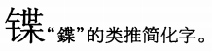

**Fig. 965. Hanyu Da Zidian v. 8 p. 4553**

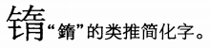

**Fig. 966. Hanyu Da Zidian v. 8 p. 4554**

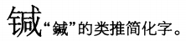

**Fig. 967. Hanyu Da Zidian v. 8 p. 4554**

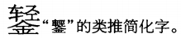

**Fig. 968. Hanyu Da Zidian v. 8 p. 4555**

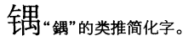

**Fig. 969. Hanyu Da Zidian v. 8 p. 4556**

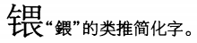

**Fig. 970. Hanyu Da Zidian v. 8 p. 4558**

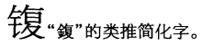

**Fig. 971. Hanyu Da Zidian v. 8 p. 4560**

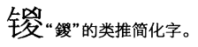

**Fig. 972. Hanyu Da Zidian v. 8 p. 4560**

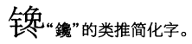

**Fig. 973. Hanyu Da Zidian v. 8 p. 4560**

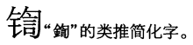

**Fig. 974. Hanyu Da Zidian v. 8 p. 4561**

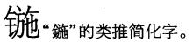

**Fig. 975. Hanyu Da Zidian v. 8 p. 4562**

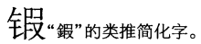

**Fig. 976. Hanyu Da Zidian v. 8 p. 4562**

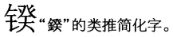

**Fig. 977. Hanyu Da Zidian v. 8 p. 4563**

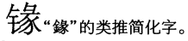

**Fig. 978. Hanyu Da Zidian v. 8 p. 4563**

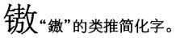

**Fig. 979. Hanyu Da Zidian v. 8 p. 4566**

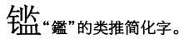

**Fig. 980. Hanyu Da Zidian v. 8 p. 4569**

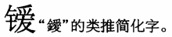

**Fig. 981. Hanyu Da Zidian v. 8 p. 4571**

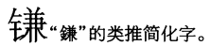

**Fig. 982. Hanyu Da Zidian v. 8 p. 4576**

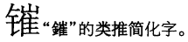

**Fig. 983. Hanyu Da Zidian v. 8 p. 4576**

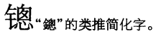

**Fig. 984. Hanyu Da Zidian v. 8 p. 4580**

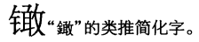

**Fig. 985. Hanyu Da Zidian v. 8 p. 4582**

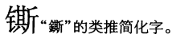

**Fig. 986. Hanyu Da Zidian v. 8 p. 4582**

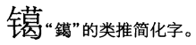

**Fig. 987. Hanyu Da Zidian v. 8 p. 4582**

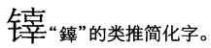

**Fig. 988. Hanyu Da Zidian v. 8 p. 4583**

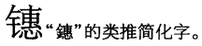

**Fig. 989. Hanyu Da Zidian v. 8 p. 4584**

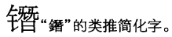

**Fig. 990. Hanyu Da Zidian v. 8 p. 4585**

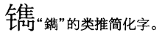

**Fig. 991. Hanyu Da Zidian v. 8 p. 4587**

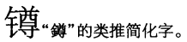

**Fig. 992. Hanyu Da Zidian v. 8 p. 4588**

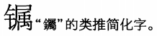

**Fig. 993. Hanyu Da Zidian v. 8 p. 4588**

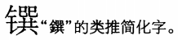

**Fig. 994. Hanyu Da Zidian v. 8 p. 4590**

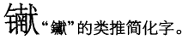

**Fig. 995. Hanyu Da Zidian v. 8 p. 4594**

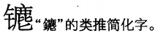

**Fig. 996. Hanyu Da Zidian v. 8 p. 4595**

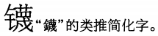

**Fig. 997. Hanyu Da Zidian v. 8 p. 4596**

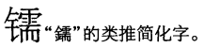

**Fig. 998. Hanyu Da Zidian v. 8 p. 4598**

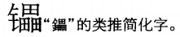

**Fig. 999. Hanyu Da Zidian v. 8 p. 4599**

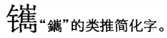

**Fig. 1000. Hanyu Da Zidian v. 8 p. 4601**

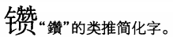

**Fig. 1001. Hanyu Da Zidian v. 8 p. 4601**

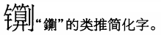

**Fig. 1002. Hanyu Da Zidian v. 8 p. 4603**

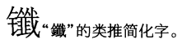

**Fig. 1003. Hanyu Da Zidian v. 8 p. 4604**

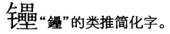

**Fig. 1004. Hanyu Da Zidian v. 8 p. 4606**

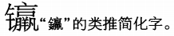

**Fig. 1005. Hanyu Da Zidian v. 8 p. 4612**

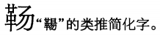

**Fig. 1006. Hanyu Da Zidian v. 8 p. 4618**

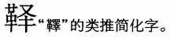

**Fig. 1007. Hanyu Da Zidian v. 8 p. 4619**

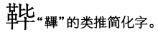

**Fig. 1008. Hanyu Da Zidian v. 8 p. 4624**

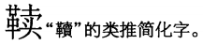

**Fig. 1009. Hanyu Da Zidian v. 8 p. 4629**

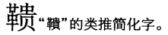

**Fig. 1010. Hanyu Da Zidian v. 8 p. 4631**

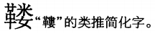

**Fig. 1011. Hanyu Da Zidian v. 8 p. 4637**

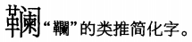

**Fig. 1012. Hanyu Da Zidian v. 8 p. 4639**

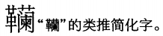

**Fig. 1013. Hanyu Da Zidian v. 8 p. 4644**

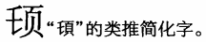

**Fig. 1014. Hanyu Da Zidian v. 8 p. 4653**

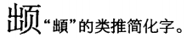

**Fig. 1015. Hanyu Da Zidian v. 8 p. 4655**

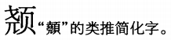

**Fig. 1016. Hanyu Da Zidian v. 8 p. 4655**

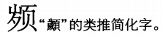

**Fig. 1017. Hanyu Da Zidian v. 8 p. 4657**

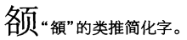

**Fig. 1018. Hanyu Da Zidian v. 8 p. 4658**

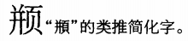

**Fig. 1019. Hanyu Da Zidian v. 8 p. 4660**

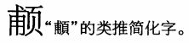

**Fig. 1020. Hanyu Da Zidian v. 8 p. 4663**

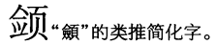

**Fig. 1021. Hanyu Da Zidian v. 8 p. 4665**

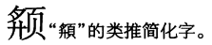

**Fig. 1022. Hanyu Da Zidian v. 8 p. 4667**

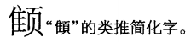

**Fig. 1023. Hanyu Da Zidian v. 8 p. 4667**

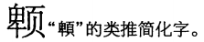

**Fig. 1024. Hanyu Da Zidian v. 8 p. 4669**

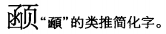

**Fig. 1025. Hanyu Da Zidian v. 8 p. 4671**

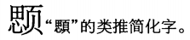

**Fig. 1026. Hanyu Da Zidian v. 8 p. 4671**

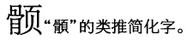

**Fig. 1027. Hanyu Da Zidian v. 8 p. 4674**

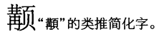

**Fig. 1028. Hanyu Da Zidian v. 8 p. 4676**

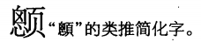

**Fig. 1029. Hanyu Da Zidian v. 8 p. 4676**

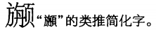

**Fig. 1030. Hanyu Da Zidian v. 8 p. 4677**

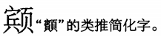

**Fig. 1031. Hanyu Da Zidian v. 8 p. 4678**

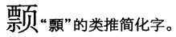

**Fig. 1032. Hanyu Da Zidian v. 8 p. 4694**

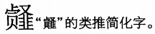

**Fig. 1033. Hanyu Da Zidian v. 8 p. 4699**

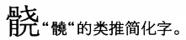

**Fig. 1034. Hanyu Da Zidian v. 8 p. 4715**

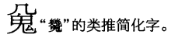

**Fig. 1035. Hanyu Da Zidian v. 8 p. 4720**

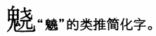

**Fig. 1036. Hanyu Da Zidian v. 8 p. 4721**

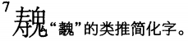

**Fig. 1037. Hanyu Da Zidian v. 8 p. 4731**

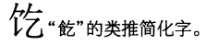

**Fig. 1038. Hanyu Da Zidian v. 8 p. 4732**

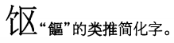

**Fig. 1039. Hanyu Da Zidian v. 8 p. 4735**

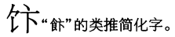

**Fig. 1040. Hanyu Da Zidian v. 8 p. 4736**

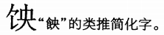

**Fig. 1041. Hanyu Da Zidian v. 8 p. 4739**

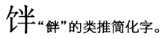

**Fig. 1042. Hanyu Da Zidian v. 8 p. 4741**

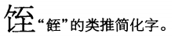

**Fig. 1043. Hanyu Da Zidian v. 8 p. 4742**

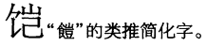

**Fig. 1044. Hanyu Da Zidian v. 8 p. 4749**

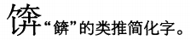

**Fig. 1045. Hanyu Da Zidian v. 8 p. 4751**

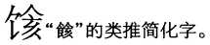

**Fig. 1046. Hanyu Da Zidian v. 8 p. 4752**

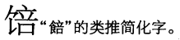

**Fig. 1047. Hanyu Da Zidian v. 8 p. 4752**

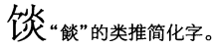

**Fig. 1048. Hanyu Da Zidian v. 8 p. 4753**

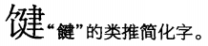

**Fig. 1049. Hanyu Da Zidian v. 8 p. 4754**

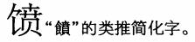

**Fig. 1050. Hanyu Da Zidian v. 8 p. 4756**

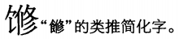

**Fig. 1051. Hanyu Da Zidian v. 8 p. 4757**

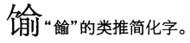

**Fig. 1052. Hanyu Da Zidian v. 8 p. 4757**

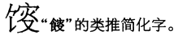

**Fig. 1053. Hanyu Da Zidian v. 8 p. 4758**

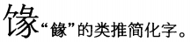

**Fig. 1054. Hanyu Da Zidian v. 8 p. 4765**

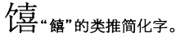

**Fig. 1055. Hanyu Da Zidian v. 8 p. 4767**

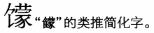

**Fig. 1056. Hanyu Da Zidian v. 8 p. 4770**

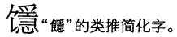

**Fig. 1057. Hanyu Da Zidian v. 8 p. 4771**

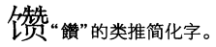

**Fig. 1058. Hanyu Da Zidian v. 8 p. 4773**

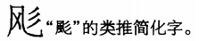

**Fig. 1059. Hanyu Da Zidian v. 8 p. 4774**

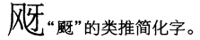

**Fig. 1060. Hanyu Da Zidian v. 8 p. 4777**

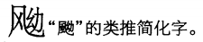

**Fig. 1061. Hanyu Da Zidian v. 8 p. 4777**

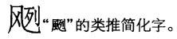

**Fig. 1062. Hanyu Da Zidian v. 8 p. 4777**

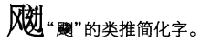

The font glyph is corrupt in this entry; see Fig. 1436 for the correct glyph form.

**Fig. 1063. Hanyu Da Zidian v. 8 p. 4778**

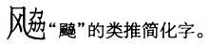

**Fig. 1064. Hanyu Da Zidian v. 8 p. 4780**

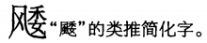

**Fig. 1065. Hanyu Da Zidian v. 8 p. 4780**

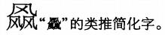

**Fig. 1066. Hanyu Da Zidian v. 8 p. 4782**

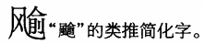

**Fig. 1067. Hanyu Da Zidian v. 8 p. 4785**

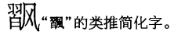

**Fig. 1068. Hanyu Da Zidian v. 8 p. 4785**

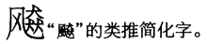

**Fig. 1069. Hanyu Da Zidian v. 8 p. 4790**

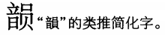

**Fig. 1070. Hanyu Da Zidian v. 8 p. 4797**

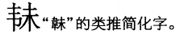

**Fig. 1071. Hanyu Da Zidian v. 8 p. 4798**

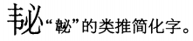

**Fig. 1072. Hanyu Da Zidian v. 8 p. 4799**

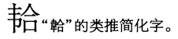

**Fig. 1073. Hanyu Da Zidian v. 8 p. 4799**

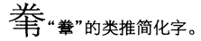

**Fig. 1074. Hanyu Da Zidian v. 8 p. 4799**

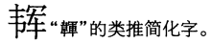

**Fig. 1075. Hanyu Da Zidian v. 8 p. 4800**

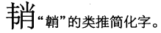

**Fig. 1076. Hanyu Da Zidian v. 8 p. 4801**

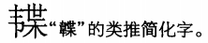

**Fig. 1077. Hanyu Da Zidian v. 8 p. 4805**

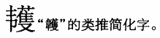

**Fig. 1078. Hanyu Da Zidian v. 8 p. 4805**

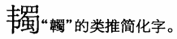

**Fig. 1079. Hanyu Da Zidian v. 8 p. 4817**

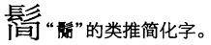

**Fig. 1080. Hanyu Da Zidian v. 8 p. 4817**

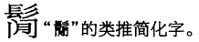

**Fig. 1081. Hanyu Da Zidian v. 8 p. 4821**

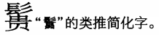

**Fig. 1082. Hanyu Da Zidian v. 8 p. 4823**

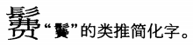

**Fig. 1083. Hanyu Da Zidian v. 8 p. 4823**

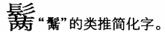

**Fig. 1084. Hanyu Da Zidian v. 8 p. 4823**

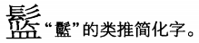

**Fig. 1085. Hanyu Da Zidian v. 8 p. 4829**

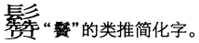

**Fig. 1086. Hanyu Da Zidian v. 8 p. 4832**

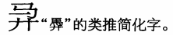

**Fig. 1087. Hanyu Da Zidian v. 8 p. 4833**

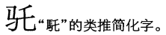

**Fig. 1088. Hanyu Da Zidian v. 8 p. 4834**

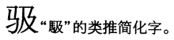

**Fig. 1089. Hanyu Da Zidian v. 8 p. 4834**

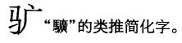

**Fig. 1090. Hanyu Da Zidian v. 8 p. 4835**

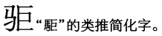

**Fig. 1091. Hanyu Da Zidian v. 8 p. 4835**

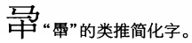

**Fig. 1092. Hanyu Da Zidian v. 8 p. 4836**

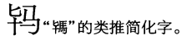

**Fig. 1093. Hanyu Da Zidian v. 8 p. 4838**

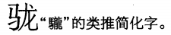

**Fig. 1094. Hanyu Da Zidian v. 8 p. 4841**

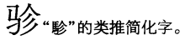

**Fig. 1095. Hanyu Da Zidian v. 8 p. 4845**

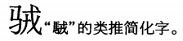

**Fig. 1096. Hanyu Da Zidian v. 8 p. 4845**

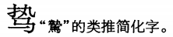

**Fig. 1097. Hanyu Da Zidian v. 8 p. 4845**

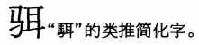

**Fig. 1098. Hanyu Da Zidian v. 8 p. 4845**

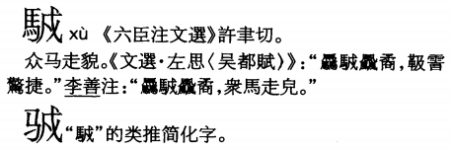

The G-source glyph for the traditional form (U+298CA 𩣊 = GHZ-74552.10) does not match the source.

**Fig. 1099. Hanyu Da Zidian v. 8 p. 4847**

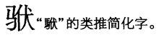

**Fig. 1100. Hanyu Da Zidian v. 8 p. 4847**

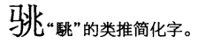

**Fig. 1101. Hanyu Da Zidian v. 8 p. 4850**

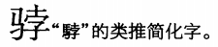

**Fig. 1102. Hanyu Da Zidian v. 8 p. 4850**

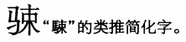

**Fig. 1103. Hanyu Da Zidian v. 8 p. 4851**

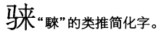

**Fig. 1104. Hanyu Da Zidian v. 8 p. 4851**

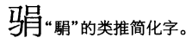

**Fig. 1105. Hanyu Da Zidian v. 8 p. 4852**

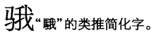

**Fig. 1106. Hanyu Da Zidian v. 8 p. 4852**

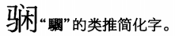

**Fig. 1107. Hanyu Da Zidian v. 8 p. 4852**

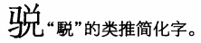

**Fig. 1108. Hanyu Da Zidian v. 8 p. 4857**

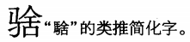

**Fig. 1109. Hanyu Da Zidian v. 8 p. 4858**

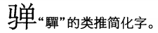

**Fig. 1110. Hanyu Da Zidian v. 8 p. 4859**

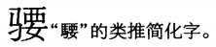

**Fig. 1111. Hanyu Da Zidian v. 8 p. 4861**

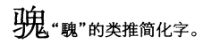

**Fig. 1112. Hanyu Da Zidian v. 8 p. 4862**

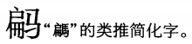

**Fig. 1113. Hanyu Da Zidian v. 8 p. 4862**

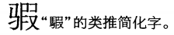

**Fig. 1114. Hanyu Da Zidian v. 8 p. 4864**

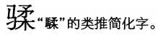

**Fig. 1115. Hanyu Da Zidian v. 8 p. 4865**

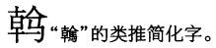

**Fig. 1116. Hanyu Da Zidian v. 8 p. 4866**

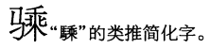

**Fig. 1117. Hanyu Da Zidian v. 8 p. 4867**

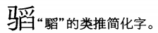

**Fig. 1118. Hanyu Da Zidian v. 8 p. 4869**

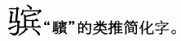

**Fig. 1119. Hanyu Da Zidian v. 8 p. 4869**

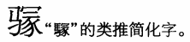

**Fig. 1120. Hanyu Da Zidian v. 8 p. 4869**

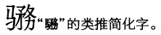

**Fig. 1121. Hanyu Da Zidian v. 8 p. 4870**

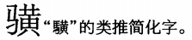

**Fig. 1122. Hanyu Da Zidian v. 8 p. 4871**

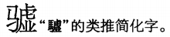

**Fig. 1123. Hanyu Da Zidian v. 8 p. 4872**

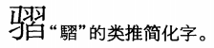

**Fig. 1124. Hanyu Da Zidian v. 8 p. 4874**

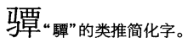

**Fig. 1125. Hanyu Da Zidian v. 8 p. 4876**

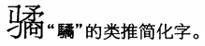

**Fig. 1126. Hanyu Da Zidian v. 8 p. 4880**

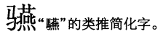

**Fig. 1127. Hanyu Da Zidian v. 8 p. 4885**

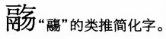

**Fig. 1128. Hanyu Da Zidian v. 8 p. 4885**

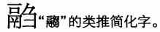

**Fig. 1129. Hanyu Da Zidian v. 8 p. 4901**

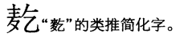

**Fig. 1130. Hanyu Da Zidian v. 8 p. 4901**

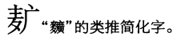

**Fig. 1131. Hanyu Da Zidian v. 8 p. 4903**

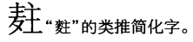

**Fig. 1132. Hanyu Da Zidian v. 8 p. 4904**

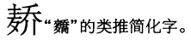

**Fig. 1133. Hanyu Da Zidian v. 8 p. 4908**

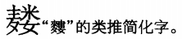

**Fig. 1134. Hanyu Da Zidian v. 8 p. 4908**

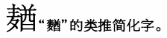

**Fig. 1135. Hanyu Da Zidian v. 8 p. 4909**

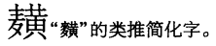

**Fig. 1136. Hanyu Da Zidian v. 8 p. 4909**

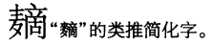

**Fig. 1137. Hanyu Da Zidian v. 8 p. 4914**

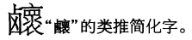

**Fig. 1138. Hanyu Da Zidian v. 8 p. 4915**

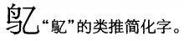

**Fig. 1139. Hanyu Da Zidian v. 8 p. 4916**

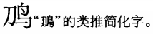

**Fig. 1140. Hanyu Da Zidian v. 8 p. 4916**

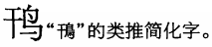

**Fig. 1141. Hanyu Da Zidian v. 8 p. 4916**

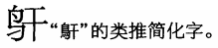

**Fig. 1142. Hanyu Da Zidian v. 8 p. 4918**

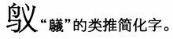

**Fig. 1143. Hanyu Da Zidian v. 8 p. 4919**

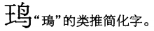

**Fig. 1144. Hanyu Da Zidian v. 8 p. 4919**

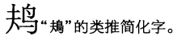

**Fig. 1145. Hanyu Da Zidian v. 8 p. 4919**

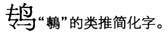

**Fig. 1146. Hanyu Da Zidian v. 8 p. 4921**

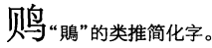

**Fig. 1147. Hanyu Da Zidian v. 8 p. 4922**

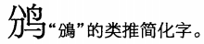

**Fig. 1148. Hanyu Da Zidian v. 8 p. 4922**

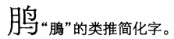

**Fig. 1149. Hanyu Da Zidian v. 8 p. 4923**

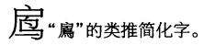

**Fig. 1150. Hanyu Da Zidian v. 8 p. 4924**

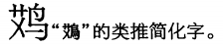

**Fig. 1151. Hanyu Da Zidian v. 8 p. 4925**

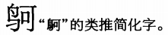

**Fig. 1152. Hanyu Da Zidian v. 8 p. 4925**

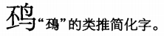

**Fig. 1153. Hanyu Da Zidian v. 8 p. 4926**

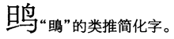

**Fig. 1154. Hanyu Da Zidian v. 8 p. 4926**

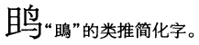

**Fig. 1155. Hanyu Da Zidian v. 8 p. 4926**

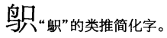

**Fig. 1156. Hanyu Da Zidian v. 8 p. 4927**

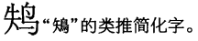

**Fig. 1157. Hanyu Da Zidian v. 8 p. 4927**

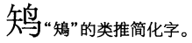

**Fig. 1158. Hanyu Da Zidian v. 8 p. 4927**

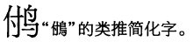

**Fig. 1159. Hanyu Da Zidian v. 8 p. 4930**

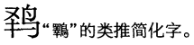

**Fig. 1160. Hanyu Da Zidian v. 8 p. 4930**

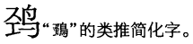

**Fig. 1161. Hanyu Da Zidian v. 8 p. 4931**

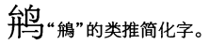

**Fig. 1162. Hanyu Da Zidian v. 8 p. 4931**

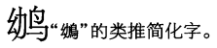

**Fig. 1163. Hanyu Da Zidian v. 8 p. 4931**

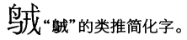

**Fig. 1164. Hanyu Da Zidian v. 8 p. 4931**

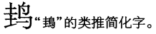

**Fig. 1165. Hanyu Da Zidian v. 8 p. 4931**

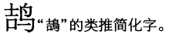

**Fig. 1166. Hanyu Da Zidian v. 8 p. 4931**

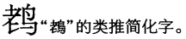

**Fig. 1167. Hanyu Da Zidian v. 8 p. 4932**

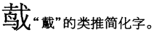

**Fig. 1168. Hanyu Da Zidian v. 8 p. 4932**

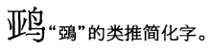

**Fig. 1169. Hanyu Da Zidian v. 8 p. 4932**

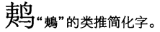

**Fig. 1170. Hanyu Da Zidian v. 8 p. 4933**

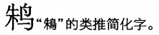

**Fig. 1171. Hanyu Da Zidian v. 8 p. 4933**

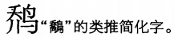

**Fig. 1172. Hanyu Da Zidian v. 8 p. 4935**

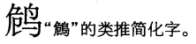

**Fig. 1173. Hanyu Da Zidian v. 8 p. 4935**

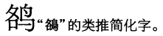

**Fig. 1174. Hanyu Da Zidian v. 8 p. 4936**

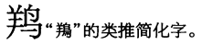

**Fig. 1175. Hanyu Da Zidian v. 8 p. 4937**

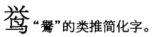

**Fig. 1176. Hanyu Da Zidian v. 8 p. 4937**

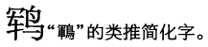

**Fig. 1177. Hanyu Da Zidian v. 8 p. 4938**

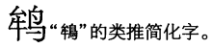

**Fig. 1178. Hanyu Da Zidian v. 8 p. 4938**

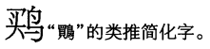

**Fig. 1179. Hanyu Da Zidian v. 8 p. 4938**

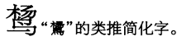

**Fig. 1180. Hanyu Da Zidian v. 8 p. 4939**

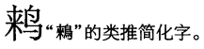

**Fig. 1181. Hanyu Da Zidian v. 8 p. 4939**

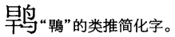

**Fig. 1182. Hanyu Da Zidian v. 8 p. 4941**

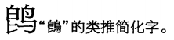

**Fig. 1183. Hanyu Da Zidian v. 8 p. 4941**

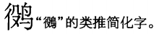

**Fig. 1184. Hanyu Da Zidian v. 8 p. 4941**

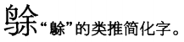

**Fig. 1185. Hanyu Da Zidian v. 8 p. 4941**

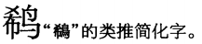

**Fig. 1186. Hanyu Da Zidian v. 8 p. 4942**

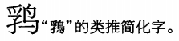

**Fig. 1187. Hanyu Da Zidian v. 8 p. 4942**

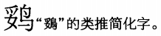

**Fig. 1188. Hanyu Da Zidian v. 8 p. 4943**

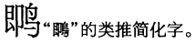

**Fig. 1189. Hanyu Da Zidian v. 8 p. 4943**

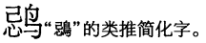

**Fig. 1190. Hanyu Da Zidian v. 8 p. 4943**

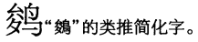

**Fig. 1191. Hanyu Da Zidian v. 8 p. 4944**

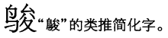

**Fig. 1192. Hanyu Da Zidian v. 8 p. 4944**

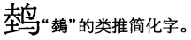

**Fig. 1193. Hanyu Da Zidian v. 8 p. 4945**

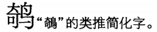

**Fig. 1194. Hanyu Da Zidian v. 8 p. 4946**

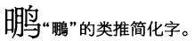

**Fig. 1195. Hanyu Da Zidian v. 8 p. 4947**

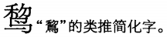

**Fig. 1196. Hanyu Da Zidian v. 8 p. 4947**

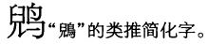

**Fig. 1197. Hanyu Da Zidian v. 8 p. 4947**

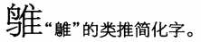

**Fig. 1198. Hanyu Da Zidian v. 8 p. 4948**

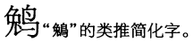

**Fig. 1199. Hanyu Da Zidian v. 8 p. 4948**

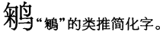

**Fig. 1200. Hanyu Da Zidian v. 8 p. 4949**

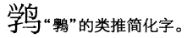

**Fig. 1201. Hanyu Da Zidian v. 8 p. 4949**

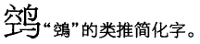

**Fig. 1202. Hanyu Da Zidian v. 8 p. 4950**

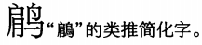

**Fig. 1203. Hanyu Da Zidian v. 8 p. 4950**

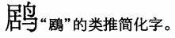

**Fig. 1204. Hanyu Da Zidian v. 8 p. 4950**

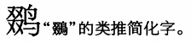

**Fig. 1205. Hanyu Da Zidian v. 8 p. 4950**

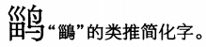

**Fig. 1206. Hanyu Da Zidian v. 8 p. 4951**

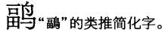

**Fig. 1207. Hanyu Da Zidian v. 8 p. 4951**

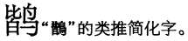

**Fig. 1208. Hanyu Da Zidian v. 8 p. 4954**

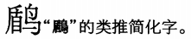

**Fig. 1209. Hanyu Da Zidian v. 8 p. 4954**

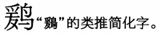

**Fig. 1210. Hanyu Da Zidian v. 8 p. 4954**

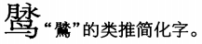

**Fig. 1211. Hanyu Da Zidian v. 8 p. 4954**

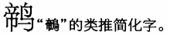

**Fig. 1212. Hanyu Da Zidian v. 8 p. 4955**

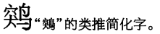

**Fig. 1213. Hanyu Da Zidian v. 8 p. 4955**

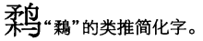

**Fig. 1214. Hanyu Da Zidian v. 8 p. 4956**

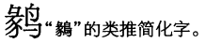

**Fig. 1215. Hanyu Da Zidian v. 8 p. 4956**

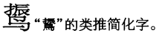

**Fig. 1216. Hanyu Da Zidian v. 8 p. 4957**

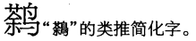

**Fig. 1217. Hanyu Da Zidian v. 8 p. 4957**

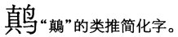

**Fig. 1218. Hanyu Da Zidian v. 8 p. 4958**

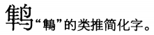

**Fig. 1219. Hanyu Da Zidian v. 8 p. 4960**

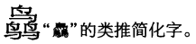

**Fig. 1220. Hanyu Da Zidian v. 8 p. 4961**

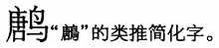

**Fig. 1221. Hanyu Da Zidian v. 8 p. 4961**

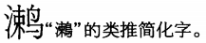

**Fig. 1222. Hanyu Da Zidian v. 8 p. 4961**

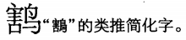

**Fig. 1223. Hanyu Da Zidian v. 8 p. 4965**

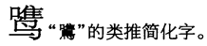

**Fig. 1224. Hanyu Da Zidian v. 8 p. 4965**

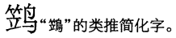

**Fig. 1225. Hanyu Da Zidian v. 8 p. 4966**

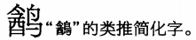

**Fig. 1226. Hanyu Da Zidian v. 8 p. 4966**

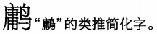

**Fig. 1227. Hanyu Da Zidian v. 8 p. 4966**

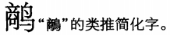

**Fig. 1228. Hanyu Da Zidian v. 8 p. 4967**

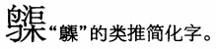

**Fig. 1229. Hanyu Da Zidian v. 8 p. 4967**

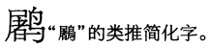

**Fig. 1230. Hanyu Da Zidian v. 8 p. 4968**

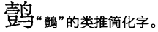

**Fig. 1231. Hanyu Da Zidian v. 8 p. 4969**

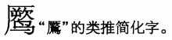

**Fig. 1232. Hanyu Da Zidian v. 8 p. 4973**

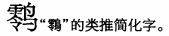

**Fig. 1233. Hanyu Da Zidian v. 8 p. 4973**

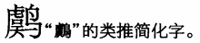

**Fig. 1234. Hanyu Da Zidian v. 8 p. 4974**

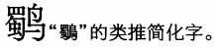

**Fig. 1235. Hanyu Da Zidian v. 8 p. 4974**

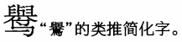

**Fig. 1236. Hanyu Da Zidian v. 8 p. 4975**

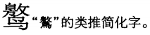

**Fig. 1237. Hanyu Da Zidian v. 8 p. 4975**

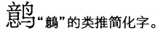

**Fig. 1238. Hanyu Da Zidian v. 8 p. 4978**

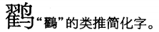

**Fig. 1239. Hanyu Da Zidian v. 8 p. 4978**

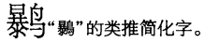

**Fig. 1240. Hanyu Da Zidian v. 8 p. 4979**

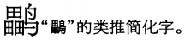

**Fig. 1241. Hanyu Da Zidian v. 8 p. 4979**

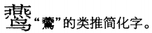

**Fig. 1242. Hanyu Da Zidian v. 8 p. 4981**

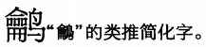

**Fig. 1243. Hanyu Da Zidian v. 8 p. 4984**

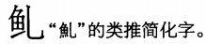

**Fig. 1244. Hanyu Da Zidian v. 8 p. 4985**

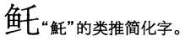

**Fig. 1245. Hanyu Da Zidian v. 8 p. 4986**

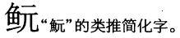

**Fig. 1246. Hanyu Da Zidian v. 8 p. 4986**

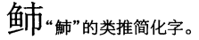

**Fig. 1247. Hanyu Da Zidian v. 8 p. 4987**

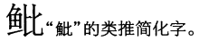

**Fig. 1248. Hanyu Da Zidian v. 8 p. 4987**

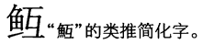

**Fig. 1249. Hanyu Da Zidian v. 8 p. 4988**

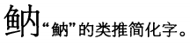

**Fig. 1250. Hanyu Da Zidian v. 8 p. 4988**

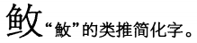

**Fig. 1251. Hanyu Da Zidian v. 8 p. 4988**

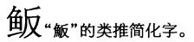

**Fig. 1252. Hanyu Da Zidian v. 8 p. 4989**

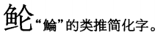

**Fig. 1253. Hanyu Da Zidian v. 8 p. 4989**

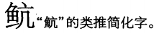

**Fig. 1254. Hanyu Da Zidian v. 8 p. 4990**

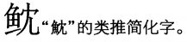

**Fig. 1255. Hanyu Da Zidian v. 8 p. 4990**

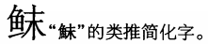

**Fig. 1256. Hanyu Da Zidian v. 8 p. 4990**

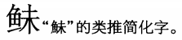

**Fig. 1257. Hanyu Da Zidian v. 8 p. 4990**

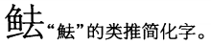

**Fig. 1258. Hanyu Da Zidian v. 8 p. 4991**

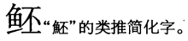

**Fig. 1259. Hanyu Da Zidian v. 8 p. 4992**

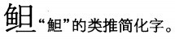

**Fig. 1260. Hanyu Da Zidian v. 8 p. 4992**

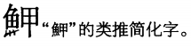

The font glyph is corrupt in this entry; see Fig. 1440 for the correct glyph form.

**Fig. 1261. Hanyu Da Zidian v. 8 p. 4992**

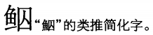

**Fig. 1262. Hanyu Da Zidian v. 8 p. 4992**

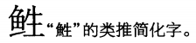

**Fig. 1263. Hanyu Da Zidian v. 8 p. 4994**

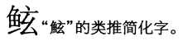

**Fig. 1264. Hanyu Da Zidian v. 8 p. 4995**

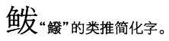

**Fig. 1265. Hanyu Da Zidian v. 8 p. 4995**

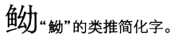

**Fig. 1266. Hanyu Da Zidian v. 8 p. 4996**

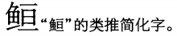

**Fig. 1267. Hanyu Da Zidian v. 8 p. 4997**

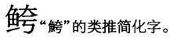

**Fig. 1268. Hanyu Da Zidian v. 8 p. 4997**

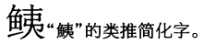

**Fig. 1269. Hanyu Da Zidian v. 8 p. 4997**

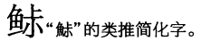

**Fig. 1270. Hanyu Da Zidian v. 8 p. 4998**

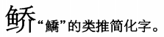

**Fig. 1271. Hanyu Da Zidian v. 8 p. 4998**

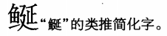

**Fig. 1272. Hanyu Da Zidian v. 8 p. 5000**

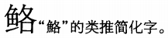

**Fig. 1273. Hanyu Da Zidian v. 8 p. 5002**

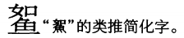

**Fig. 1274. Hanyu Da Zidian v. 8 p. 5002**

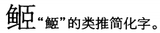

**Fig. 1275. Hanyu Da Zidian v. 8 p. 5003**

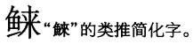

**Fig. 1276. Hanyu Da Zidian v. 8 p. 5003**

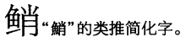

**Fig. 1277. Hanyu Da Zidian v. 8 p. 5004**

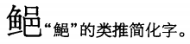

**Fig. 1278. Hanyu Da Zidian v. 8 p. 5004**

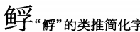

**Fig. 1279. Hanyu Da Zidian v. 8 p. 5007**

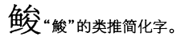

**Fig. 1280. Hanyu Da Zidian v. 8 p. 5007**

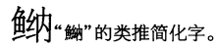

**Fig. 1281. Hanyu Da Zidian v. 8 p. 5007**

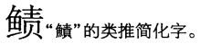

**Fig. 1282. Hanyu Da Zidian v. 8 p. 5007**

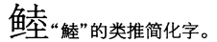

**Fig. 1283. Hanyu Da Zidian v. 8 p. 5008**

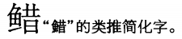

**Fig. 1284. Hanyu Da Zidian v. 8 p. 5009**

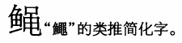

**Fig. 1285. Hanyu Da Zidian v. 8 p. 5010**

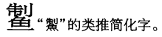

**Fig. 1286. Hanyu Da Zidian v. 8 p. 5010**

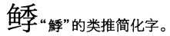

**Fig. 1287. Hanyu Da Zidian v. 8 p. 5011**

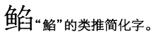

**Fig. 1288. Hanyu Da Zidian v. 8 p. 5011**

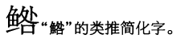

**Fig. 1289. Hanyu Da Zidian v. 8 p. 5011**

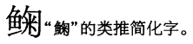

**Fig. 1290. Hanyu Da Zidian v. 8 p. 5012**

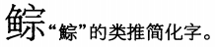

**Fig. 1291. Hanyu Da Zidian v. 8 p. 5013**

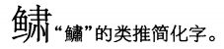

**Fig. 1292. Hanyu Da Zidian v. 8 p. 5013**

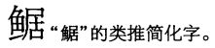

**Fig. 1293. Hanyu Da Zidian v. 8 p. 5015**

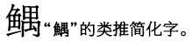

**Fig. 1294. Hanyu Da Zidian v. 8 p. 5016**

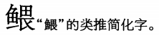

**Fig. 1295. Hanyu Da Zidian v. 8 p. 5017**

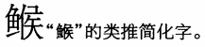

**Fig. 1296. Hanyu Da Zidian v. 8 p. 5017**

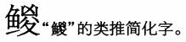

**Fig. 1297. Hanyu Da Zidian v. 8 p. 5018**

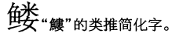

**Fig. 1298. Hanyu Da Zidian v. 8 p. 5018**

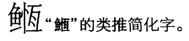

**Fig. 1299. Hanyu Da Zidian v. 8 p. 5021**

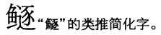

**Fig. 1300. Hanyu Da Zidian v. 8 p. 5021**

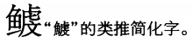

**Fig. 1301. Hanyu Da Zidian v. 8 p. 5023**

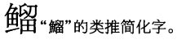

**Fig. 1302. Hanyu Da Zidian v. 8 p. 5023**

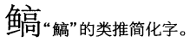

**Fig. 1303. Hanyu Da Zidian v. 8 p. 5023**

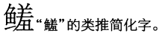

**Fig. 1304. Hanyu Da Zidian v. 8 p. 5024**

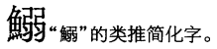

The font glyph is corrupt in this entry; see Fig. 1443 for the correct glyph form.

**Fig. 1305. Hanyu Da Zidian v. 8 p. 5024**

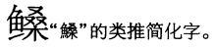

**Fig. 1306. Hanyu Da Zidian v. 8 p. 5025**

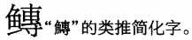

**Fig. 1307. Hanyu Da Zidian v. 8 p. 5028**

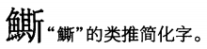

The font glyph is corrupt in this entry; see Fig. 1444 for the correct glyph form.

**Fig. 1308. Hanyu Da Zidian v. 8 p. 5029**

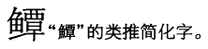

**Fig. 1309. Hanyu Da Zidian v. 8 p. 5029**

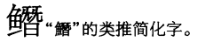

**Fig. 1310. Hanyu Da Zidian v. 8 p. 5030**

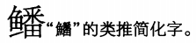

**Fig. 1311. Hanyu Da Zidian v. 8 p. 5032**

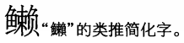

**Fig. 1312. Hanyu Da Zidian v. 8 p. 5035**

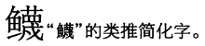

**Fig. 1313. Hanyu Da Zidian v. 8 p. 5035**

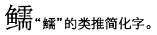

**Fig. 1314. Hanyu Da Zidian v. 8 p. 5035**

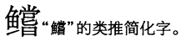

**Fig. 1315. Hanyu Da Zidian v. 8 p. 5036**

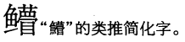

**Fig. 1316. Hanyu Da Zidian v. 8 p. 5037**

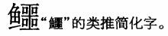

**Fig. 1317. Hanyu Da Zidian v. 8 p. 5041**

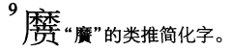

**Fig. 1318. Hanyu Da Zidian v. 8 p. 5062**

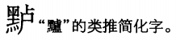

**Fig. 1319. Hanyu Da Zidian v. 8 p. 5079**

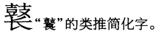

**Fig. 1320. Hanyu Da Zidian v. 8 p. 5083**

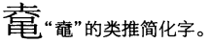

**Fig. 1321. Hanyu Da Zidian v. 8 p. 5083**

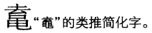

**Fig. 1322. Hanyu Da Zidian v. 8 p. 5084**

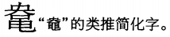

**Fig. 1323. Hanyu Da Zidian v. 8 p. 5084**

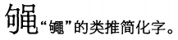

**Fig. 1324. Hanyu Da Zidian v. 8 p. 5084**

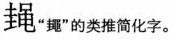

**Fig. 1325. Hanyu Da Zidian v. 8 p. 5085**

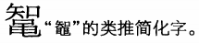

**Fig. 1326. Hanyu Da Zidian v. 8 p. 5085**

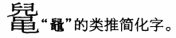

**Fig. 1327. Hanyu Da Zidian v. 8 p. 5086**

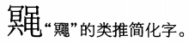

**Fig. 1328. Hanyu Da Zidian v. 8 p. 5086**

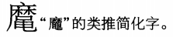

**Fig. 1329. Hanyu Da Zidian v. 8 p. 5086**

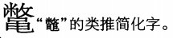

**Fig. 1330. Hanyu Da Zidian v. 8 p. 5086**

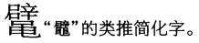

**Fig. 1331. Hanyu Da Zidian v. 8 p. 5090**

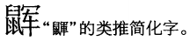

**Fig. 1332. Hanyu Da Zidian v. 8 p. 5096**

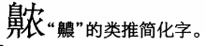

**Fig. 1333. Hanyu Da Zidian v. 8 p. 5101**

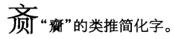

**Fig. 1334. Hanyu Da Zidian v. 8 p. 5101**

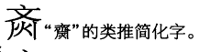

**Fig. 1335. Hanyu Da Zidian v. 8 p. 5101**

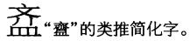

**Fig. 1336. Hanyu Da Zidian v. 8 p. 5102**

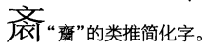

**Fig. 1337. Hanyu Da Zidian v. 8 p. 5106**

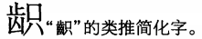

**Fig. 1338. Hanyu Da Zidian v. 8 p. 5106**

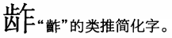

**Fig. 1339. Hanyu Da Zidian v. 8 p. 5107**

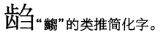

**Fig. 1340. Hanyu Da Zidian v. 8 p. 5108**

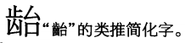

**Fig. 1341. Hanyu Da Zidian v. 8 p. 5108**

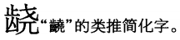

**Fig. 1342. Hanyu Da Zidian v. 8 p. 5109**

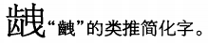

**Fig. 1343. Hanyu Da Zidian v. 8 p. 5110**

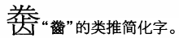

**Fig. 1344. Hanyu Da Zidian v. 8 p. 5110**

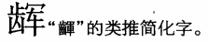

**Fig. 1345. Hanyu Da Zidian v. 8 p. 5111**

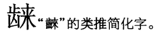

**Fig. 1346. Hanyu Da Zidian v. 8 p. 5111**

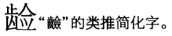

**Fig. 1347. Hanyu Da Zidian v. 8 p. 5112**

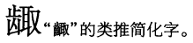

**Fig. 1348. Hanyu Da Zidian v. 8 p. 5112**

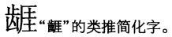

**Fig. 1349. Hanyu Da Zidian v. 8 p. 5113**

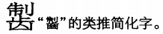

**Fig. 1350. Hanyu Da Zidian v. 8 p. 5114**

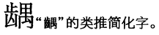

**Fig. 1351. Hanyu Da Zidian v. 8 p. 5115**

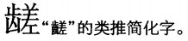

**Fig. 1352. Hanyu Da Zidian v. 8 p. 5116**

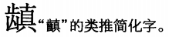

**Fig. 1353. Hanyu Da Zidian v. 8 p. 5117**

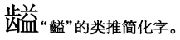

**Fig. 1354. Hanyu Da Zidian v. 8 p. 5121**

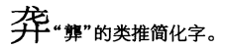

**Fig. 1355. Hanyu Da Zidian v. 8 p. 5126**

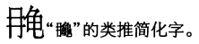

**Fig. 1356. Hanyu Da Zidian v. 8 p. 5127**

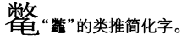

**Fig. 1357. *Zhonghua Zihai* (Beijing, 2000) p. 37 col. C**

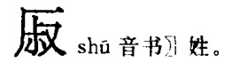

**Fig. 1358. *Zhonghua Zihai* (Beijing, 2000) p. 173 col. C**

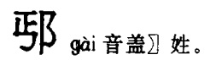

**Fig. 1359. *Zhonghua Zihai* (Beijing, 2000) p. 177 col. C**

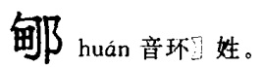

**Fig. 1360. *Zhonghua Zihai* (Beijing, 2000) p. 177 col. C**

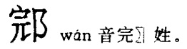

**Fig. 1361. *Zhonghua Zihai* (Beijing, 2000) p. 179 col. A**

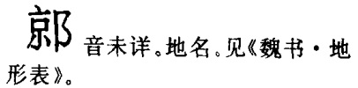

**Fig. 1362. *Zhonghua Zihai* (Beijing, 2000) p. 221 col. A**

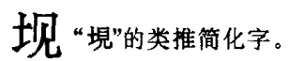

**Fig. 1363. *Zhonghua Zihai* (Beijing, 2000) p. 224 col. C**

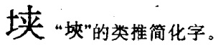

**Fig. 1364. *Zhonghua Zihai* (Beijing, 2000) p. 225 col. B**

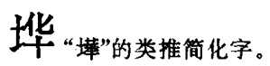

**Fig. 1365. *Zhonghua Zihai* (Beijing, 2000) p. 234 col. C**

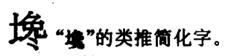

**Fig. 1366. *Zhonghua Zihai* (Beijing, 2000) p. 234 col. C**

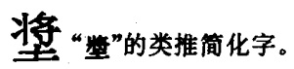

**Fig. 1367. *Zhonghua Zihai* (Beijing, 2000) p. 236 col. A**

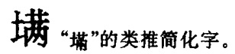

**Fig. 1368. *Zhonghua Zihai* (Beijing, 2000) p. 239 col. A**

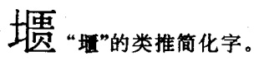

**Fig. 1369. *Zhonghua Zihai* (Beijing, 2000) p. 246 col. B**

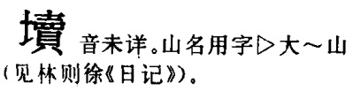

**Fig. 1370. *Zhonghua Zihai* (Beijing, 2000) p. 254 col. B**

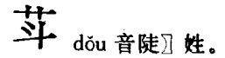

**Fig. 1371. *Zhonghua Zihai* (Beijing, 2000) p. 297 col. B**

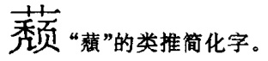

**Fig. 1372. *Zhonghua Zihai* (Beijing, 2000) p. 298 col. B**

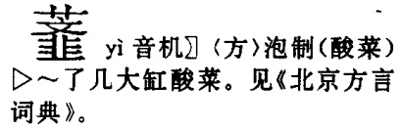

**Fig. 1373. *Zhonghua Zihai* (Beijing, 2000) p. 344 col. B**

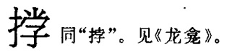

**Fig. 1374. *Zhonghua Zihai* (Beijing, 2000) p. 347 col. A**

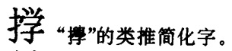

**Fig. 1375. *Zhonghua Zihai* (Beijing, 2000) p. 357 col. A**

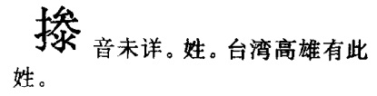

**Fig. 1376. *Zhonghua Zihai* (Beijing, 2000) p. 363 col. B**

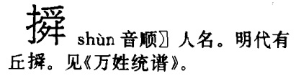

**Fig. 1377. *Zhonghua Zihai* (Beijing, 2000) p. 386 col. B**

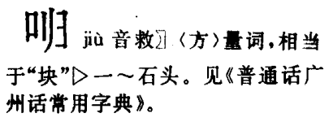

**Fig. 1378. *Zhonghua Zihai* (Beijing, 2000) p. 412 col. C**

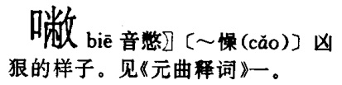

**Fig. 1379. *Zhonghua Zihai* (Beijing, 2000) p. 413 col. C**

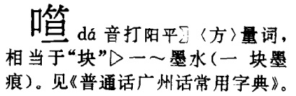

**Fig. 1380. *Zhonghua Zihai* (Beijing, 2000) p. 446 col. C**

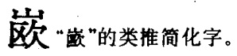

**Fig. 1381. *Zhonghua Zihai* (Beijing, 2000) p. 450 col. B**

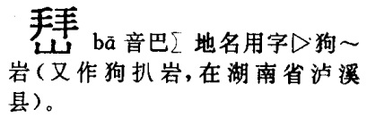

**Fig. 1382. *Zhonghua Zihai* (Beijing, 2000) p. 460 col. A**

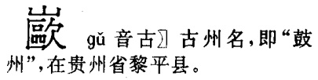

**Fig. 1383. *Zhonghua Zihai* (Beijing, 2000) p. 471 col. A**

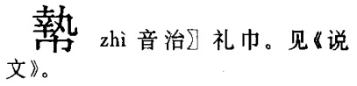

**Fig. 1384. *Zhonghua Zihai* (Beijing, 2000) p. 552 col. B**

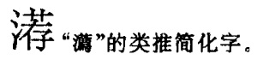

**Fig. 1385. *Zhonghua Zihai* (Beijing, 2000) p. 686 col. B**

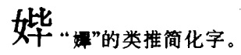

**Fig. 1386. *Zhonghua Zihai* (Beijing, 2000) p. 686 col. B**

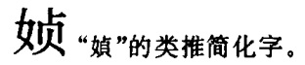

**Fig. 1387. *Zhonghua Zihai* (Beijing, 2000) p. 691 col. C**

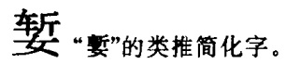

**Fig. 1388. *Zhonghua Zihai* (Beijing, 2000) p. 730 col. C**

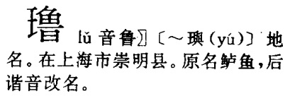

**Fig. 1389. *Zhonghua Zihai* (Beijing, 2000) p. 822 col. C**

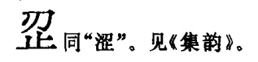

**Fig. 1390. *Zhonghua Zihai* (Beijing, 2000) p. 829 col. B**

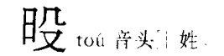

**Fig. 1391. *Zhonghua Zihai* (Beijing, 2000) p. 902 col. A**

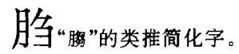

**Fig. 1392. *Zhonghua Zihai* (Beijing, 2000) p. 938 col. A**

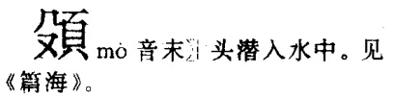

**Fig. 1393. *Zhonghua Zihai* (Beijing, 2000) p. 953 col. B**

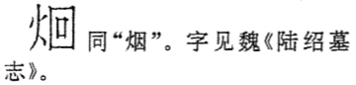

**Fig. 1394. *Zhonghua Zihai* (Beijing, 2000) p. 954 col. A**

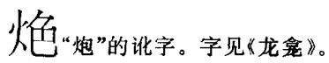

**Fig. 1395. *Zhonghua Zihai* (Beijing, 2000) p. 954 col. C**

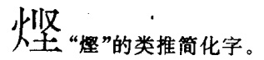

**Fig. 1396. *Zhonghua Zihai* (Beijing, 2000) p. 974 col. A**

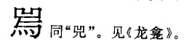

**Fig. 1397. *Zhonghua Zihai* (Beijing, 2000) p. 986 col. A**

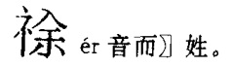

**Fig. 1398. *Zhonghua Zihai* (Beijing, 2000) p. 996 col. B**

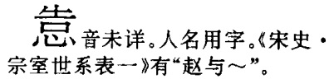

**Fig. 1399. *Zhonghua Zihai* (Beijing, 2000) p. 1021 col. B**

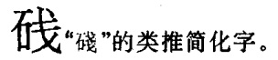

**Fig. 1400. *Zhonghua Zihai* (Beijing, 2000) p. 1028 col. B**

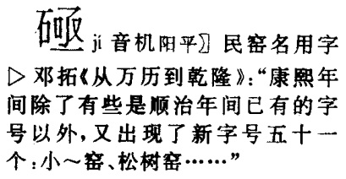

**Fig. 1401. *Zhonghua Zihai* (Beijing, 2000) p. 1061 col. A**

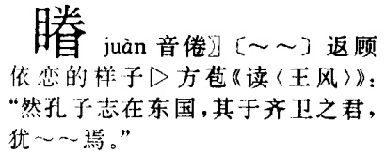

**Fig. 1402. *Zhonghua Zihai* (Beijing, 2000) p. 1073 col. B**

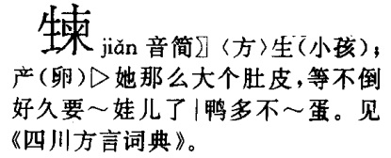

**Fig. 1403. *Zhonghua Zihai* (Beijing, 2000) p. 1097 col. A**

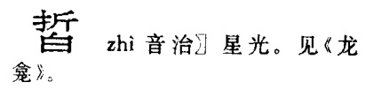

**Fig. 1404. *Zhonghua Zihai* (Beijing, 2000) p. 1104 col. B**

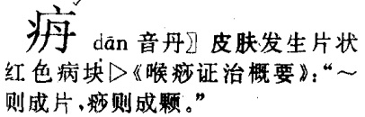

**Fig. 1405. *Zhonghua Zihai* (Beijing, 2000) p. 1109 col. A**

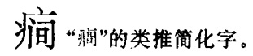

**Fig. 1406. *Zhonghua Zihai* (Beijing, 2000) p. 1114 col. A**

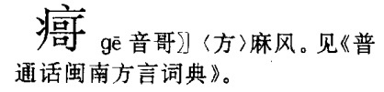

**Fig. 1407. *Zhonghua Zihai* (Beijing, 2000) p. 1114 col. B**

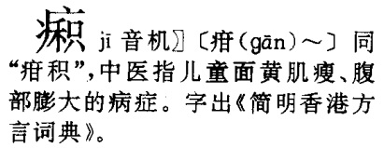

**Fig. 1408. *Zhonghua Zihai* (Beijing, 2000) p. 1174 col. C**

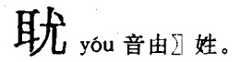

**Fig. 1409. *Zhonghua Zihai* (Beijing, 2000) p. 1197 col. B**

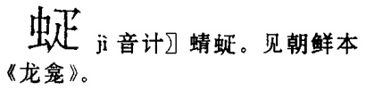

**Fig. 1410. *Zhonghua Zihai* (Beijing, 2000) p. 1293 col. C**

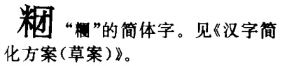

**Fig. 1411. *Zhonghua Zihai* (Beijing, 2000) p. 1313 col. C**

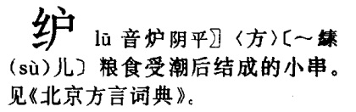

**Fig. 1412. *Zhonghua Zihai* (Beijing, 2000) p. 1353 col. A**

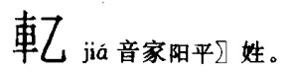

**Fig. 1413. *Zhonghua Zihai* (Beijing, 2000) p. 1353 col. A**

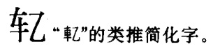

**Fig. 1414. *Zhonghua Zihai* (Beijing, 2000) p. 1356 col. C**

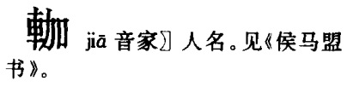

**Fig. 1415. *Zhonghua Zihai* (Beijing, 2000) p. 1401 col. B**

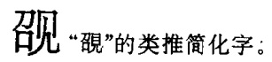

**Fig. 1416. *Zhonghua Zihai* (Beijing, 2000) p. 1402 col. B**

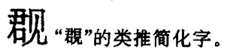

**Fig. 1417. *Zhonghua Zihai* (Beijing, 2000) p. 1413 col. B**

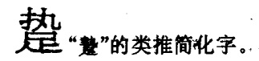

**Fig. 1418. *Zhonghua Zihai* (Beijing, 2000) p. 1447 col. B**

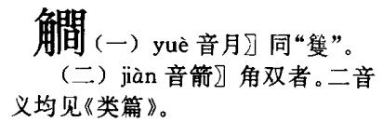

**Fig. 1419. *Zhonghua Zihai* (Beijing, 2000) p. 1451 col. A**

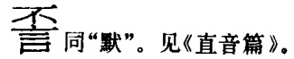

**Fig. 1420. *Zhonghua Zihai* (Beijing, 2000) p. 1461 col. C**

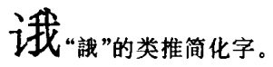

**Fig. 1421. *Zhonghua Zihai* (Beijing, 2000) p. 1501 col. A**

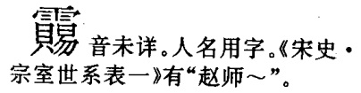

**Fig. 1422. *Zhonghua Zihai* (Beijing, 2000) p. 1515 col. B**

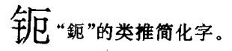

**Fig. 1423. *Zhonghua Zihai* (Beijing, 2000) p. 1520 col. B**

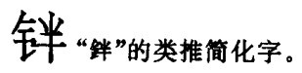

**Fig. 1424. *Zhonghua Zihai* (Beijing, 2000) p. 1521 col. B**

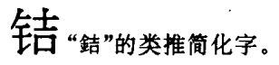

**Fig. 1425. *Zhonghua Zihai* (Beijing, 2000) p. 1525 col. A**

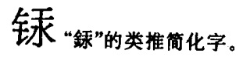

**Fig. 1426. *Zhonghua Zihai* (Beijing, 2000) p. 1530 col. A**

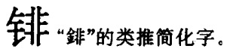

**Fig. 1427. *Zhonghua Zihai* (Beijing, 2000) p. 1534 col. B**

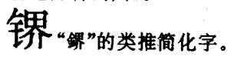

**Fig. 1428. *Zhonghua Zihai* (Beijing, 2000) p. 1534 col. C**

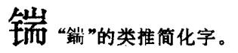

**Fig. 1429. *Zhonghua Zihai* (Beijing, 2000) p. 1537 col. A**

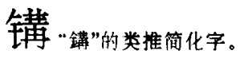

**Fig. 1430. *Zhonghua Zihai* (Beijing, 2000) p. 1537 col. B**

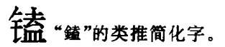

**Fig. 1431. *Zhonghua Zihai* (Beijing, 2000) p. 1539 col. C**

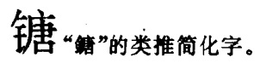

**Fig. 1432. *Zhonghua Zihai* (Beijing, 2000) p. 1542 col. C**

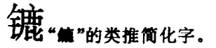

**Fig. 1433. *Zhonghua Zihai* (Beijing, 2000) p. 1544 col. C**

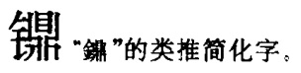

**Fig. 1434. *Zhonghua Zihai* (Beijing, 2000) p. 1570 col. C**

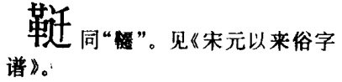

**Fig. 1435. *Zhonghua Zihai* (Beijing, 2000) p. 1625 col. C**

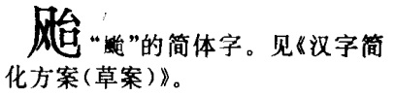

**Fig. 1436. *Zhonghua Zihai* (Beijing, 2000) p. 1626 col. A**

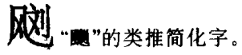

**Fig. 1437. *Zhonghua Zihai* (Beijing, 2000) p. 1647 col. C**

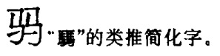

**Fig. 1438. *Zhonghua Zihai* (Beijing, 2000) p. 1672 col. B**

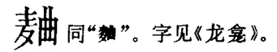

**Fig. 1439. *Zhonghua Zihai* (Beijing, 2000) p. 1676 col. A**

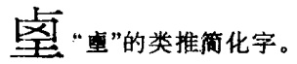

**Fig. 1440. *Zhonghua Zihai* (Beijing, 2000) p. 1703 col. A**

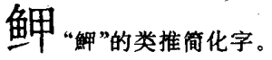

**Fig. 1441. *Zhonghua Zihai* (Beijing, 2000) p. 1708 col. C**

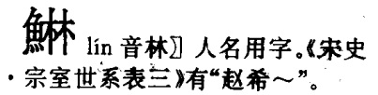

**Fig. 1442. *Zhonghua Zihai* (Beijing, 2000) p. 1713 col. A**

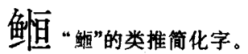

**Fig. 1443. *Zhonghua Zihai* (Beijing, 2000) p. 1714 col. C**

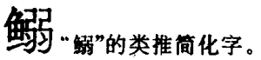

**Fig. 1444. *Zhonghua Zihai* (Beijing, 2000) p. 1716 col. C**

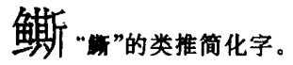

**Fig. 1445. *Zhonghua Zihai* (Beijing, 2000) p. 1749 col. B**

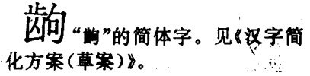

**Fig. 1446. *Zhonghua Zihai* (Beijing, 2000) p. 1755 col. B**

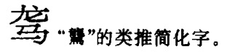

**Fig. 1447. *Zhonghua Zihai* (Beijing, 2000) p. 1755 col. C**

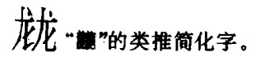

**Fig. 1448. *Zhonghua Zihai* (Beijing, 2000) p. 1757 col. B**

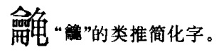

**Fig. 1449. *Zhonghua Zihai* (Beijing, 2000) p. 1758 col. B**

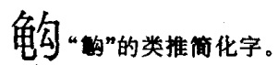

**Fig. 1450. *Zhonghua Zihai* (Beijing, 2000) p. 1758 col. B**

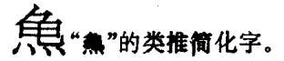

**Fig. 1451. *Zhonghua Zihai* (Beijing, 2000) p. 1758 col. C**

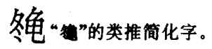

**Fig. 1452. *Zhonghua Zihai* (Beijing, 2000) p. 1763 col. C**

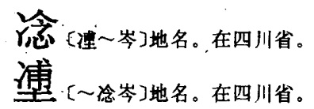

**Fig. 1453. *Zhonghua Zihai* (Beijing, 2000) p. 1764 col. B**

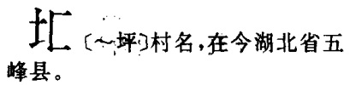

**Fig. 1454. *Zhonghua Zihai* (Beijing, 2000) p. 1764 col. C**

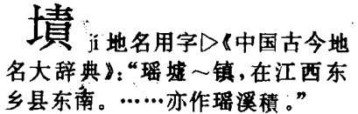

**Fig. 1455. *Zhonghua Zihai* (Beijing, 2000) p. 1764 col. C**

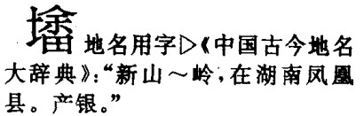

**Fig. 1456. *Zhonghua Zihai* (Beijing, 2000) p. 1770 col. C**

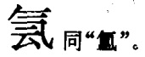

**Fig. 1457. *Zhonghua Zihai* (Beijing, 2000) p. 1772 col. B**

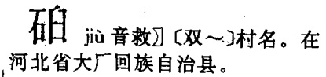

**Fig. 1458. *Zhonghua Zihai* (Beijing, 2000) p. 1772 col. C**

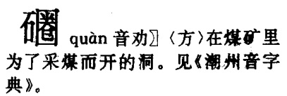

**Fig. 1459. *Zhonghua Zihai* (Beijing, 2000) p. 1775 col. B**

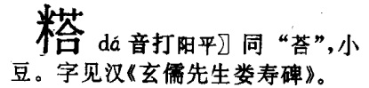

**Fig. 1460. *Zhonghua Zihai* (Beijing, 2000) p. 1777 col. A**

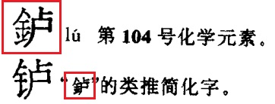

**Fig. 1461. *Gudai Hanyu Cidian* (Beijing, 2003) p. 167**

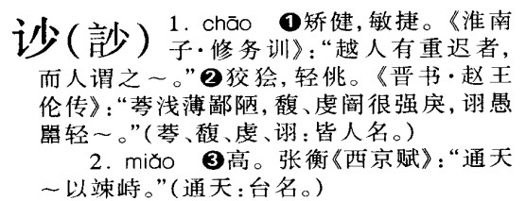

**Fig. 1462. *Gudai Hanyu Cidian* (Beijing, 2003) p. 178**

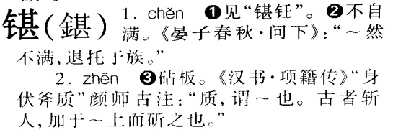

**Fig. 1463. *Gudai Hanyu Cidian* (Beijing, 2003) p. 197**

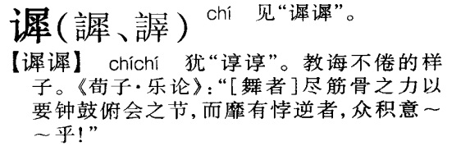

**Fig. 1464. *Gudai Hanyu Cidian* (Beijing, 2003) p. 214**

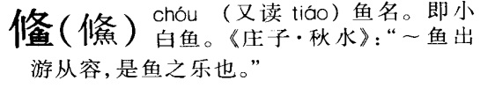

**Fig. 1465. *Gudai Hanyu Cidian* (Beijing, 2003) p. 214**

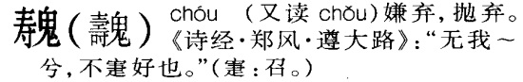

**Fig. 1466. *Gudai Hanyu Cidian* (Beijing, 2003) p. 253**

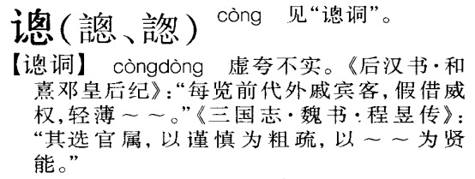

**Fig. 1467. *Gudai Hanyu Cidian* (Beijing, 2003) p. 260**

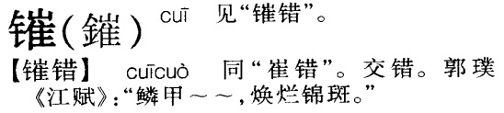

**Fig. 1468. *Gudai Hanyu Cidian* (Beijing, 2003) p. 279**

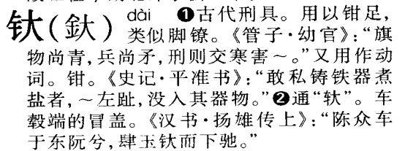

**Fig. 1469. *Gudai Hanyu Cidian* (Beijing, 2003) p. 333**

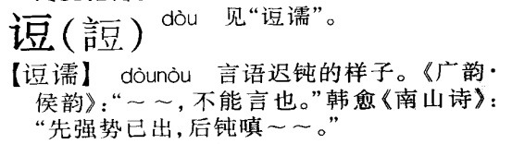

**Fig. 1470. *Gudai Hanyu Cidian* (Beijing, 2003) p. 356**

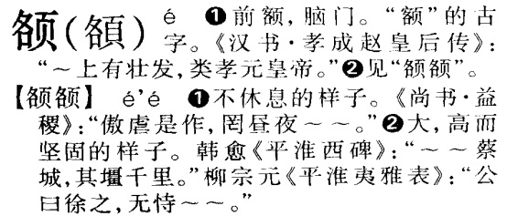

**Fig. 1471. *Gudai Hanyu Cidian* (Beijing, 2003) p. 362**

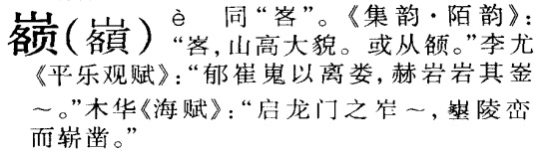

**Fig. 1472. *Gudai Hanyu Cidian* (Beijing, 2003) p. 426**

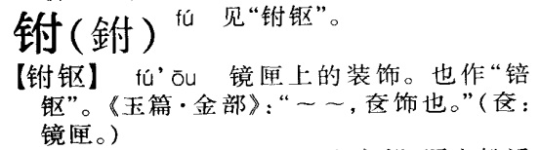

**Fig. 1473. *Gudai Hanyu Cidian* (Beijing, 2003) p. 435**

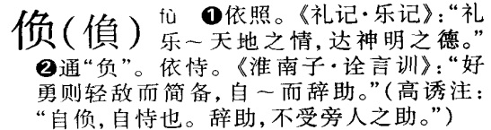

**Fig. 1474. *Gudai Hanyu Cidian* (Beijing, 2003) p. 518**

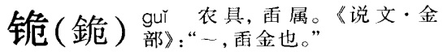

**Fig. 1475. *Gudai Hanyu Cidian* (Beijing, 2003) p. 543**

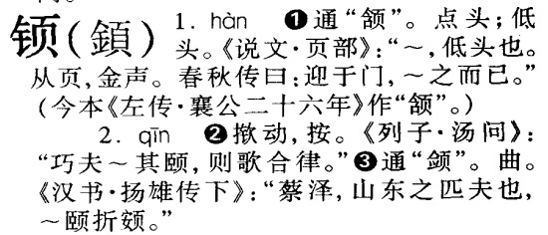

**Fig. 1476. *Gudai Hanyu Cidian* (Beijing, 2003) p. 581**

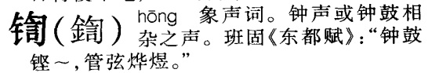

**Fig. 1477. *Gudai Hanyu Cidian* (Beijing, 2003) p. 599**

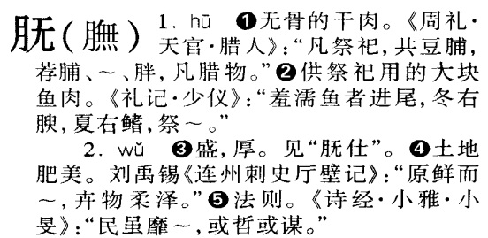

**Fig. 1478. *Gudai Hanyu Cidian* (Beijing, 2003) p. 651**

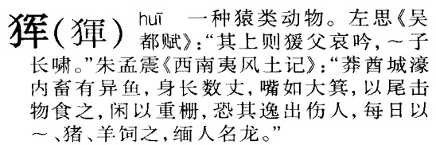

**Fig. 1479. *Gudai Hanyu Cidian* (Beijing, 2003) p. 684**

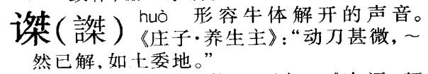

**Fig. 1480. *Gudai Hanyu Cidian* (Beijing, 2003) p. 693**

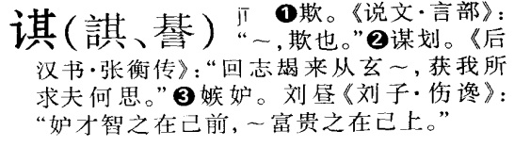

**Fig. 1481. *Gudai Hanyu Cidian* (Beijing, 2003) p. 786**

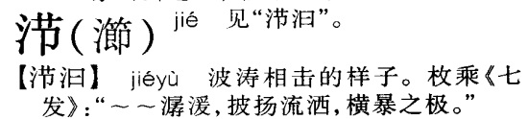

**Fig. 1482. *Gudai Hanyu Cidian* (Beijing, 2003) p. 834**

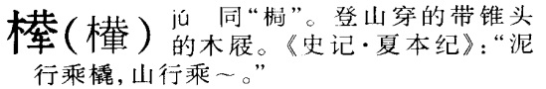

**Fig. 1483. *Gudai Hanyu Cidian* (Beijing, 2003) p. 846**

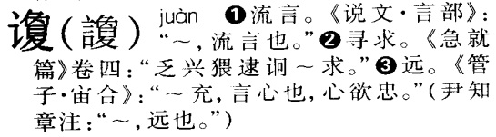

**Fig. 1484. *Gudai Hanyu Cidian* (Beijing, 2003) p. 882**

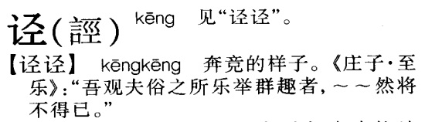

**Fig. 1485. *Gudai Hanyu Cidian* (Beijing, 2003) p. 897**

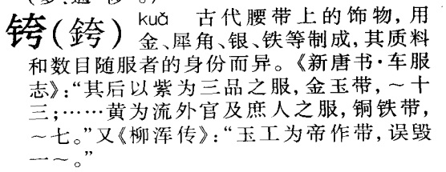

**Fig. 1486. *Gudai Hanyu Cidian* (Beijing, 2003) p. 931**

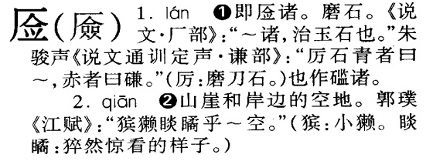

**Fig. 1487. *Gudai Hanyu Cidian* (Beijing, 2003) p. 933**

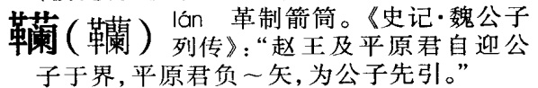

**Fig. 1488. *Gudai Hanyu Cidian* (Beijing, 2003) p. 1099**

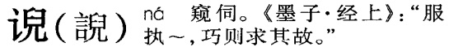

**Fig. 1489. *Gudai Hanyu Cidian* (Beijing, 2003) p. 1152**

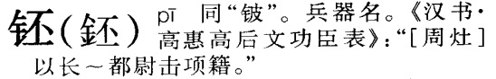

**Fig. 1490. *Gudai Hanyu Cidian* (Beijing, 2003) p. 1314**

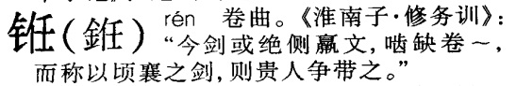

**Fig. 1491. *Gudai Hanyu Cidian* (Beijing, 2003) p. 1356**

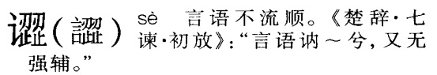

**Fig. 1492. *Gudai Hanyu Cidian* (Beijing, 2003) p. 1409**

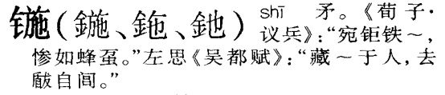

**Fig. 1493. *Gudai Hanyu Cidian* (Beijing, 2003) p. 1485**

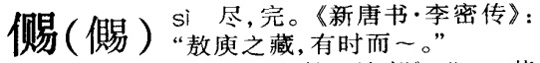

**Fig. 1494. *Gudai Hanyu Cidian* (Beijing, 2003) p. 1509**

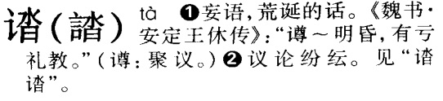

**Fig. 1495. *Gudai Hanyu Cidian* (Beijing, 2003) p. 1510**

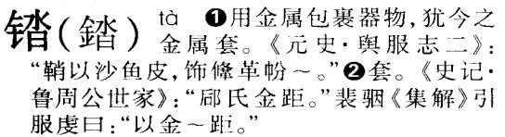

**Fig. 1496. *Gudai Hanyu Cidian* (Beijing, 2003) p. 1527**

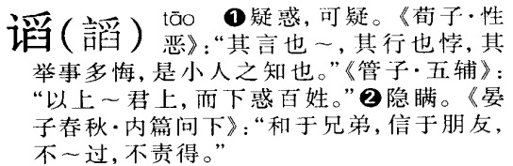

**Fig. 1497. *Gudai Hanyu Cidian* (Beijing, 2003) p. 1547**

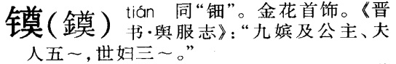

**Fig. 1498. *Gudai Hanyu Cidian* (Beijing, 2003) p. 1677**

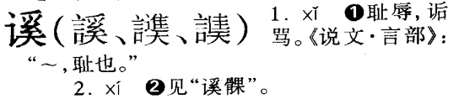

**Fig. 1499. *Gudai Hanyu Cidian* (Beijing, 2003) p. 1768**

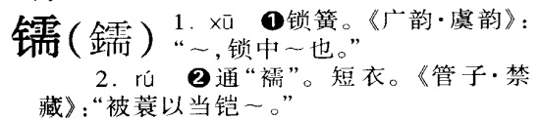

**Fig. 1500. *Gudai Hanyu Cidian* (Beijing, 2003) p. 1770**

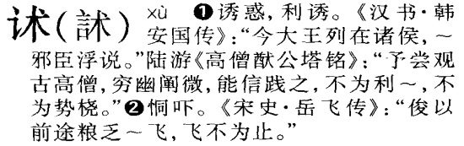

**Fig. 1501. *Gudai Hanyu Cidian* (Beijing, 2003) p. 1794**

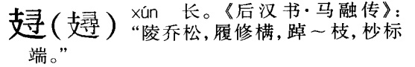

**Fig. 1502. *Gudai Hanyu Cidian* (Beijing, 2003) p. 1799**

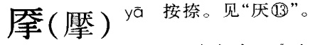

**Fig. 1503. *Gudai Hanyu Cidian* (Beijing, 2003) p. 1804**

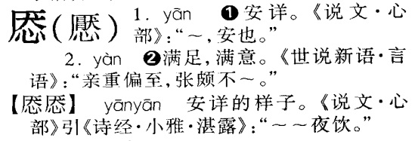

**Fig. 1504. *Gudai Hanyu Cidian* (Beijing, 2003) p. 1813**

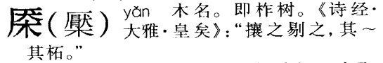

**Fig. 1505. *Gudai Hanyu Cidian* (Beijing, 2003) p. 1853**

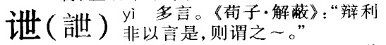

**Fig. 1506. *Gudai Hanyu Cidian* (Beijing, 2003) p. 1871**

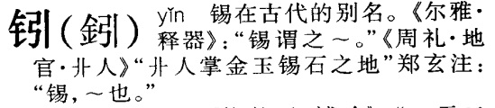

**Fig. 1507. *Gudai Hanyu Cidian* (Beijing, 2003) p. 1897**

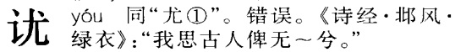

**Fig. 1508. *Gudai Hanyu Cidian* (Beijing, 2003) p. 1919**

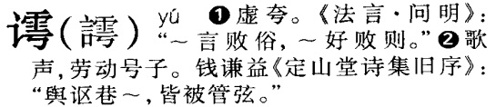

**Fig. 1509. *Gudai Hanyu Cidian* (Beijing, 2003) p. 1931**

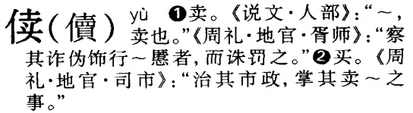

**Fig. 1510. *Gudai Hanyu Cidian* (Beijing, 2003) p. 1935**

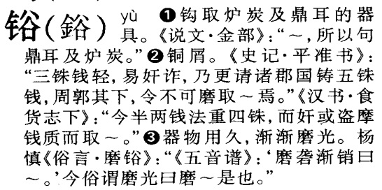

**Fig. 1511. *Gudai Hanyu Cidian* (Beijing, 2003) p. 2047**

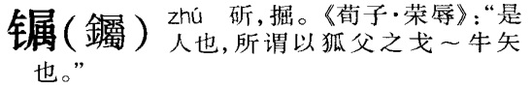

**Fig. 1512. *Gudai Hanyu Cidian* (Beijing, 2003) p. 2059**

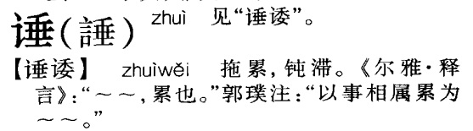

**Fig. 1513. *Hanyu Fangyan Da Cidian* (Beijing, 1999) p. 108**

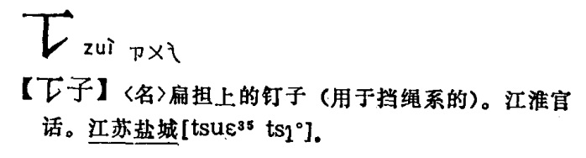

**Fig. 1514. *Hanyu Fangyan Da Cidian* (Beijing, 1999) p. 143**

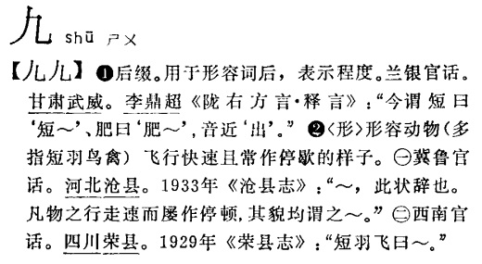

**Fig. 1515. *Hanyu Fangyan Da Cidian* (Beijing, 1999) p. 341**

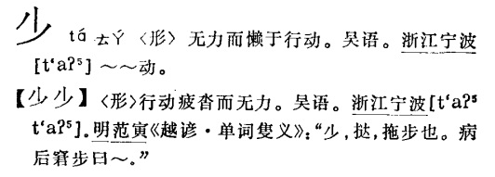

**Fig. 1516. *Hanyu Fangyan Da Cidian* (Beijing, 1999) pp. 672-673**

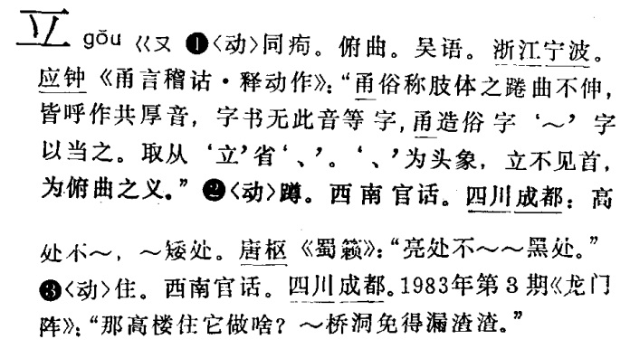

**Fig. 1517. *Hanyu Fangyan Da Cidian* (Beijing, 1999) p. 906**

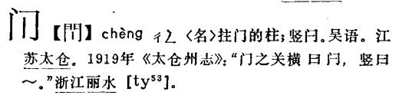

**Fig. 1518. *Hanyu Fangyan Da Cidian* (Beijing, 1999) p. 1117**

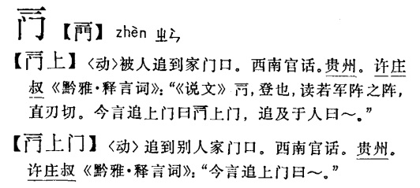

**Fig. 1519. *Hanyu Fangyan Da Cidian* (Beijing, 1999) p. 1204**

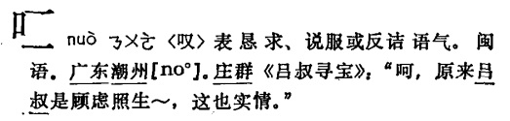

**Fig. 1520. *Hanyu Fangyan Da Cidian* (Beijing, 1999) p. 1454**

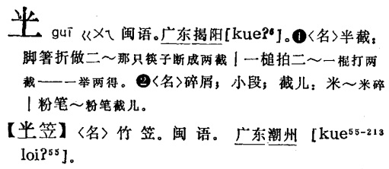

**Fig. 1521. *Hanyu Fangyan Da Cidian* (Beijing, 1999) p. 2131**

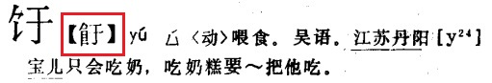

**Fig. 1522. *Hanyu Fangyan Da Cidian* (Beijing, 1999) p. 2131**

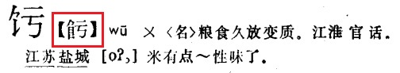

**Fig. 1523. *Hanyu Fangyan Da Cidian* (Beijing, 1999) p. 2180**

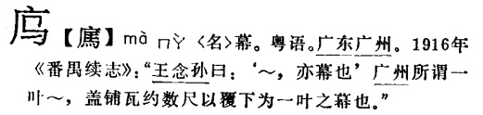

**Fig. 1524. *Hanyu Fangyan Da Cidian* (Beijing, 1999) p. 2370**

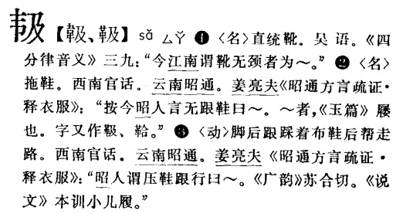

**Fig. 1525. *Hanyu Fangyan Da Cidian* (Beijing, 1999) p. 2793**

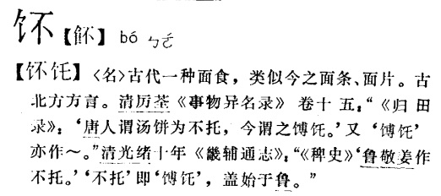

**Fig. 1526. *Hanyu Fangyan Da Cidian* (Beijing, 1999) p. 2952**

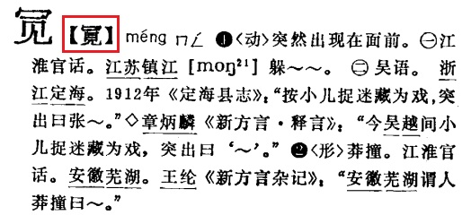

**Fig. 1527. *Hanyu Fangyan Da Cidian* (Beijing, 1999) p. 3038**

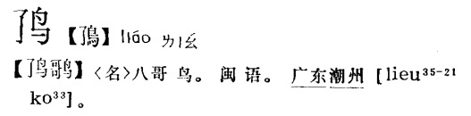

**Fig. 1528. *Hanyu Fangyan Da Cidian* (Beijing, 1999) p. 3052**

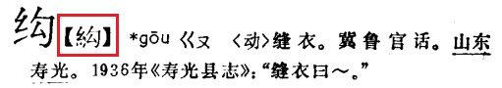

**Fig. 1529. *Hanyu Fangyan Da Cidian* (Beijing, 1999) p. 3184**

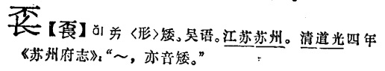

**Fig. 1530. *Hanyu Fangyan Da Cidian* (Beijing, 1999) p. 3199**

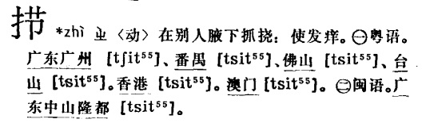

**Fig. 1531. *Hanyu Fangyan Da Cidian* (Beijing, 1999) p. 3236**

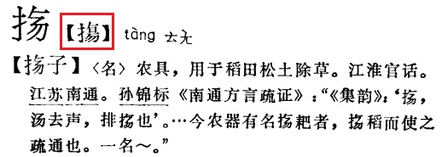

**Fig. 1532. *Hanyu Fangyan Da Cidian* (Beijing, 1999) p. 3286**

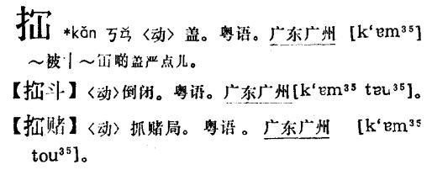

**Fig. 1533. *Hanyu Fangyan Da Cidian* (Beijing, 1999) p. 3416**

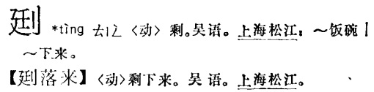

**Fig. 1534. *Hanyu Fangyan Da Cidian* (Beijing, 1999) p. 3421**

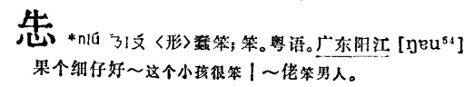

**Fig. 1535. *Hanyu Fangyan Da Cidian* (Beijing, 1999) p. 3440**

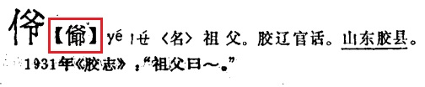

**Fig. 1536. *Hanyu Fangyan Da Cidian* (Beijing, 1999) p. 3450**

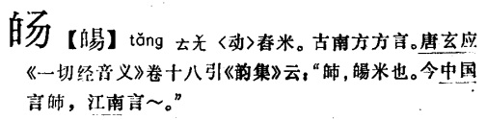

**Fig. 1537. *Hanyu Fangyan Da Cidian* (Beijing, 1999) p. 3800**

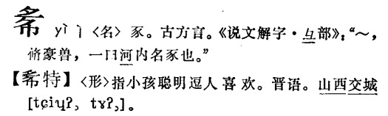

**Fig. 1538. *Hanyu Fangyan Da Cidian* (Beijing, 1999) p. 3869**

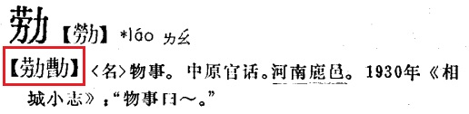

**Fig. 1539. *Hanyu Fangyan Da Cidian* (Beijing, 1999) p. 3996**

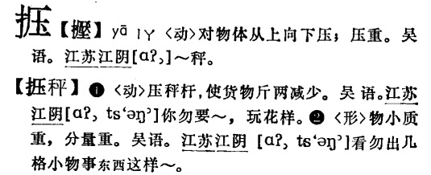

**Fig. 1540. *Hanyu Fangyan Da Cidian* (Beijing, 1999) p. 4022**

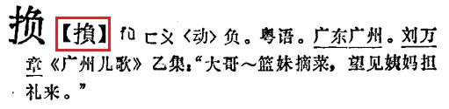

**Fig. 1541. *Hanyu Fangyan Da Cidian* (Beijing, 1999) p. 4141**

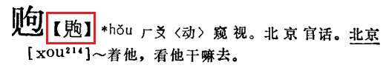

**Fig. 1542. *Hanyu Fangyan Da Cidian* (Beijing, 1999) p. 4185**

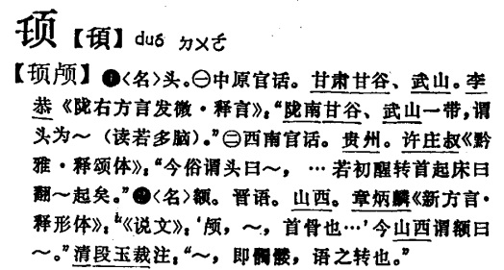

**Fig. 1543. *Hanyu Fangyan Da Cidian* (Beijing, 1999) p. 4221**

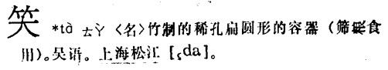

**Fig. 1544. *Hanyu Fangyan Da Cidian* (Beijing, 1999) p. 4316**

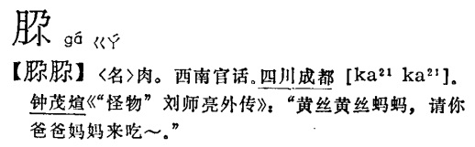

**Fig. 1545. *Hanyu Fangyan Da Cidian* (Beijing, 1999) p. 4351**

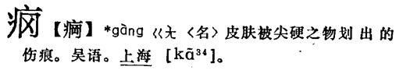

**Fig. 1546. *Hanyu Fangyan Da Cidian* (Beijing, 1999) p. 4429**

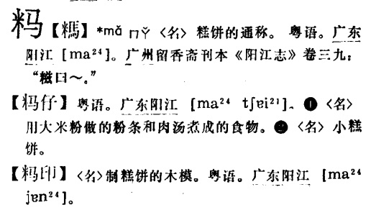

**Fig. 1547. *Hanyu Fangyan Da Cidian* (Beijing, 1999) p. 4475**

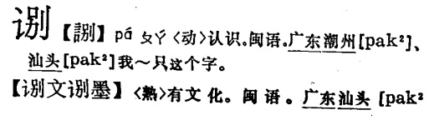

**Fig. 1548. *Hanyu Fangyan Da Cidian* (Beijing, 1999) p. 4482**

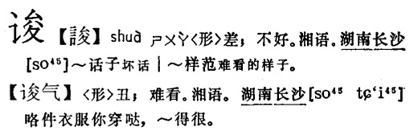

**Fig. 1549. *Hanyu Fangyan Da Cidian* (Beijing, 1999) p. 4629**

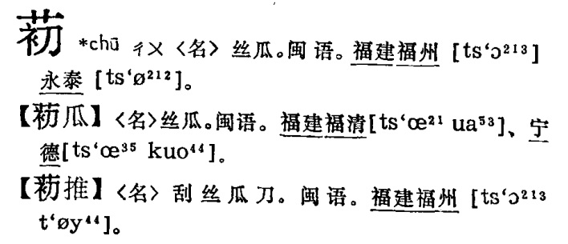

**Fig. 1550. *Hanyu Fangyan Da Cidian* (Beijing, 1999) p. 4629**

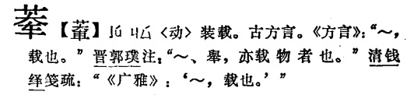

**Fig. 1551. *Hanyu Fangyan Da Cidian* (Beijing, 1999) p. 4694**

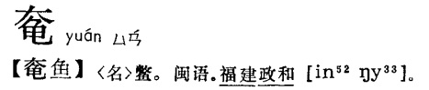

**Fig. 1552. *Hanyu Fangyan Da Cidian* (Beijing, 1999) p. 4808**

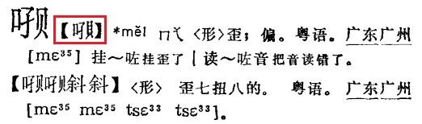

**Fig. 1553. *Hanyu Fangyan Da Cidian* (Beijing, 1999) p. 4858**

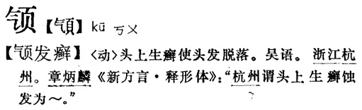

**Fig. 1554. *Hanyu Fangyan Da Cidian* (Beijing, 1999) p. 4944**

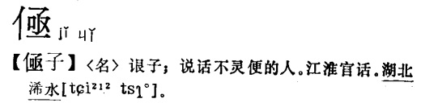

**Fig. 1555. *Hanyu Fangyan Da Cidian* (Beijing, 1999) p. 5089**

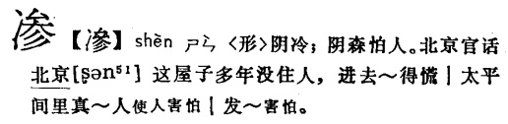

**Fig. 1556. *Hanyu Fangyan Da Cidian* (Beijing, 1999) p. 5135**

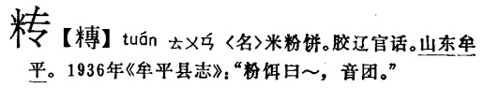

**Fig. 1557. *Hanyu Fangyan Da Cidian* (Beijing, 1999) p. 5188**

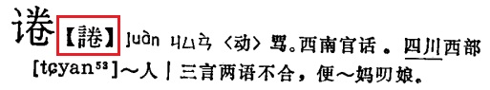

**Fig. 1558. *Hanyu Fangyan Da Cidian* (Beijing, 1999) p. 5211**

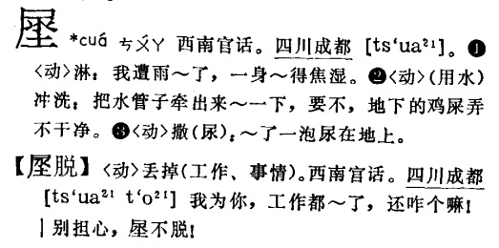

**Fig. 1559. *Hanyu Fangyan Da Cidian* (Beijing, 1999) p. 5386**

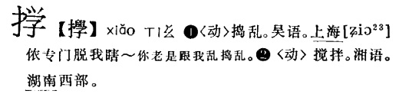

**Fig. 1560. *Hanyu Fangyan Da Cidian* (Beijing, 1999) p. 5434**

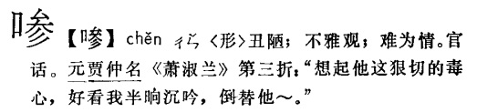

**Fig. 1561. *Hanyu Fangyan Da Cidian* (Beijing, 1999) p. 5574**

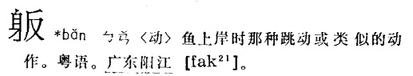

**Fig. 1562. *Hanyu Fangyan Da Cidian* (Beijing, 1999) p. 5643**

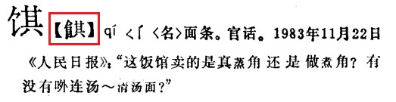

**Fig. 1563. *Hanyu Fangyan Da Cidian* (Beijing, 1999) p. 5687**

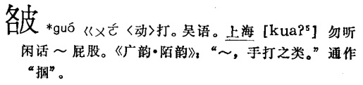

**Fig. 1564. *Hanyu Fangyan Da Cidian* (Beijing, 1999) p. 5690**

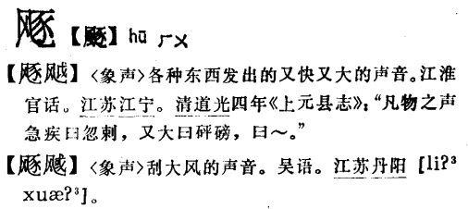

**Fig. 1565. *Hanyu Fangyan Da Cidian* (Beijing, 1999) p. 5830**

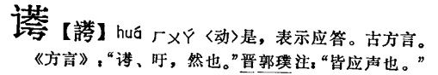

**Fig. 1566. *Hanyu Fangyan Da Cidian* (Beijing, 1999) p. 5851**

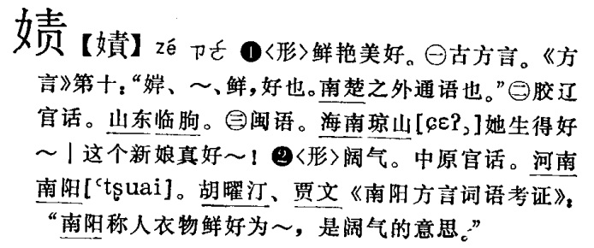

**Fig. 1567. *Hanyu Fangyan Da Cidian* (Beijing, 1999) p. 5854**

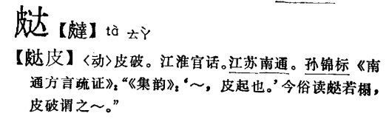

**Fig. 1568. *Hanyu Fangyan Da Cidian* (Beijing, 1999) p. 5860**

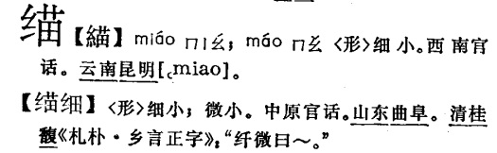

**Fig. 1569. *Hanyu Fangyan Da Cidian* (Beijing, 1999) p. 5876**

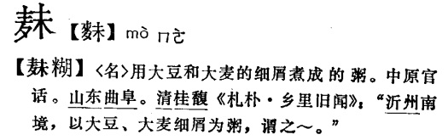

**Fig. 1570. *Hanyu Fangyan Da Cidian* (Beijing, 1999) p. 5877**

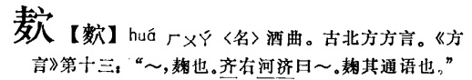

**Fig. 1571. *Hanyu Fangyan Da Cidian* (Beijing, 1999) p. 5877**

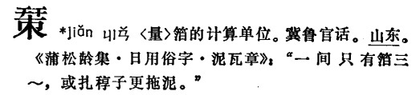

**Fig. 1572. *Hanyu Fangyan Da Cidian* (Beijing, 1999) p. 6022**

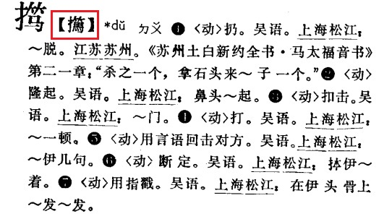

**Fig. 1573. *Hanyu Fangyan Da Cidian* (Beijing, 1999) p. 6040**

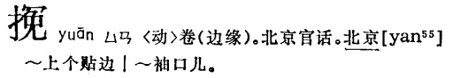

**Fig. 1574. *Hanyu Fangyan Da Cidian* (Beijing, 1999) p. 6049**

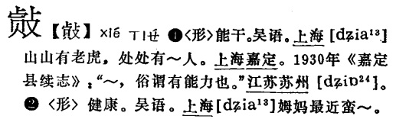

**Fig. 1575. *Hanyu Fangyan Da Cidian* (Beijing, 1999) p. 6049**

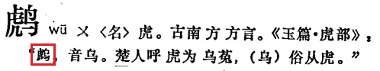

**Fig. 1576. *Hanyu Fangyan Da Cidian* (Beijing, 1999) p. 6125**

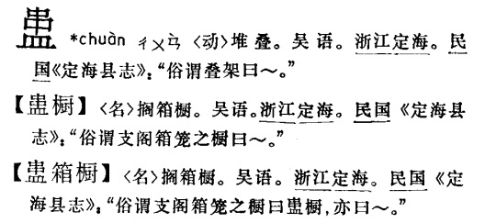

**Fig. 1577. *Hanyu Fangyan Da Cidian* (Beijing, 1999) p. 6150**

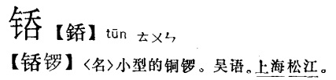

**Fig. 1578. *Hanyu Fangyan Da Cidian* (Beijing, 1999) p. 6165**

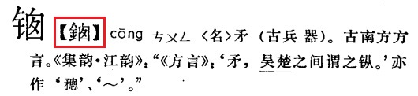

**Fig. 1579. *Hanyu Fangyan Da Cidian* (Beijing, 1999) p. 6206**

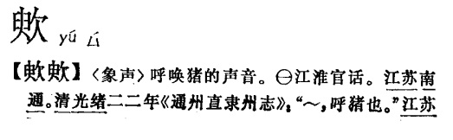

**Fig. 1580. *Hanyu Fangyan Da Cidian* (Beijing, 1999) p. 6237**

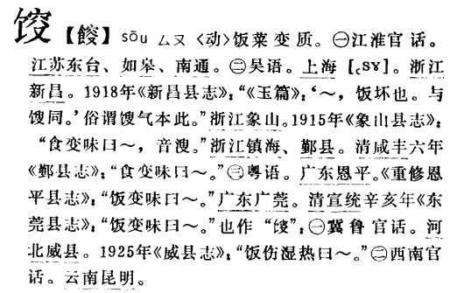

**Fig. 1581. *Hanyu Fangyan Da Cidian* (Beijing, 1999) p. 6248**

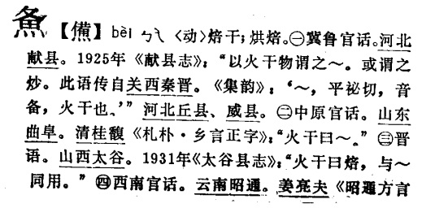

**Fig. 1582. *Hanyu Fangyan Da Cidian* (Beijing, 1999) p. 6303**

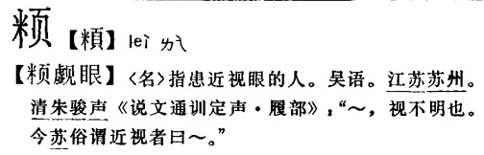

**Fig. 1583. *Hanyu Fangyan Da Cidian* (Beijing, 1999) p. 6303**

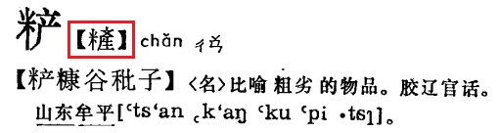

**Fig. 1584. *Hanyu Fangyan Da Cidian* (Beijing, 1999) p. 6403**

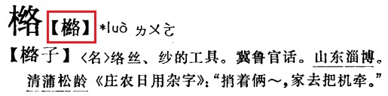

**Fig. 1585. *Hanyu Fangyan Da Cidian* (Beijing, 1999) p. 6470**

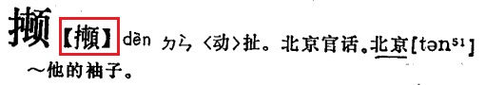

**Fig. 1586. *Hanyu Fangyan Da Cidian* (Beijing, 1999) p. 6496**

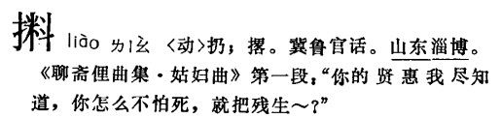

**Fig. 1587. *Hanyu Fangyan Da Cidian* (Beijing, 1999) p. 6504**

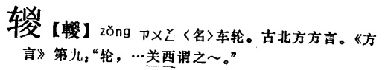

**Fig. 1588. *Hanyu Fangyan Da Cidian* (Beijing, 1999) p. 6556**

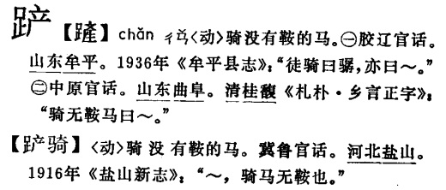

**Fig. 1589. *Hanyu Fangyan Da Cidian* (Beijing, 1999) p. 6595**

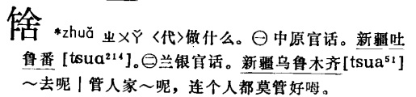

**Fig. 1590. *Hanyu Fangyan Da Cidian* (Beijing, 1999) p. 6624**

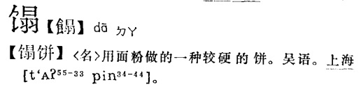

**Fig. 1591. *Hanyu Fangyan Da Cidian* (Beijing, 1999) p. 6678**

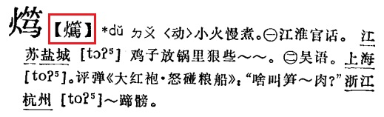

**Fig. 1592. *Hanyu Fangyan Da Cidian* (Beijing, 1999) p. 6679**

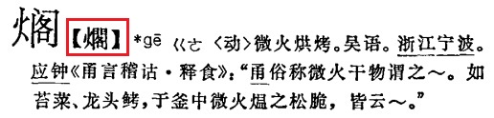

**Fig. 1593. *Hanyu Fangyan Da Cidian* (Beijing, 1999) p. 6710**

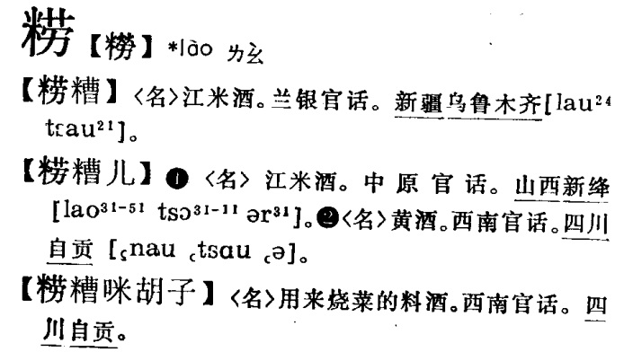

**Fig. 1594. *Hanyu Fangyan Da Cidian* (Beijing, 1999) p. 6728**

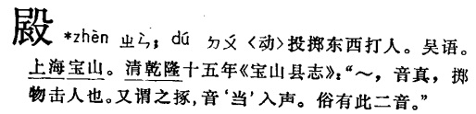

**Fig. 1595. *Hanyu Fangyan Da Cidian* (Beijing, 1999) p. 6729**

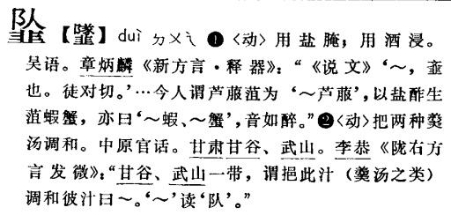

**Fig. 1596. *Hanyu Fangyan Da Cidian* (Beijing, 1999) p. 6750**

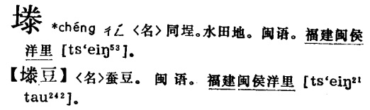

**Fig. 1597. *Hanyu Fangyan Da Cidian* (Beijing, 1999) p. 6758**

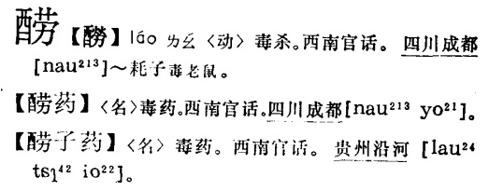

**Fig. 1598. *Hanyu Fangyan Da Cidian* (Beijing, 1999) p. 6797**

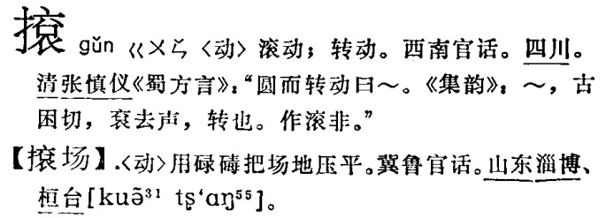

**Fig. 1599. *Hanyu Fangyan Da Cidian* (Beijing, 1999) p. 6840**

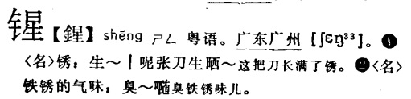

**Fig. 1600. *Hanyu Fangyan Da Cidian* (Beijing, 1999) p. 6846**

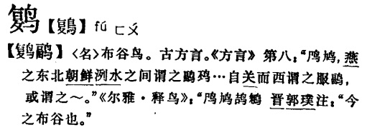

**Fig. 1601. *Hanyu Fangyan Da Cidian* (Beijing, 1999) p. 6878**

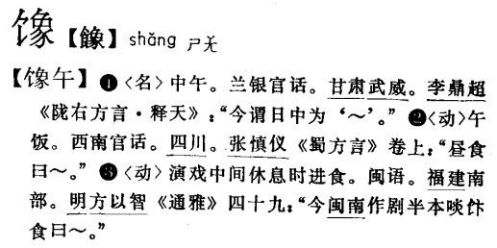

**Fig. 1602. *Hanyu Fangyan Da Cidian* (Beijing, 1999) p. 6879**

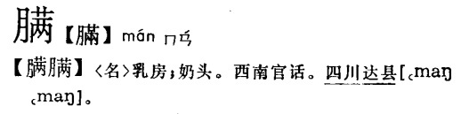

**Fig. 1603. *Hanyu Fangyan Da Cidian* (Beijing, 1999) p. 6956**

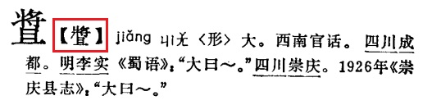

**Fig. 1604. *Hanyu Fangyan Da Cidian* (Beijing, 1999) p. 6957**

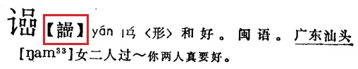

**Fig. 1605. *Hanyu Fangyan Da Cidian* (Beijing, 1999) p. 6963**

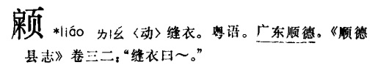

**Fig. 1606. *Hanyu Fangyan Da Cidian* (Beijing, 1999) p. 6969**

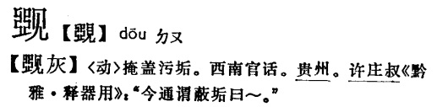

**Fig. 1607. *Hanyu Fangyan Da Cidian* (Beijing, 1999) p. 6969**

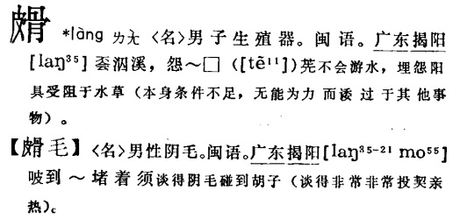

**Fig. 1608. *Hanyu Fangyan Da Cidian* (Beijing, 1999) p. 6988**

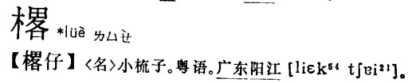

**Fig. 1609. *Hanyu Fangyan Da Cidian* (Beijing, 1999) p. 7058**

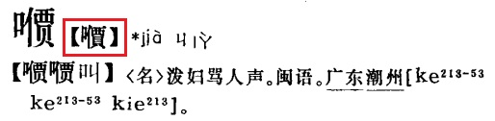

**Fig. 1610. *Hanyu Fangyan Da Cidian* (Beijing, 1999) p. 7061**

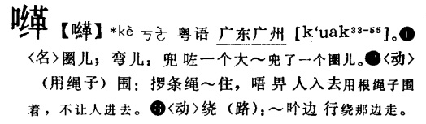

**Fig. 1611. *Hanyu Fangyan Da Cidian* (Beijing, 1999) p. 7080**

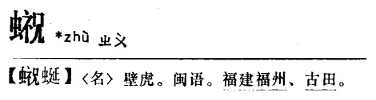

**Fig. 1612. *Hanyu Fangyan Da Cidian* (Beijing, 1999) p. 7126**

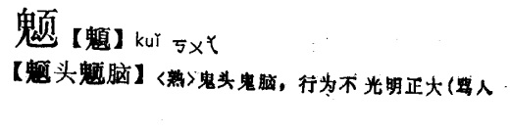

**Fig. 1613. *Hanyu Fangyan Da Cidian* (Beijing, 1999) p. 7127**

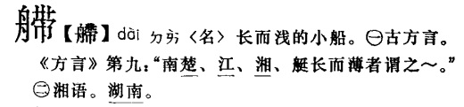

**Fig. 1614. *Hanyu Fangyan Da Cidian* (Beijing, 1999) p. 7136**

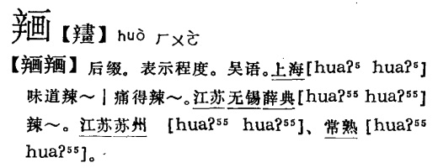

**Fig. 1615. *Hanyu Fangyan Da Cidian* (Beijing, 1999) p. 7185**

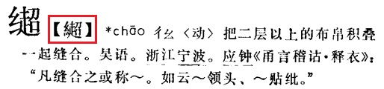

**Fig. 1616. *Hanyu Fangyan Da Cidian* (Beijing, 1999) p. 7243**

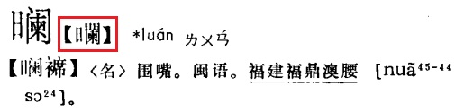

**Fig. 1617. *Hanyu Fangyan Da Cidian* (Beijing, 1999) p. 7246**

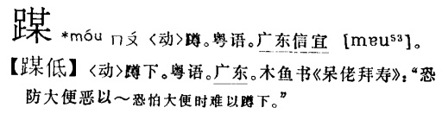

**Fig. 1618. *Hanyu Fangyan Da Cidian* (Beijing, 1999) p. 7293**

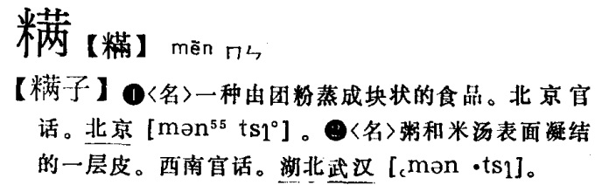

**Fig. 1619. *Hanyu Fangyan Da Cidian* (Beijing, 1999) p. 7312**

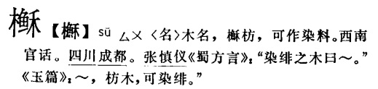

**Fig. 1620. *Hanyu Fangyan Da Cidian* (Beijing, 1999) p. 7312**

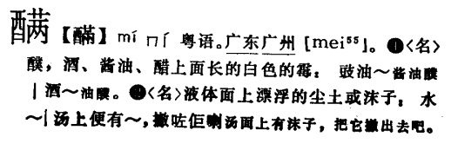

**Fig. 1621. *Hanyu Fangyan Da Cidian* (Beijing, 1999) p. 7314**

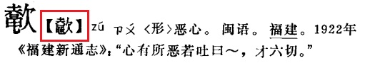

**Fig. 1622. *Hanyu Fangyan Da Cidian* (Beijing, 1999) p. 7321**

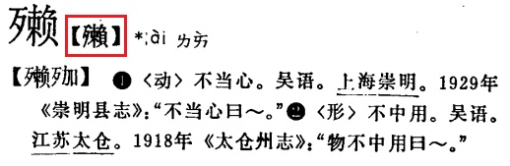

**Fig. 1623. *Hanyu Fangyan Da Cidian* (Beijing, 1999) p. 7343**

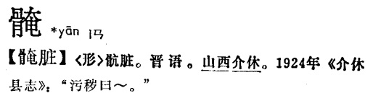

**Fig. 1624. *Hanyu Fangyan Da Cidian* (Beijing, 1999) p. 7354**

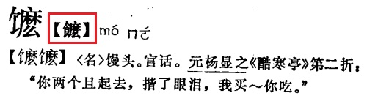

**Fig. 1625. *Hanyu Fangyan Da Cidian* (Beijing, 1999) p. 7359**

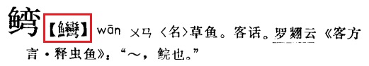

**Fig. 1626. *Hanyu Fangyan Da Cidian* (Beijing, 1999) p. 7423**

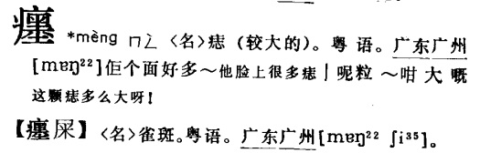

**Fig. 1627. *Hanyu Fangyan Da Cidian* (Beijing, 1999) p. 7438**

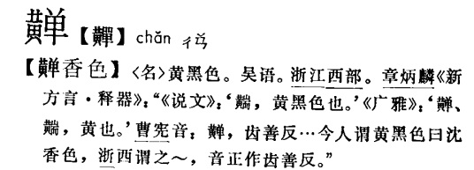

**Fig. 1628. *Hanyu Fangyan Da Cidian* (Beijing, 1999) p. 7444**

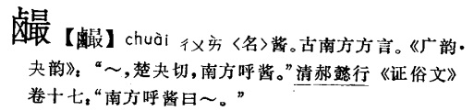

**Fig. 1629. *Hanyu Fangyan Da Cidian* (Beijing, 1999) p. 7444**

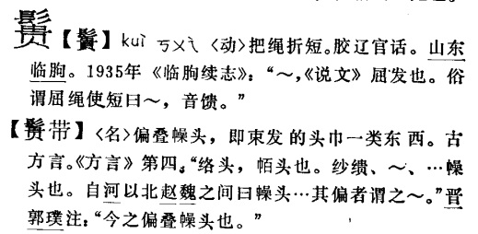

**Fig. 1630. *Hanyu Fangyan Da Cidian* (Beijing, 1999) p. 7470**

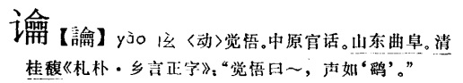

**Fig. 1631. *Hanyu Fangyan Da Cidian* (Beijing, 1999) p. 7519**

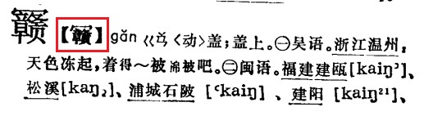

**Fig. 1632. *Song Shi* (Beijing, 2000) p. 527**

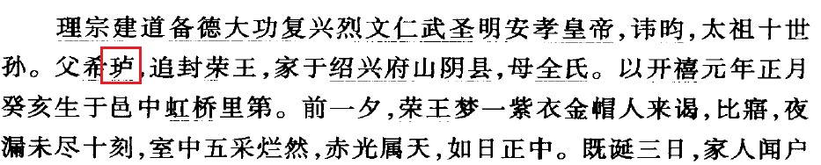

**Fig. 1633. *Ming Shi* (Beijing, 2000) p. 1688**

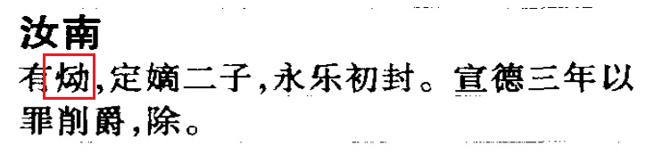

**Fig. 1634. *Ming Shi* (Beijing, 2000) p. 1738**

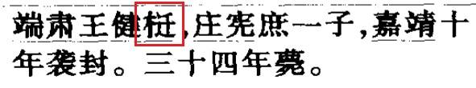

**Fig. 1635. *Ming Shi* (Beijing, 2000) p. 1797**

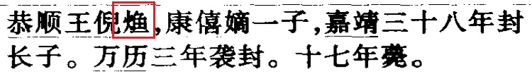

**Fig. 1636. *Ming Shi* (Beijing, 2000) p. 1806**

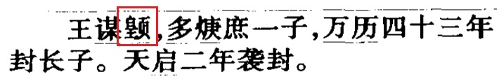

**Fig. 1637. *Ming Shi* (Beijing, 2000) p. 1811**

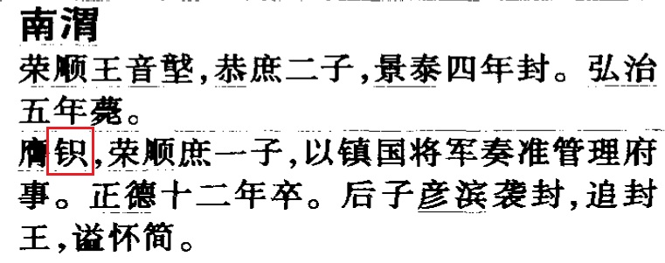

**Fig. 1638. *Ming Shi* (Beijing, 2000) p. 1916**

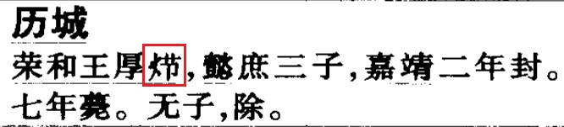

**Fig. 1639. *Ming Shi* (Beijing, 2000) p. 1943**

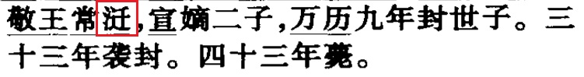

**Fig. 1640. *Ming Shi* (Beijing, 2000) p. 1943**

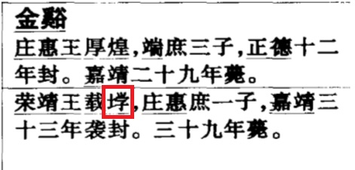

**Fig. 1641. *Ming Shi* (Beijing, 2000) p. 2357**

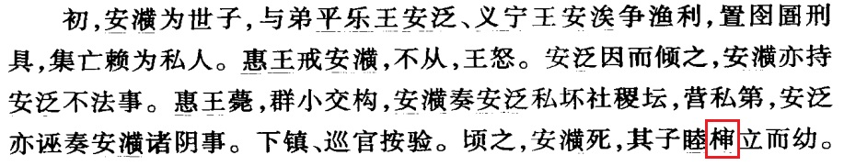

**Fig. 1642. *Ming Shi* (Beijing, 2000) p. 2419**

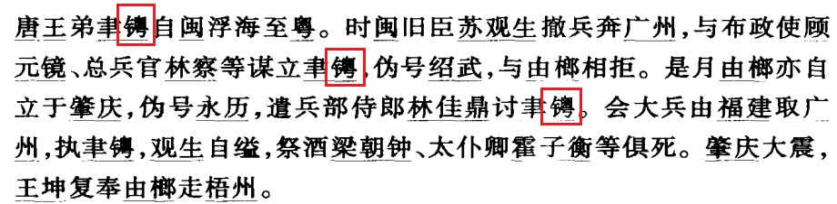

**Fig. 1643. *Nan Ming Shi* (Beijing, 2006) v. 5 p. 1460**

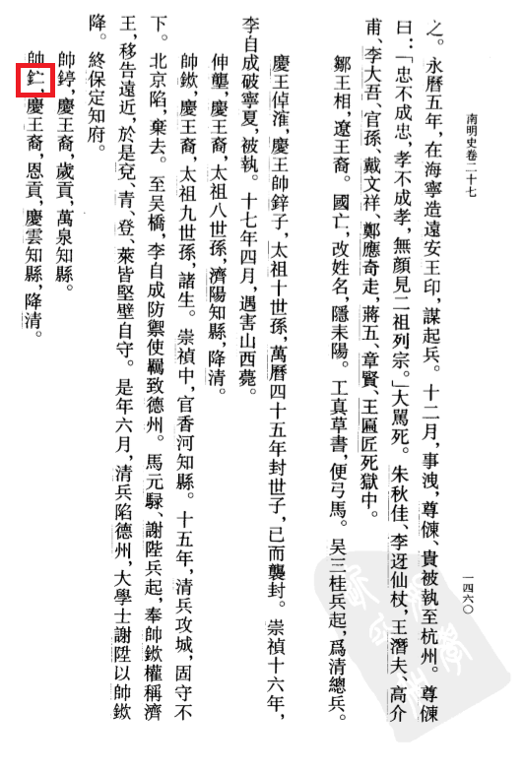

**Fig. 1644. *Nan Ming Shi* (Beijing, 2006) v. 5 p. 1489**

`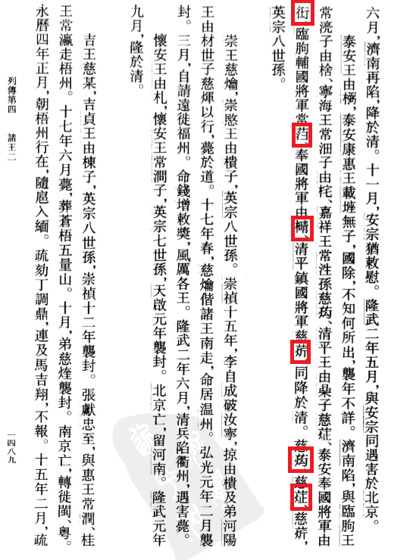

**Fig. 1645. *Nan Ming Shi* (Beijing, 2006) v. 5 p. 1499**

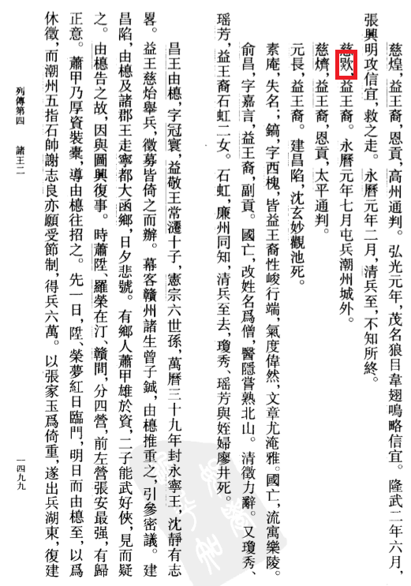

**Fig. 1646. *Nan Ming Shi* (Beijing, 2006) v. 5 p. 1501**

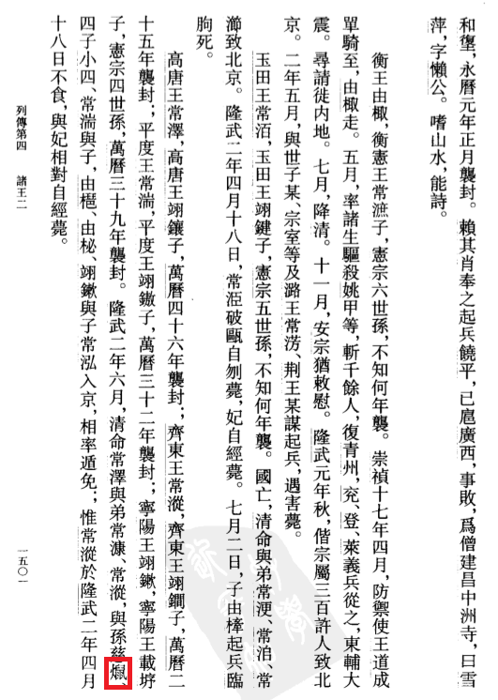

**Fig. 1647. *Nan Ming Shi* (Beijing, 2006) v. 5 p. 1502**

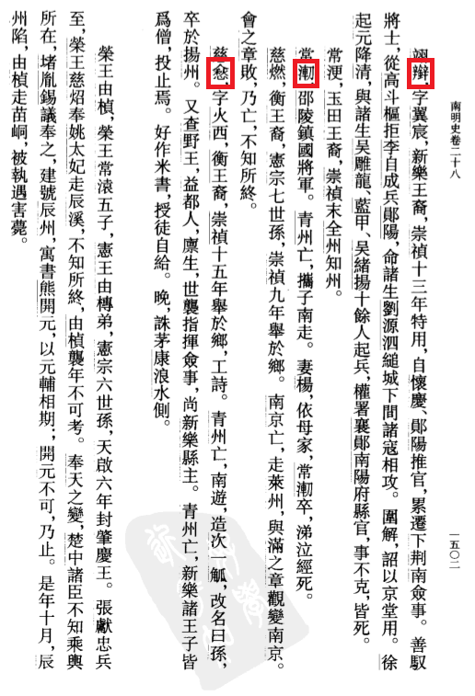

**Fig. 1648. *Yanshantang Bieji* (Beijing, 1985) *juan* 70 p. 1319**

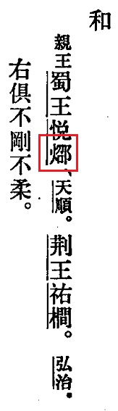

**Fig. 1649. *Jinhuazi Yanjiu* (Beijing, 2004) p. 92**

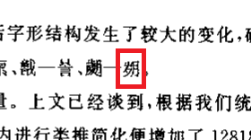

**Fig. 1650. *Jinhuazi Yanjiu* (Beijing, 2004) p. 187**

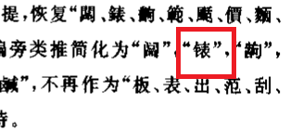

**Fig. 1651. *Jiangxi Chutu Muzhi Xuanbian* (Nancheng, 1991) p. 534**

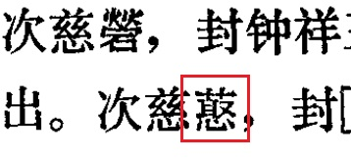

**Fig. 1652. *Zhongguo Lishi Dituji* (Beijing, 1982) vol. 3 p. 34**

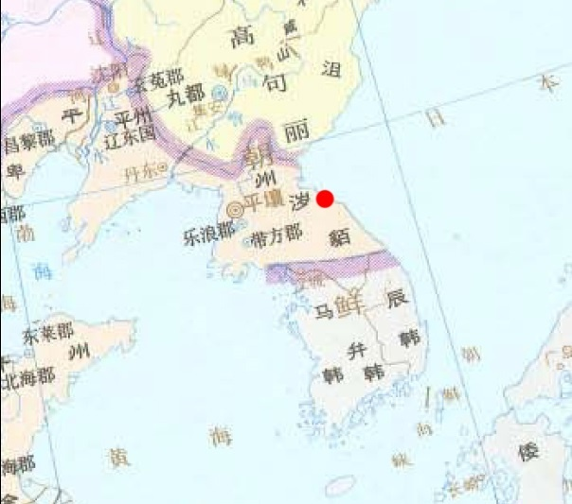

**Fig. 1653. Article in *Yunlin Guojiao* (2014) p. 1 title and p. 2 fig. 1**

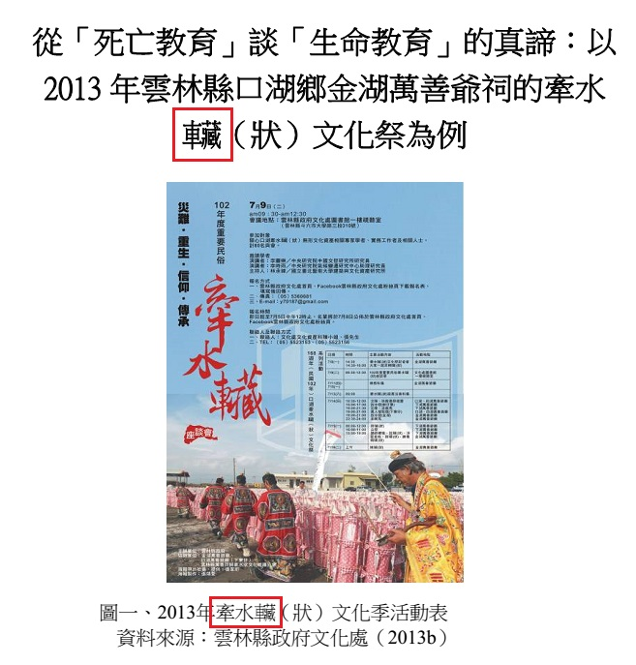

**Fig. 1654. *Tujue Hanguo* (Taipei, 2011) p. 22**

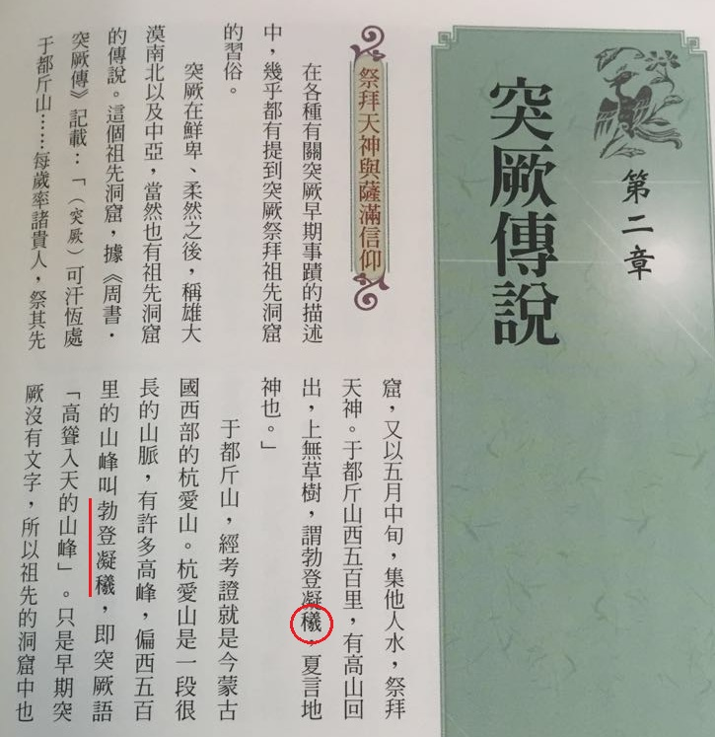

**Fig. 1655. Article in *Zhongguo Keji Shuyu* (2013.6) p. 53**

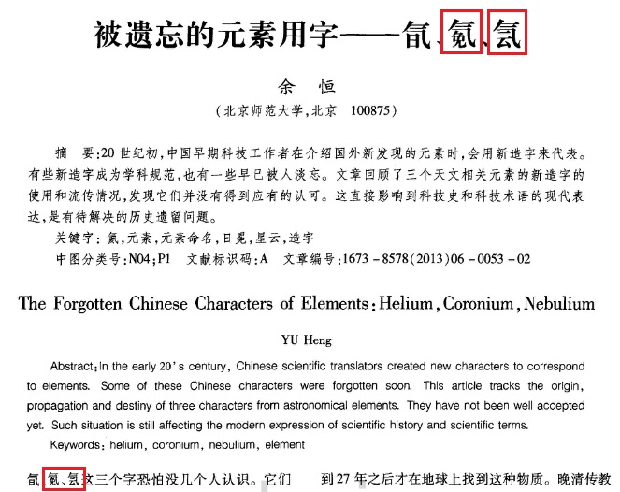

**Fig. 1656. Article in *Hebei Shifan Daxue Xuebao* (1999.4) p. 12**

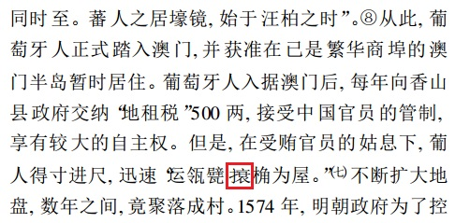

**Fig. 1657. *Gospel of St. Matthew* translated by Joannes Lassar & Joshua Marshman (Serampore, 1810) p. 1a**

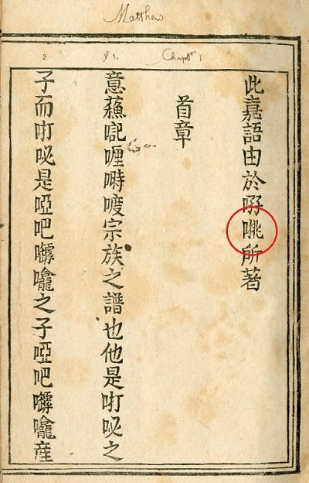

**Fig. 1658. *Nhật dụng thường đàm* p. 47a**

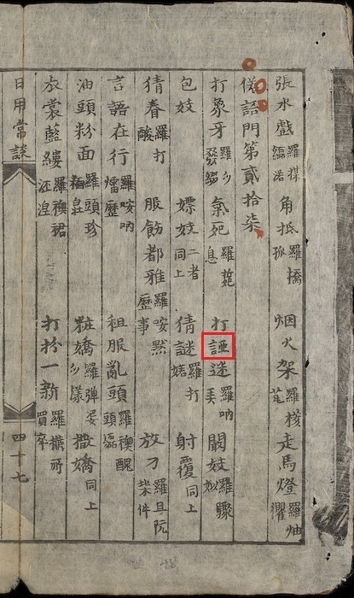

**Fig. 1659. *Kangxi Zidian* (Beijing 1958) p. 124**

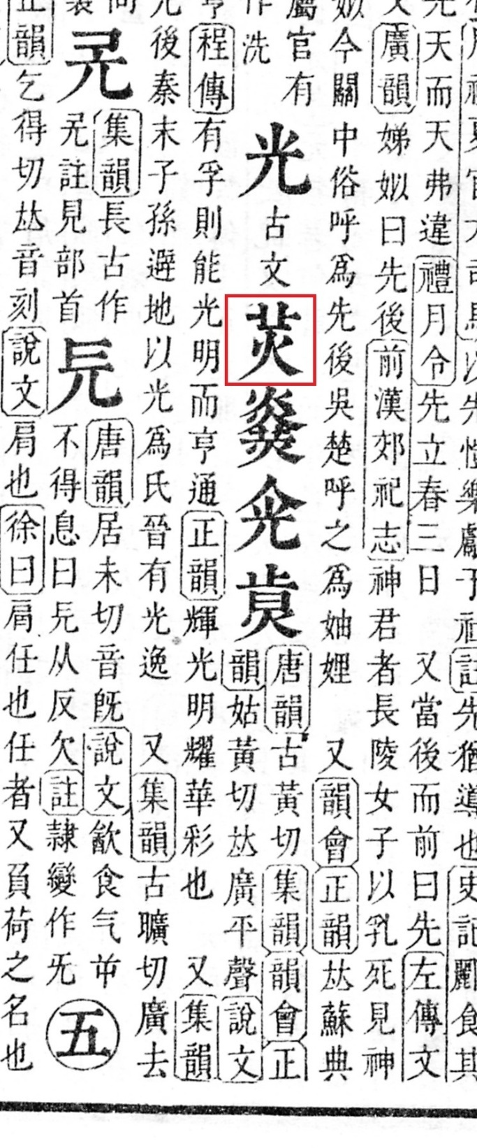

**Fig. 1660. *Kangxi Zidian* (Beijing 1958) p. 238**

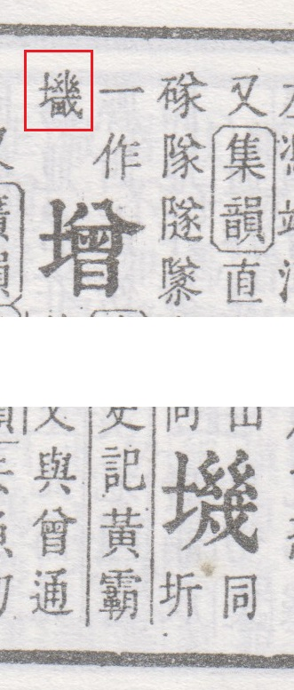

**Fig. 1661. *Kangxi Zidian* (Beijing 1958) p. 369**

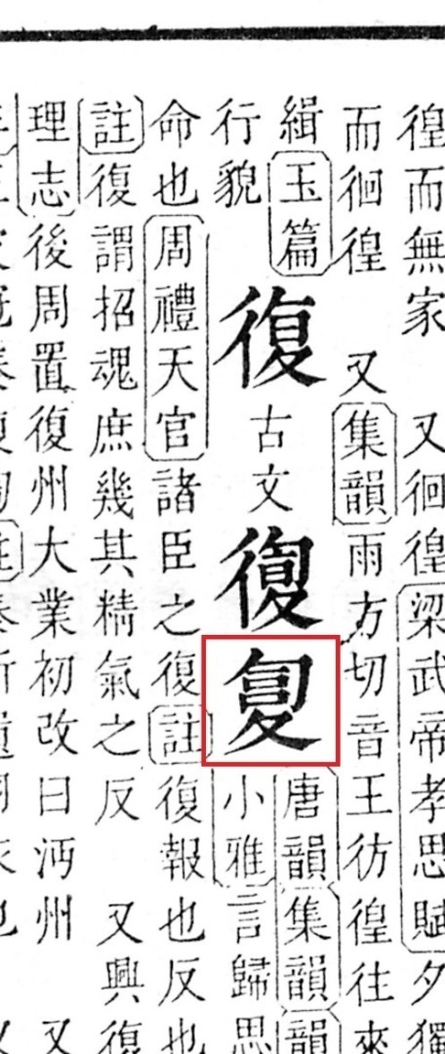

**Fig. 1662. *Kangxi Zidian* (Beijing 1958) p. 547**

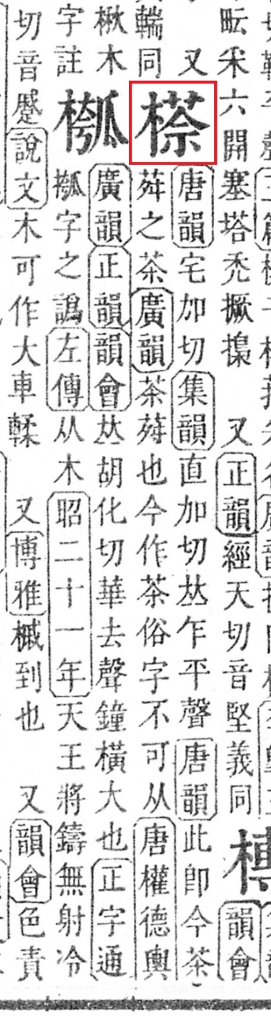

**Fig. 1663. *Kangxi Zidian* (Beijing 1958) p. 563**

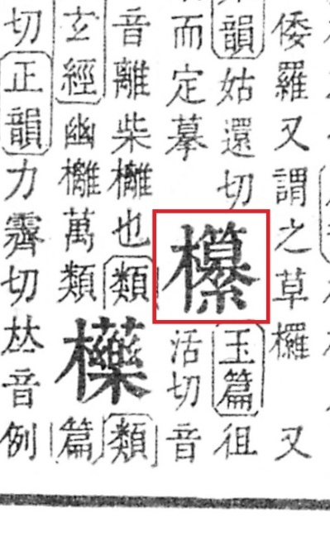

**Fig. 1664. *Kangxi Zidian* (Beijing 1958) p. 762**

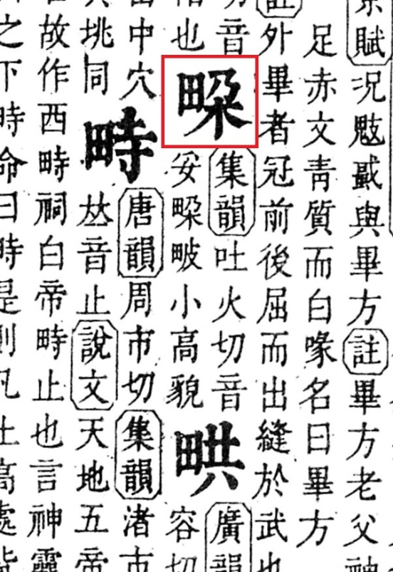

**Fig. 1665. *Kangxi Zidian* (Beijing 1958) p. 852**

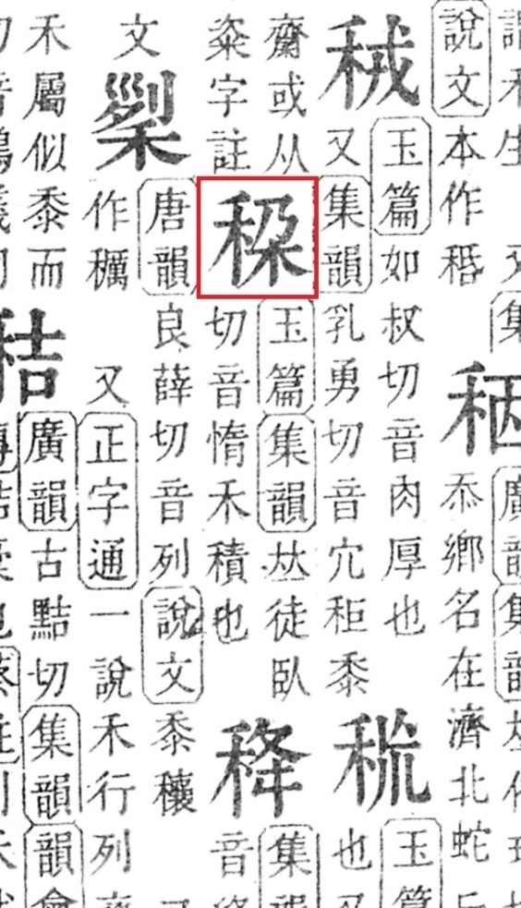

**Fig. 1666. *Kangxi Zidian* (Beijing 1958) p. 1061**

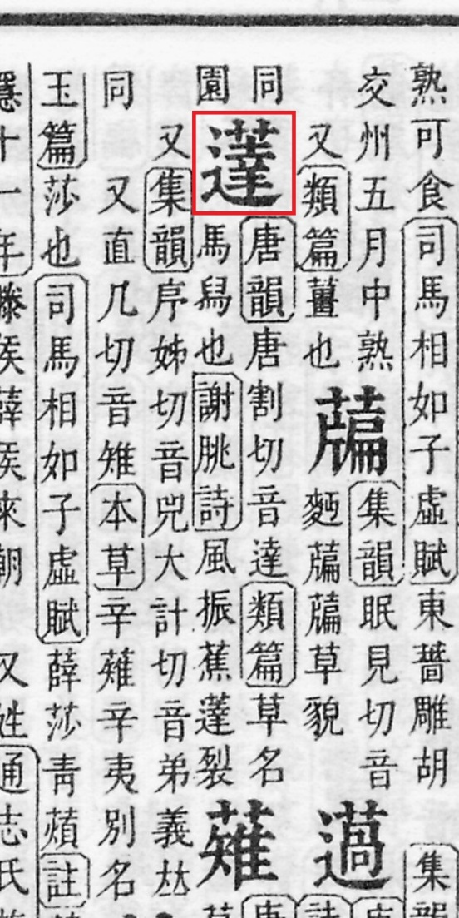

**Fig. 1667. *Kangxi Zidian* (Beijing 1958) p. 1098**

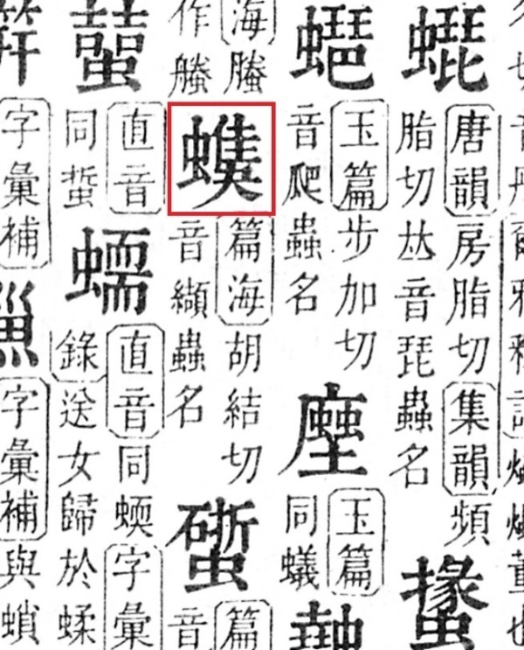

**Fig. 1668. *Kangxi Zidian* (Beijing 1958) p. 1454**

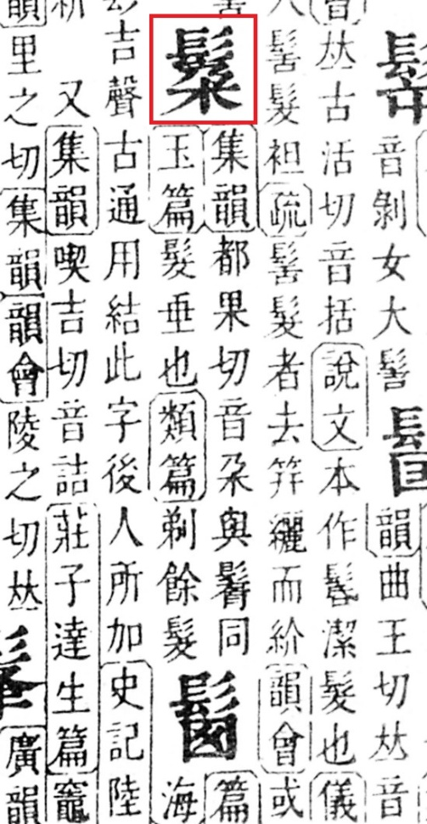

**Fig. 1669. *Kangxi Zidian* (Beijing 1958) p. 1563**

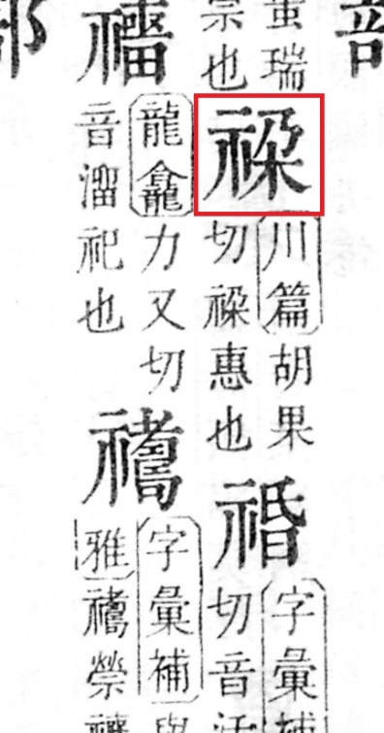

**Fig. 1670. *Kangxi Zidian* (Beijing 1958) p. 1613**

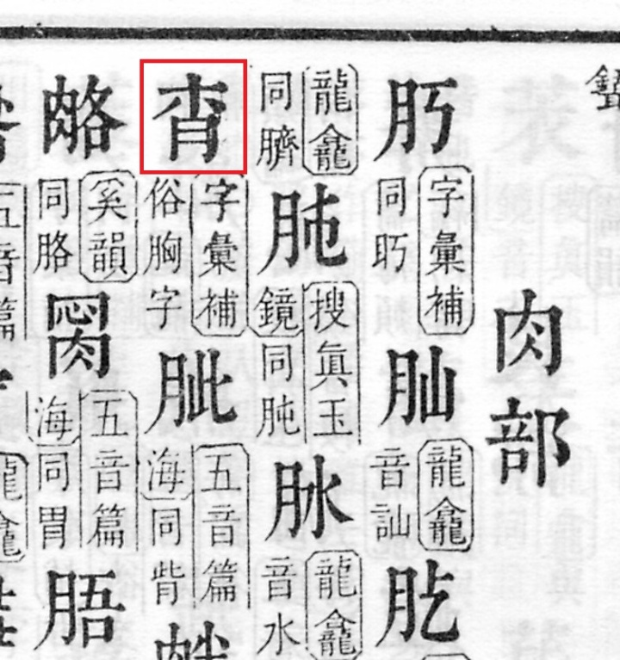

**Fig. 1671. *Yangzhou Wanbao* 2012-08-18 p. A9**

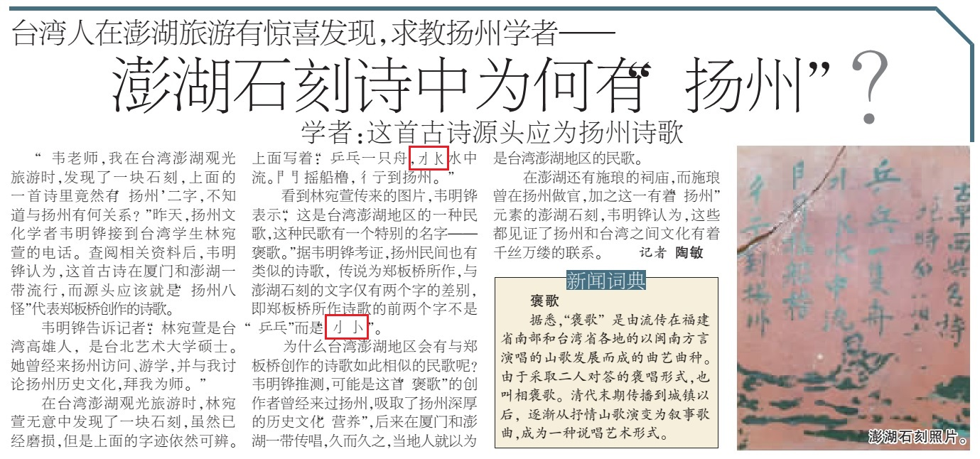

**Fig. 1672. *Xi’an Difang Zhi* (2013) no. 4 p. 33**

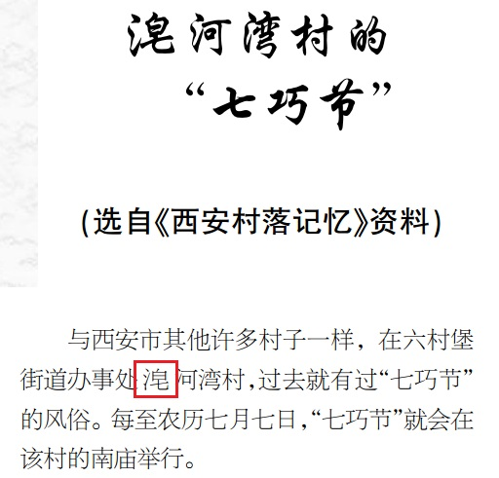

**Fig. 1673. Report by the Xi'an City Bureau of Environmental Protection (2015) p. 16**

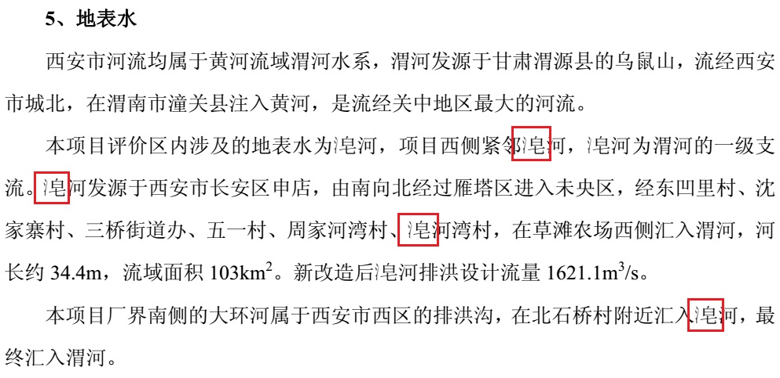

**Fig. 1674. *Shanxi Economic Yearbook for 2012* p. 293 (县域经济发展概况)**

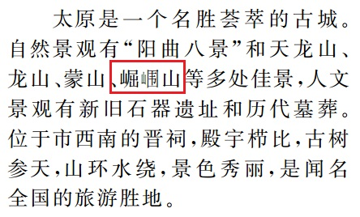

**Fig. 1675. Article in *Shanxi Nongye: Cunwei Zhuren* 2010 no. 5 p. 20**

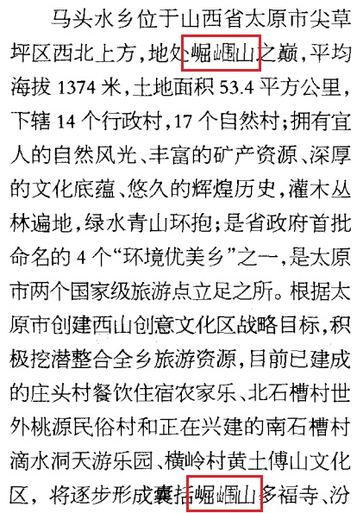

**Fig. 1676. Article in *Lishi Wenhua Mingcheng Baohu Zhongwai Meiti Xinxi Cankao* 2013.11 (no. 20) p. 11**

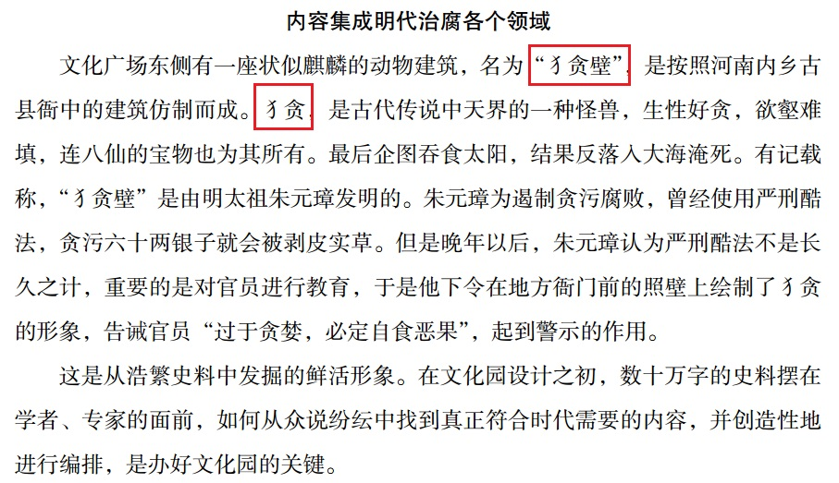

**Fig. 1677. Article in *Lishi Dongnan Kuaibao* 2015-05-11 p. A5**

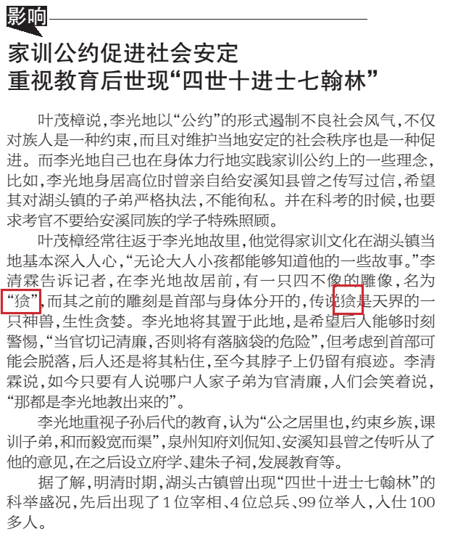

**Fig. 1678. *Pingtan Shibao* (2012-05-23) p. 6 (Text of 海坛赋并序)**

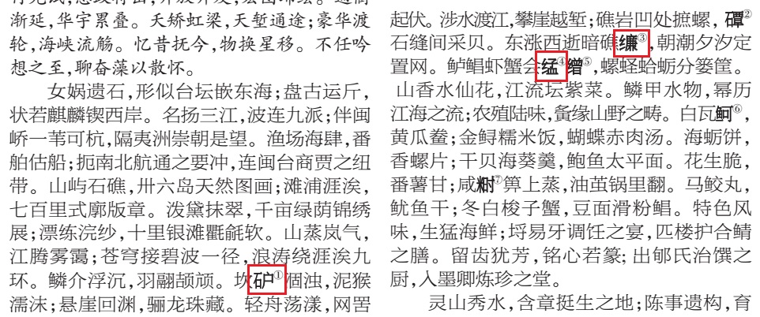

**Fig. 1679. *Pingtan Shibao* (2012-05-23) p. 6 (Notes to海坛赋并序)**

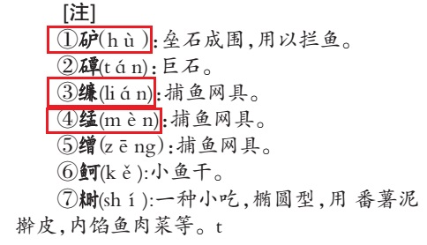

**Fig. 1680. Article in *Zhongguo Nongye Daxue Xuebao* 13 (2008) no. 3 p. 7**

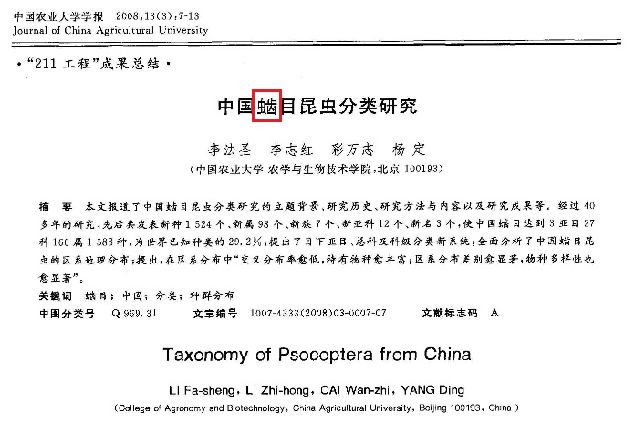

**Fig. 1681. Article in *Gushengwu Xuebao* 43 (2004) no. 2 p. 287**

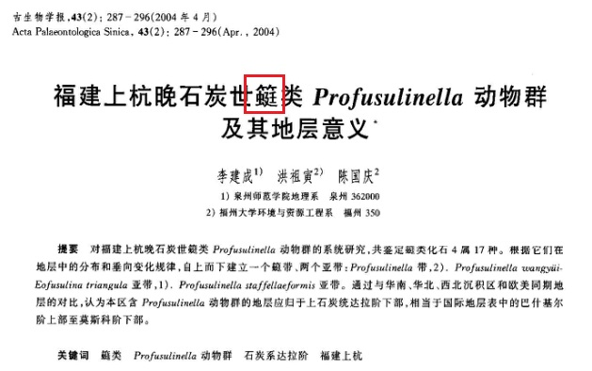

**Fig. 1682. Article in *Weiti Gushengwu Xuebao* 22 (2005) no. 4 p. 400**

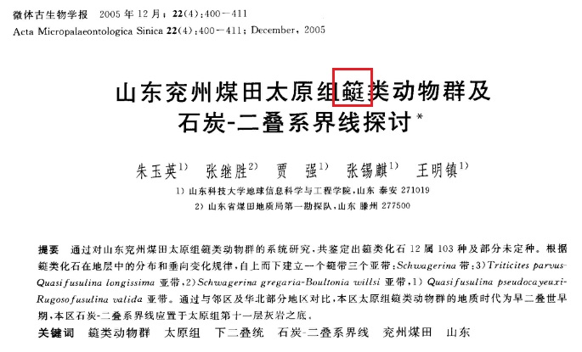

**Fig. 1683. Article in*Guangxi Linye Keji* (1989 no. 3) p. 38**

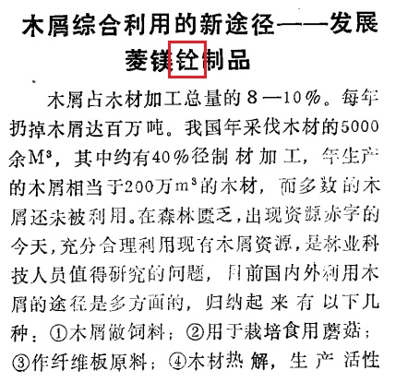

**Fig. 1684. Article in*Xi'an Jinrong* (2005 no. 11) p. 78**

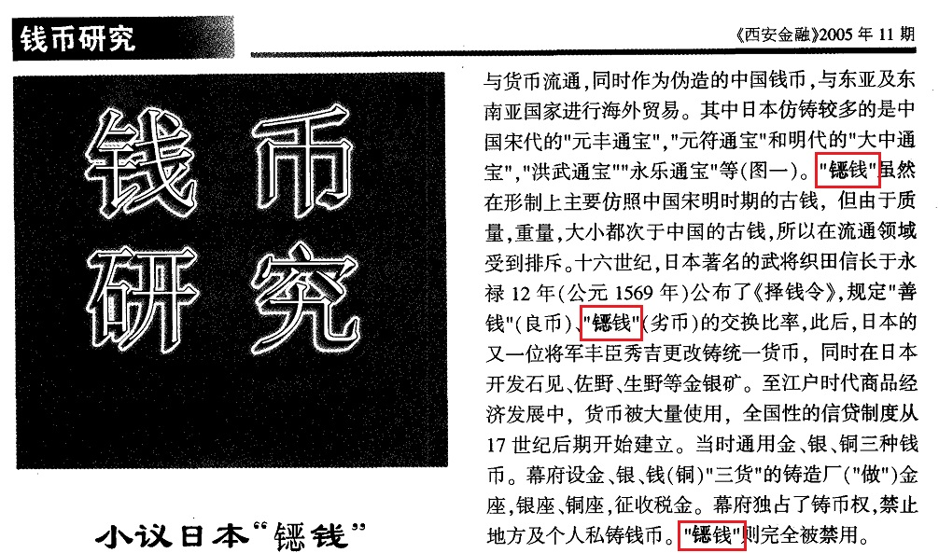

**Fig. 1685. Article in *Yinyue Shijie* (1987 no. 6) p. 44**

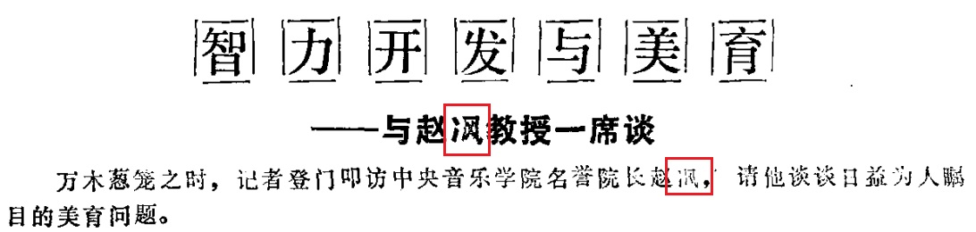

**Fig. 1686. Article in *Gongcheng Dizhi Xuebao* (2001 no. 3) p. 272**

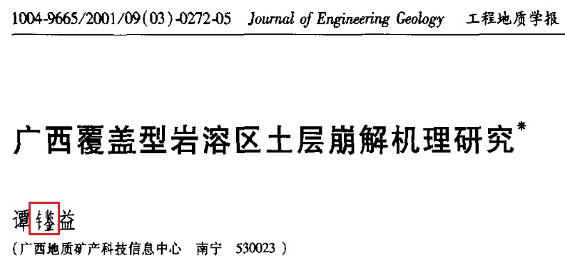

**Fig. 1687. Article in *Lishui Shifan Zhuanke Xuexiao Xuebao* (2001 no. 5) p. 31**

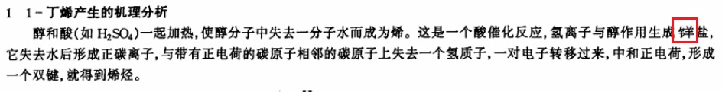

**Fig. 1688. Article in *Shandi Nongye Shengwu Xuebao* (2007 no. 2) p. 64**

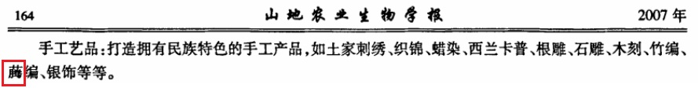

**Fig. 1689. Article in *Shuichan Keji Qingbao* (1973 no. 2) p. 1**

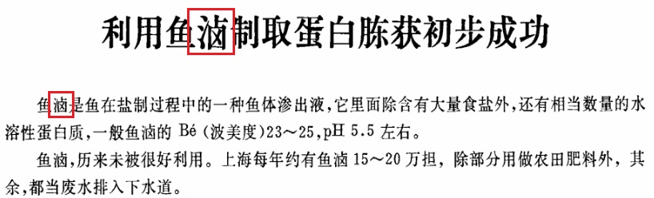

**Fig. 1690. Article in *Wenshi Tiandi* (1998 no. 2) p. 18**

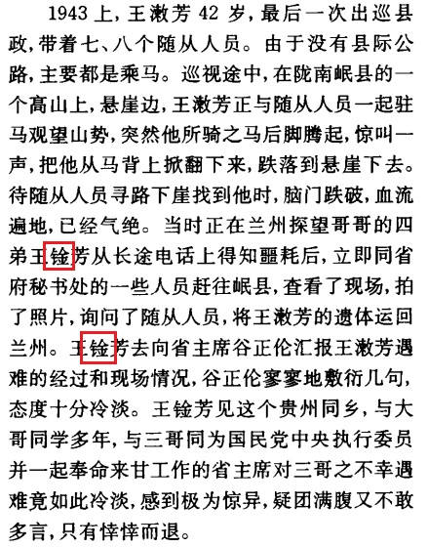

**Fig. 1691. Article in *Yuwen Tiandi* (2000 no. 16) p. 30**

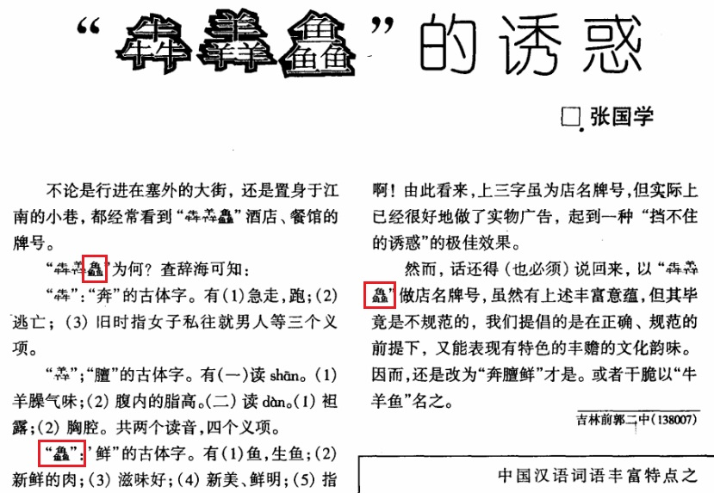

**Fig. 1692. *Aximofu Zuixin Kexue Zhinan* (Nanjing, 1999) v. 1 p. 329**

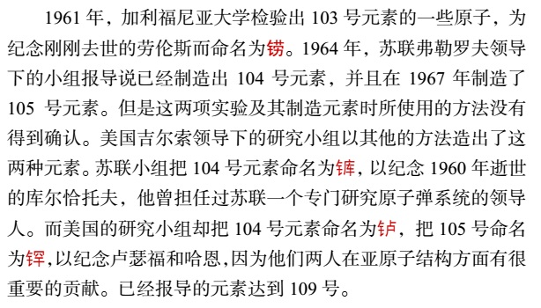

**Fig. 1693. *Yangxinxian Dimingzhi* (1984) map**

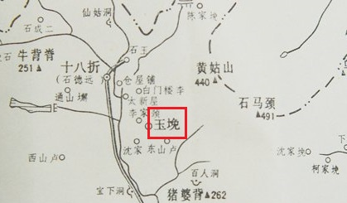

**Fig. 1694. *Shanhai Jing* (2000) p. 167**

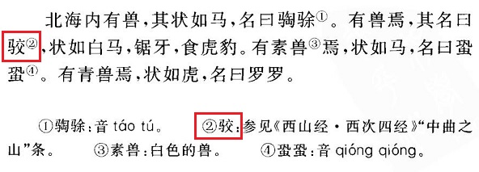

**Fig. 1695. *Pu Songling Ji* (1986) p. 881**

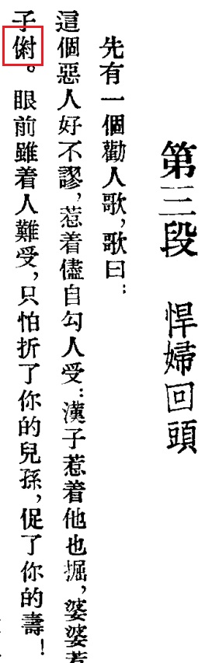

**Fig. 1696. *Gu Zhuangzi Zidian* (1989) p. 179**

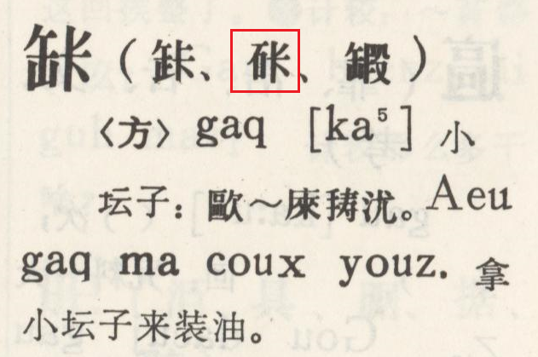

**Fig. 1697. *Gu Zhuangzi Zidian* (1989) p. 347**

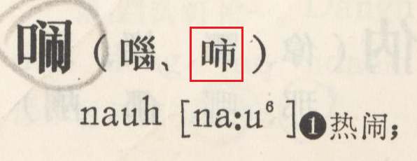

**Fig. 1698. *Hebei Zhongxiyi Jiehe Zazhi* 1996 no. 1 p. 81**

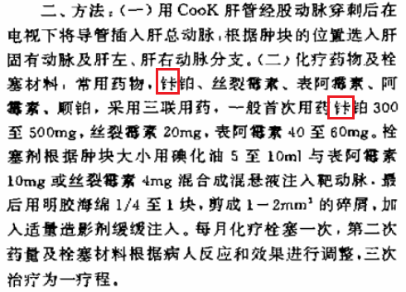

**Fig. 1699. Resident Identity Card (PRC) of Ma Cheng**

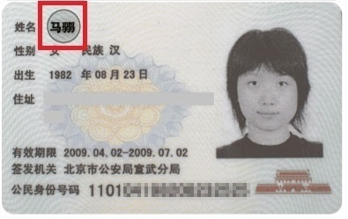

**Fig. 1700. *Nandoku Seishi Jiten* (Tokyo, 1977) p. 213**

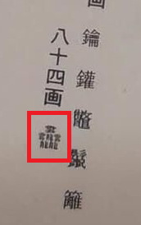

**Fig. 1701. *Chokkanryoku ga mi ni tsuku Kanji Jukugo kuizu* (Tokyo, 2011) p. 52**

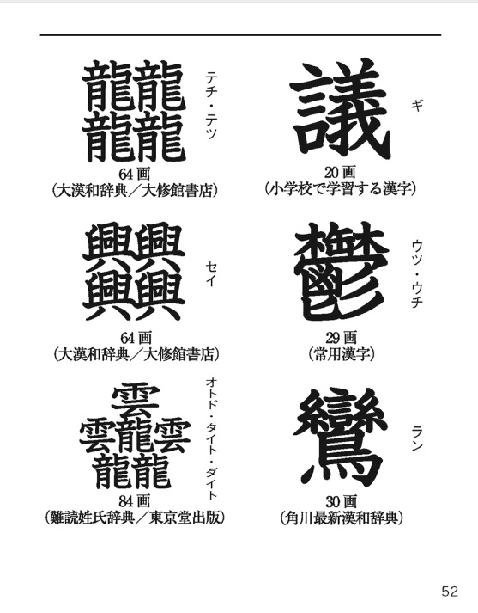

Note that the other five characters shown on this page are already encoded, including U+2A6A5 𪚥 and U+2053B 𠔻.

**Fig. 1702. *Noumin to Tomo ni* (Tokyo, 1940) p. 58**

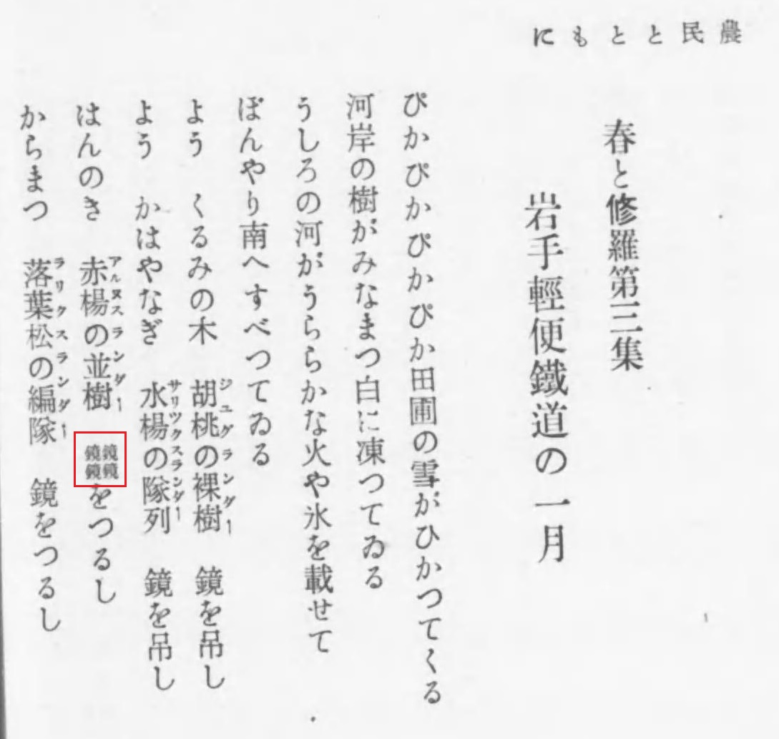

**Fig. 1703. *Za Besuto Hausu Zukan* (Tokyo, 2007) p. 135**

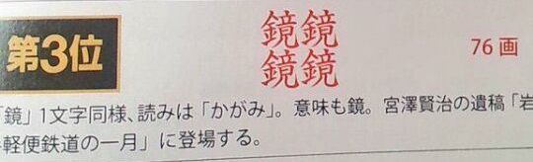

**Fig. 1704. *Shuofu Sanzhong* (Beijing, 1988) vol. 1 p. 645**

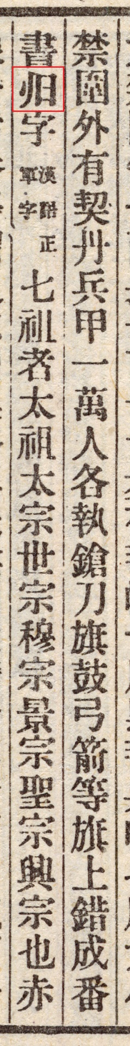

**Fig. 1705. *Shuofu* vol. 56 no. 3 p. 2**

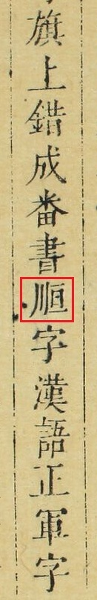

**Fig. 1706. *Jianhuazi Jianzi* (Beijing, 1973) p. ii**

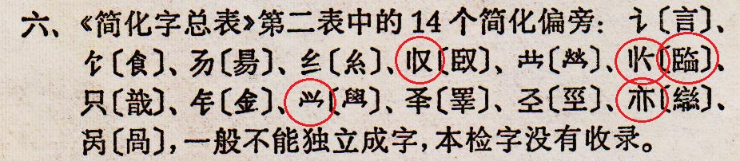

**Fig. 1707. *Jianhuazi Zongbiao* (Beijing, 1977) p. 13 (also 1986 ed. pp. 24, 33-34)**

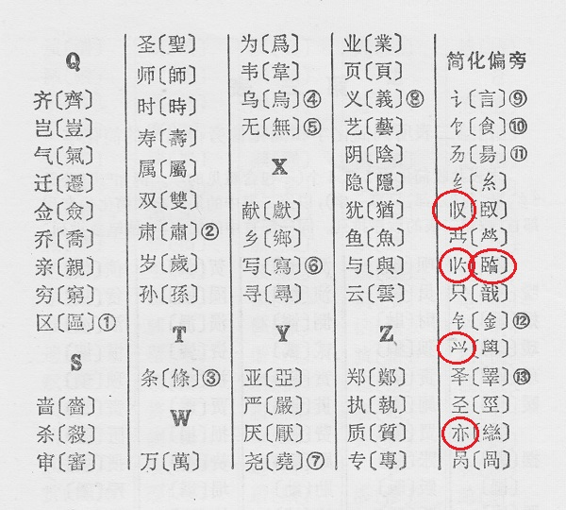

**Fig. 1708. SJ/T 11239-2001 p. 3 Zone 16**

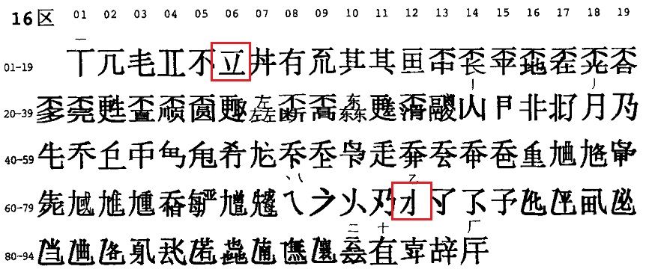

**Fig. 1709. SJ/T 11239-2001 p. 4 Zone 20**

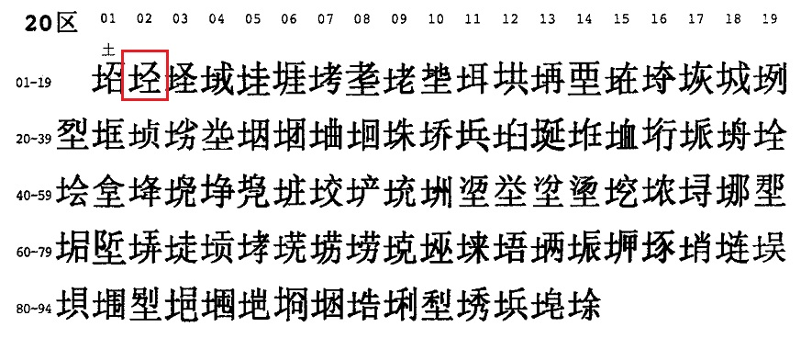

**Fig. 1710. SJ/T 11239-2001 p. 4 Zone 21**

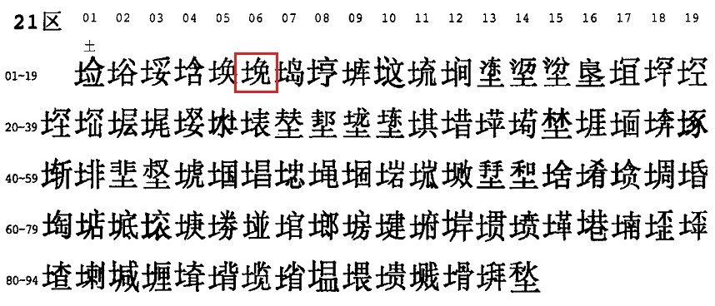

**Fig. 1711. SJ/T 11239-2001 p. 7 Zone 30**

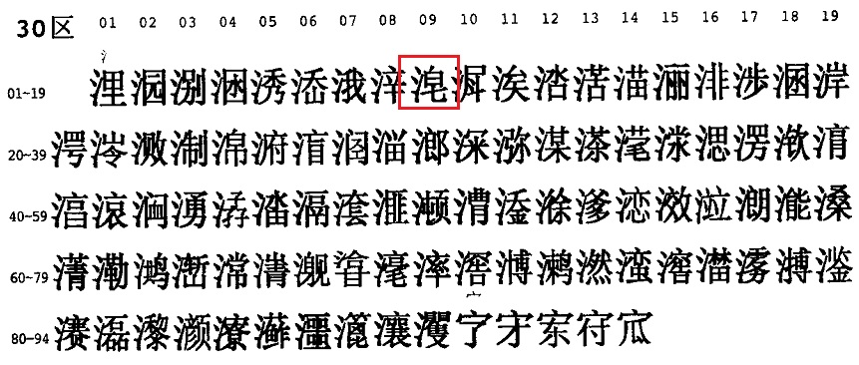

**Fig. 1712. SJ/T 11239-2001 p. 8 Zone 32**

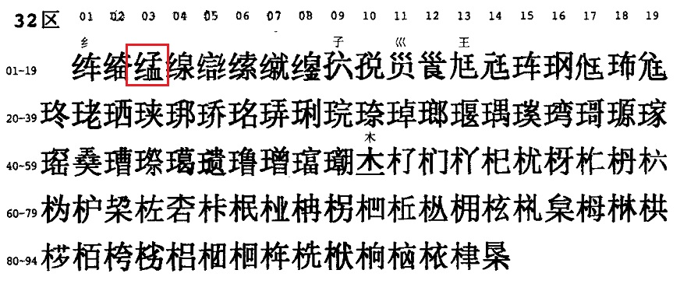

**Fig. 1713. SJ/T 11239-2001 p. 9 Zone 36**

